1. **OPERATING SYSTEM STRUCTURE**

An operating system provides the environment within which programs are executed. The operating system provides the means for proper use of hardware, CPU resources in the operation of the computer system. An operating system is similar to a government. Like a government, it performs no useful function by itself. It simply provides an environment within which other programs can do useful work.

* 1. **Operating-System Services** :

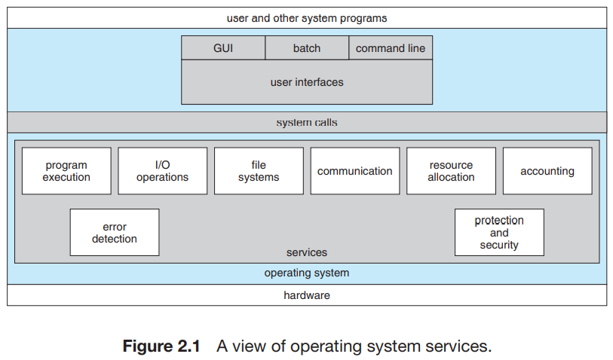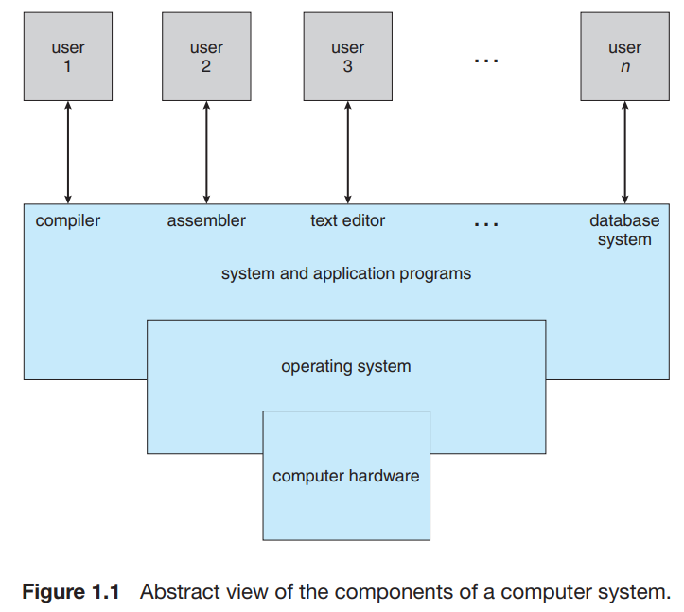

* 1. **User and Operating system interface** :

• ***User interface*** : One is a *command-line interface (CLI)*, which uses text commands and a method for entering them. Another is a *batch interface*, in which commands and directives to control those commands are entered into files, and those files are executed. Most commonly, a *graphical user interface (GUI)* is used. Here, the interface is a window system with a pointing device to direct I/O, choose from menus, and make selections and a keyboard to enter text.

• ***Program execution*** : The system must be able to load a program into memory and to run that program.

• ***I/O operations*** : A running program may require I/O, which may involve a file or an I/O device.

• ***File-system manipulation***. The file system is of particular interest. Obviously, programs need to read and write files and directories. They also need to create and delete them by name, search for a given file, and list file information.

• ***Communication*** : Communications may be implemented via shared memory, in which two or more processes read and write to a shared section of memory, or message passing, in which packets of information in predefined formats are moved between processes by the operating system.

• ***Error detection***

* 1. **System Calls** :

*System calls provide an interface to the services made available by an operating system*. These calls are generally available as routines written in C and C++, although certain low-level tasks (for example, tasks where hardware must be accessed directly) may have to be written using assembly-language instructions. These calls are invoked through software interrupts only.

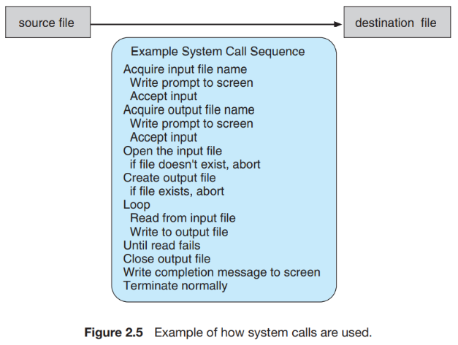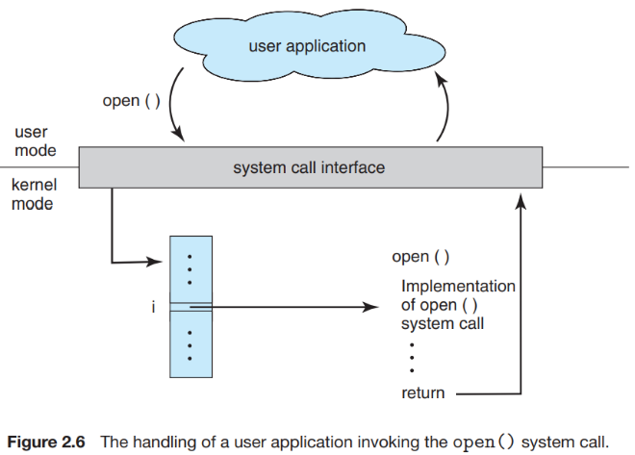

Most programmers never see this level of detail, however. Typically, application developers design programs according to an **Application programming interface (API)**. *The API specifies a set of functions that are available to an application programmer, including the parameters that are passed to each function and the return values the programmer can expect.* For most programming languages, the run-time support system (a set of functions built into libraries included with a compiler) provides a **system call interface** that serves as the link to system calls made available by the operating system.

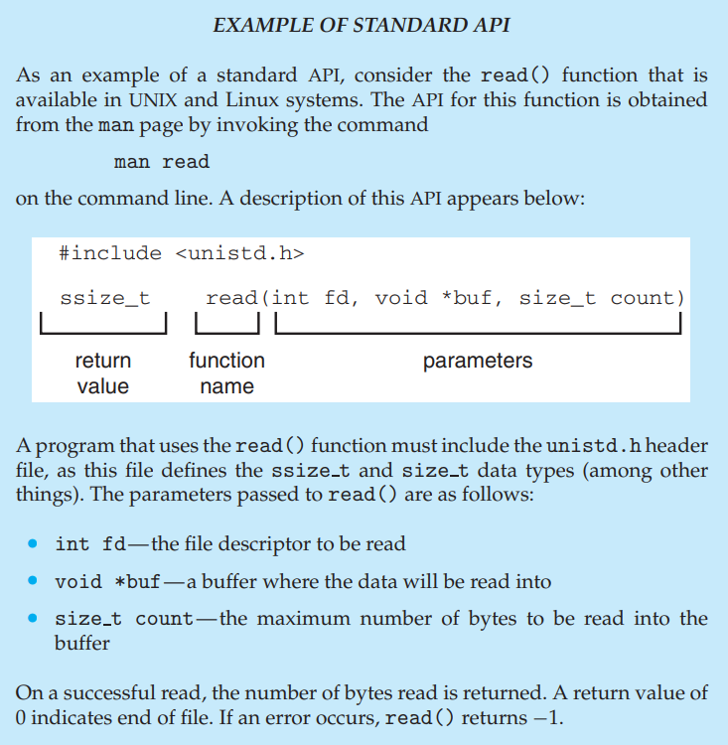***1.3.1) Types of System Calls :***

System calls can be grouped roughly into six major categories:

**process control,**

**file manipulation,**

**device manipulation,**

**information maintenance, communications, and protection.**

1. *Process Control* : A running program needs to be able to halt its execution either normally (end()) or abnormally (abort()). Under either normal or abnormal circumstances, the operating system must transfer control to the invoking command interpreter. The command interpreter then reads the next command.

There are so many facets of and variations in process and job control that we next use two examples—one involving a **single-tasking system** and the other a **multitasking system**.

* 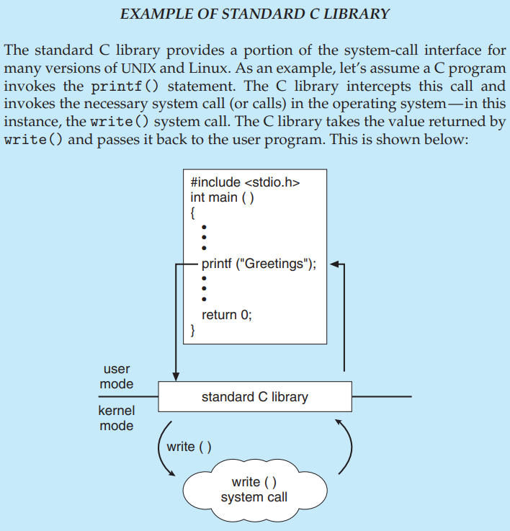*MS-DOS is single-tasking, it uses a simple method to run a program and does not create a new process. It loads the program into memory, writing over most of itself to give the program as much memory as possible (Figure 2.9(b)). Next, it sets the instruction pointer to the first instruction of the program. The program then runs, and either an error causes a trap, or the program executes a system call to terminate.*
* 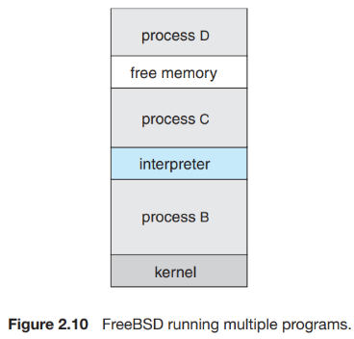*FreeBSD is a multitasking system; the command interpreter may continue running while another program is executed (Figure 2.10). To start a new process, the shell executes a fork() system call. Then, the selected program is loaded into memory via an exec() system call, and the program is executed. When the process is done, it executes an exit() system call to terminate, returning to the invoking process a status code of 0 or a nonzero error code.*

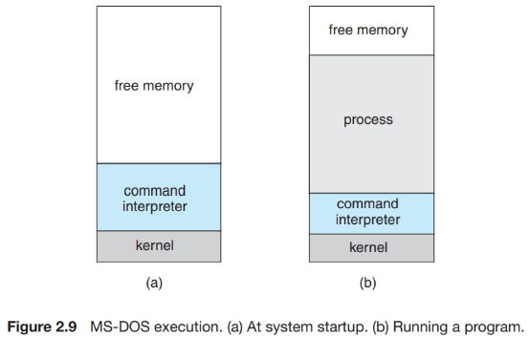

1. *File Management* : The file system is discussed in more detail in Chapters 11 and 12.
2. *Device Management* : A process may need several resources to execute—main memory, disk drives, access to files, and so on. If the resources are available, they can be granted, and control can be returned to the user process. Otherwise, the process will have to wait until sufficient resources are available.
3. *Information Maintenance* : Many system calls exist simply for the purpose of transferring information between the user program and the operating system. For example, most systems have a system call to return the current time() and date().
4. *Communication* : There are two common models of interprocess communication: the **message passing model** and the **shared-memory model**.

* In the message-passing model, the communicating processes exchange messages with one another to transfer information. Messages can be exchanged between the processes either directly or indirectly through a common mailbox.
* In the shared-memory model, processes use shared memory create() and shared memory attach() system calls to create and gain access to regions of memory owned by other processes. They can then exchange information by reading and writing data in the shared areas. System calls are needed set up shared memory between two processes.
  1. **System Programs** :

If you look at the computer hierarchy at the lowest level is hardware. Next is the operating system, then the system programs, and finally the application programs. **System programs**, also known as **system utilities**, provide a convenient environment for program development and execution.

*Constantly running system-program processes are known as services, subsystems, or daemons.*

**NOTE** :

* From computer’s point of view, its operating system is both resource allocation and control program. Control program because it controls I/O devices and switches programs.
* **Multitasking** and **multiprogramming** :

When multiple programs execute at a time on a single device, it is multiprogramming. Multiprogramming keeps several programs in main memory at the same time and execute them concurrently utilizing single CPU. But multiprogramming is non-preemptive. So, while one process is executing, we cannot switch with another process provided the first process is not getting any I/O. If so then we allocate CPU to another processor.

Multi-tasking is an extension of multiprogramming. In multiprogramming there is can current processing with context switching while in multi-tasking there is concept of context switching with additional feature of time sharing.

1. **PROCESSES**

A **process**, which is a program in execution. A process is the unit of work in a modern time-sharing system.

* 1. **Process Concept** :

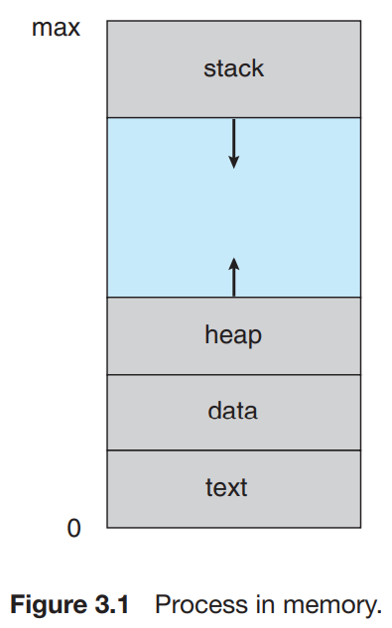A question that arises in discussing operating systems involves what to call all the CPU activities. A batch system executes **jobs**, whereas a time-shared system has **user** **programs**, or **tasks**. The terms job and process are used almost interchangeably in this text.

***2.1.1) The Processes*** : Informally, as mentioned earlier, a process is a program in execution. A process is more than the program code, which is sometimes known as the **text section**. It also includes the current activity, as represented by the value of the **program counter** and the contents of the **processor’s registers**. A process generally also includes the **process stack**, which contains temporary data (such as function parameters, return addresses, and local variables), and a **data section**, which contains global variables. A process may also include a **heap**, which is memory that is dynamically allocated during process run time. The structure of a process in memory is shown in Figure 3.1. We emphasize that a program by itself is not a process. *A program is a passive entity, such as a file containing a list of instructions stored on disk (often called an executable file). In contrast, a process is an active entity, with a program counter specifying the next instruction to execute and a set of associated resources. A program becomes a process when an executable file is loaded into memory.*

**NOTE** : For passing parameter there can be many methods. Which method and how many methods used, is totally depend on the OS.

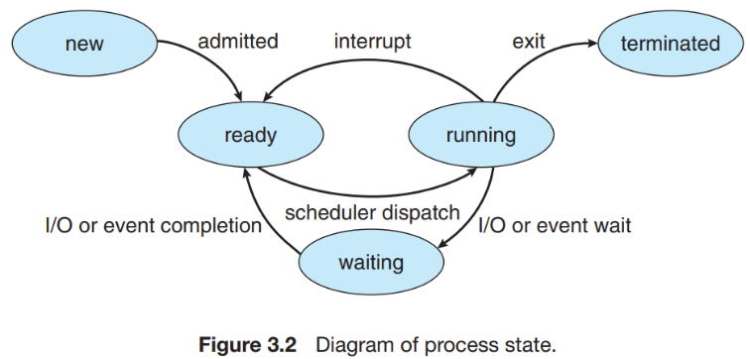***2.1.2) Process State*** : As a process executes, it changes state. The state of a process is defined in part by the current activity of that process. A process may be in one of the following states:

• **New**. The process is being created.

• **Running**. Instructions are being executed.

• **Waiting**. The process is waiting for some event to occur (such as an I/O completion or reception of a signal).

• **Ready**. The process is waiting to be assigned to a processor.

• **Terminated**. The process has finished execution.

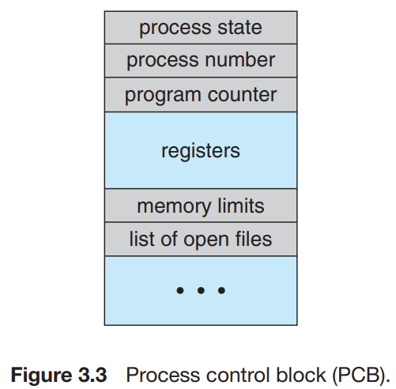***2.1.3) Process Control Block*** : Each process is represented in the operating system by a **process control block (PCB)**—also called a **task control block**. It contains many pieces of information associated with a specific process, including these:

• **Process state**. The state may be new, ready, running, waiting, halted, and so on.

• **Program counter**. The counter indicates the address of the next instruction to be executed for this process.

• **CPU registers**. The registers vary in number and type, depending on the computer architecture.

• **CPU-scheduling information**.

• **Memory-management information**. This information may include such items as the value of the base and limit registers and the page tables, or the segment tables, depending on the memory system used by the operating system.

• **Accounting information**. This information includes the amount of CPU and real time used, time limits, account numbers, job or process numbers, and so on.

• **I/O status information**. This information includes the list of I/O devices allocated to the process, a list of open files, and so on.

* 1. **Process Scheduling** :

The objective of multiprogramming is to have some process running at all times, to maximize CPU utilization.

The objective of time sharing is to switch the CPU among processes so frequently that users can interact with each program while it is running. To meet these objectives, the **process scheduler** selects an available process (possibly from a set of several available processes) for program execution on the CPU. The objective of scheduling is not to decide which waiting process to unblock first but *to decide which ready process to run next*.

***2.2.1) Scheduling Queues*** : As processes enter the system, they are put into a **job queue**, which consists of all processes in the system. The processes that are residing in main memory and are ready and waiting to execute are kept on a list called the **ready queue**. This queue is generally stored as a linked list. The list of processes waiting for a particular I/O device is called a **device queue**. A common representation of process scheduling is a **queueing diagram**, such as that in Figure 3.6.

A new process is initially put in the ready queue. It waits there until it is selected for execution, or **dispatched**. Once the process is allocated the CPU and is executing, one of several these events could occur as shown in figure.

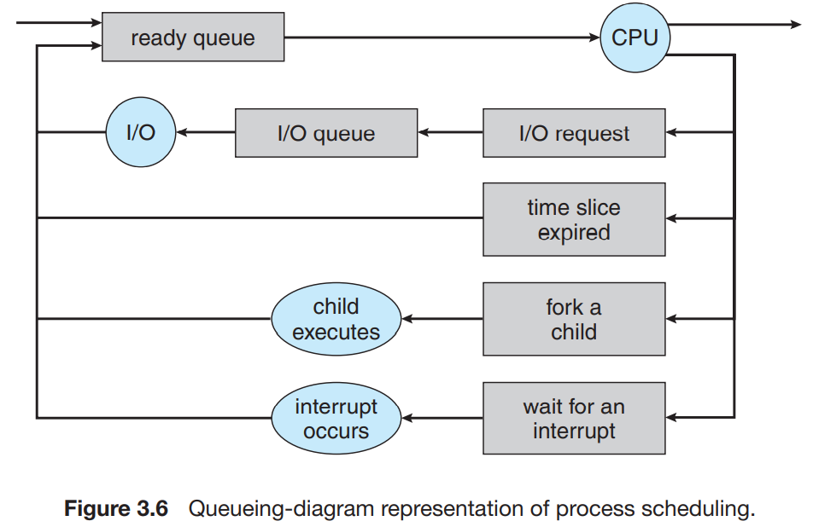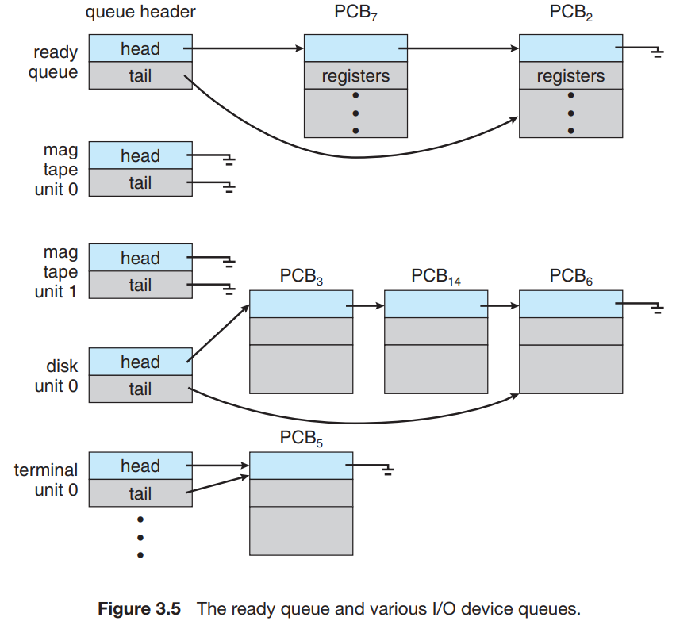

***2.2.2) Schedulers :*** The operating system must select, for scheduling purposes, processes from these queues in some fashion. The selection process is carried out by the appropriate **scheduler**. Often, in a batch system, more processes are submitted than can be executed immediately.

The **long-term scheduler**, or job scheduler, selects processes from this pool and loads them into memory for execution. The **short-term scheduler**, or CPU scheduler, selects from among the processes that are ready to execute and allocates the CPU to one of them. The primary distinction between these two schedulers lies in frequency of execution.

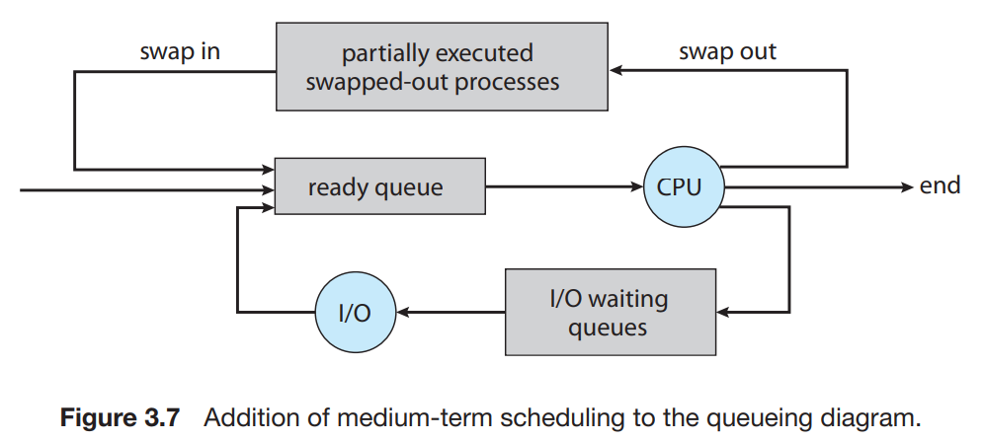Degree of multiprogramming = the number of processes in memory.

In general, most processes can be described as either **I/O bound** or **CPU bound**. An I/O-bound process is one that spends more of its time doing I/O than it spends doing computations. A CPU-bound process, in contrast, generates I/O requests infrequently, using more of its time doing computations. For example, If all processes are I/O bound, the ready queue will almost always be empty, and the short-term scheduler will have little to do.

The key idea behind a **medium-term scheduler** is that sometimes it can be advantageous to remove a process from memory to secondary memory (and from active contention for the CPU) and thus reduce the degree of multiprogramming. Later, the process can be reintroduced into memory, and its execution can be continued where it left off. This scheme is called **swapping**.

***2.2.3) Context Switch*** : When an interrupt occurs, the system needs to save the current **context** of the process running on the CPU so that it can restore that context when its processing is done, essentially suspending the process and then resuming it. Generically, we perform a **state save** of the current state of the CPU, be it in kernel or user mode, and then a **state restore** to resume operations. Switching the CPU to another process requires performing a *state save* of the current process **not state save of CPU** and a *state restore* of a different process. This task is known as a **context switch**. When a context switch occurs, the kernel saves the context of the old process in its PCB and loads the saved context of the new process scheduled to run. *Note here state of process only includes information about the data that was stored in registers, the value of program counter, and the stack pointer. It does not include global variables, dynamically allocated memory.*

Context switch = user to kernel switch + save/load PCB + kernel to user switch (to do transition from user to kernel and vice versa OS just have to make mode bit to 0 and 1 which requires very less time)

In Special cases, after finishing its job in kernel mode, the OS may sometimes decide to go back to the user mode of the same process, without switching to another process.

*Difference between Apple and android* : Apple probably limits multitasking due to battery life and memory use concerns Android does not place such constraints on the types of applications that can run in the background. If an application requires processing while in the background, the application must use a **service**, a separate application component that runs on behalf of the background process.

* 1. **Operations on Processes** :

The processes in most systems can execute concurrently, and they may be created and deleted dynamically. Thus, these systems must provide a mechanism for process creation and termination.

***2.3.1) Process Creation*** : During the course of execution, a process may create several new processes. As mentioned earlier, the creating process is called a **parent process**, and the new processes are called the **children** of that process. Most operating systems (including UNIX, Linux, and Windows) identify processes according to a **unique process identifier** (or pid), which is typically an integer number. The pid provides a unique value for each process in the system, and it can be used as an index to access various attributes of a process within the kernel. Figure 3.8 illustrates a typical process tree for the Linux operating system, showing the name of each process and its pid.

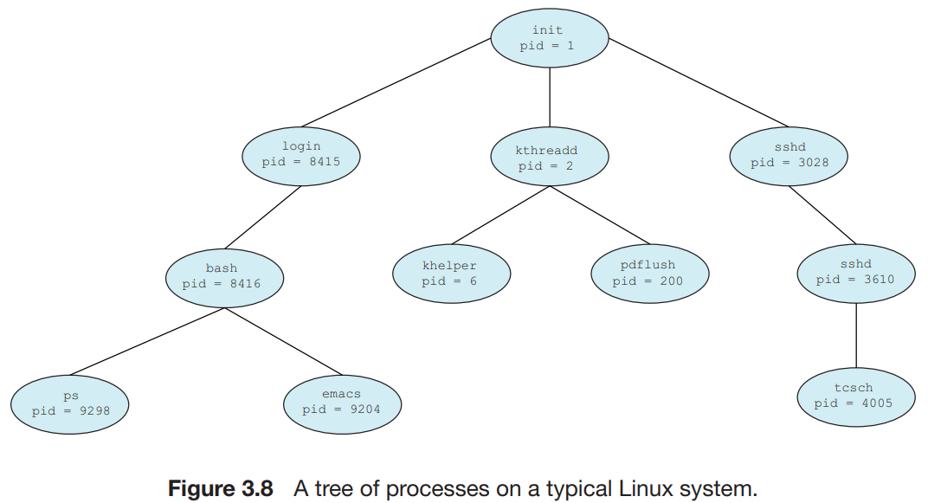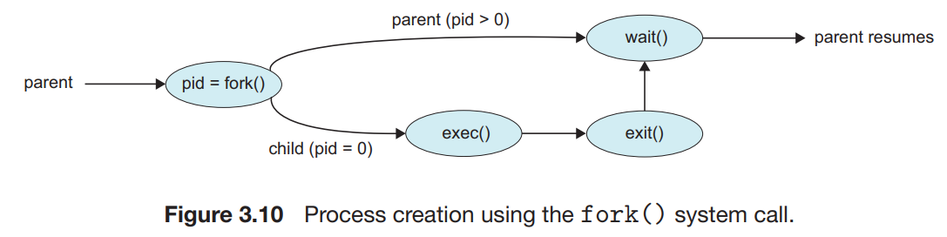

Without this they are Orphan

Here they are zombie

In general, when a process creates a child process, that child process will need certain resources (CPU time, memory, files, I/O devices) to accomplish its task. A child process may be able to obtain its resources directly from the operating system, or it may be constrained to a subset of the resources of the parent process.

*For example : When click on image app and then select particular image then the selected image act as child process and app as parent.*

When a process creates a new process, two possibilities for execution exist:

1. The parent continues to execute concurrently with its children.

2. The parent waits until some or all of its children have terminated.

There are also two address-space possibilities for the new process:

1. The child process is a duplicate of the parent process (it has the same program and data as the parent).

2. The child process has a new program loaded into it.

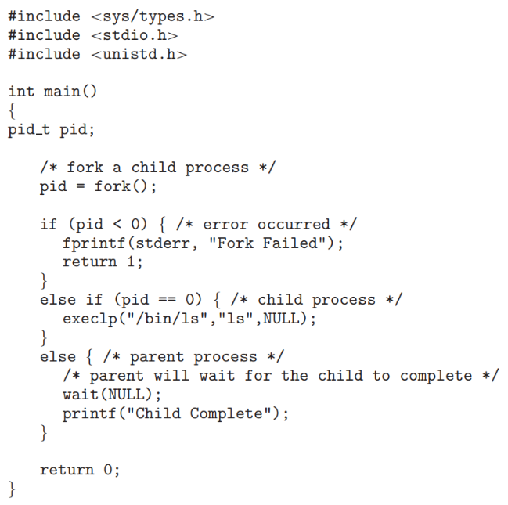

If the call to fork() is executed successfully, Unix will

* make two identical copies of address spaces, one for the parent and the other for the child.
* Both processes will start their execution at the next statement following the fork() call.

Since both processes have identical but separate address spaces, those variables initialized before the fork() call have the same values in both address spaces. Since every process has its own address space, any modifications will be independent of the others including other segment like heap, code, data, global etc. In other words, if the parent changes the value of its variable, the modification will only affect the variable in the parent process's address space. Other address spaces created by fork() calls will not be affected even though they have identical variable names. After a fork() system call, one of the two processes typically uses the exec() system call to replace the process’s memory space with a new program. The exec() system call loads a binary file into memory (destroying the memory image of the program containing the exec() system call) and starts its execution. *The parent can then create more children; or, if it has nothing else to do while the child runs, it can issue a wait() system call to move itself off the ready queue until the termination of the child.*

***2.3.2) Process Termination*** : A process terminates when it finishes executing its final statement and asks the operating system to delete it by using the exit() system call. At that point, the process may return a status value (typically an integer) to its parent process (via the wait() system call).

Some systems do not allow a child to exist if its parent has terminated. In such systems, if a process terminates (either normally or abnormally), then all its children must also be terminated. This phenomenon, referred to as **cascading termination**, is normally initiated by the operating system.

A parent process may wait for the termination of a child process by using the wait() system call. The wait() system call is passed a parameter that allows the parent to obtain the exit status of the child. This system call also returns the process identifier of the terminated child so that the parent can tell which of its children has terminated.

When a process terminates, its resources are deallocated by the operating system. However, its entry in the process table must remain there until the parent calls wait(), because the process table contains the process’s exit status. A **zombie process** or **defunct process** is a process that has completed execution but still has an entry in the process table as its parent process didn't invoke a wait() system call. All processes transition to this state when they terminate, but generally they exist as zombies only briefly. Once the parent calls wait(), the process identifier of the zombie process and its entry in the process table are released. Now consider what would happen if a parent did not invoke wait() and instead terminated, thereby leaving its child processes as **orphans**. The kill( ) system call is used by operating system to send a termination signal to a process that urges the process to exit.

* 1. **Interprocess Communication** :

Processes executing concurrently in the operating system may be either **independent processes** or **cooperating processes**. A process is independent if it cannot affect or be affected by the other processes executing in the system. Any process that does not share data with any other process is independent. A process is cooperating if it can affect or be affected by the other processes executing in the system. Clearly, any process that shares data with other processes is a cooperating process.

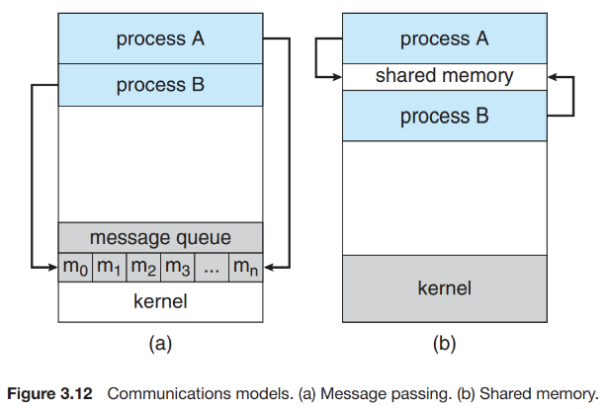Cooperating processes require an **interprocess communication** (IPC) mechanism that will allow them to exchange data and information. There are two fundamental models of interprocess communication: shared memory and message passing. In the **shared-memory model**, a region of memory that is shared by cooperating processes is established. Processes can then exchange information by reading and writing data to the shared region. In the **message-passing model**, communication takes place by means of messages exchanged between the cooperating processes.

***2.4.1) Shared Memory System :***

Here we only talk about cooperative process as independent process do not share data with each other. To illustrate the concept of cooperating processes, let’s consider the **producer–consumer problem**, which is a common paradigm for cooperating processes. A producer process produces information that is consumed by a consumer process. For example, a compiler may produce assembly code that is consumed by an assembler. The assembler, in turn, may produce object modules that are consumed by the loader.

***2.4.2) Message-Passing Systems*** : A message-passing facility provides at least two operations: send(message) receive(message) Messages sent by a process can be either fixed or variable in size. If only fixed-sized messages can be sent, the system-level implementation is straightforward. This restriction, however, makes the task of programming more difficult. Conversely, variable-sized messages require a more complex system-level implementation, but the programming task becomes simpler. This is a common kind of tradeoff seen throughout operating-system design.

• *Direct* or *indirect communication* :

**Direct** = • send(P, message)—Send a message to process P.

• receive(Q, message)—Receive a message from process Q.

**Indirect** = • send(A, message)—Send a message to mailbox A.

• receive(A, message)—Receive a message from mailbox A.

• *Synchronous* or *asynchronous communication* : Synchronous communication means each sender sends message synch with receiver.

• *Automatic* or *explicit buffering*.

* 1. **Pipes** : A pipe acts as a conduit allowing two processes to communicate. Pipes were one of the first IPC mechanisms in early UNIX systems. They typically provide one of the simpler ways for processes to communicate with one another, although they also have some limitations.

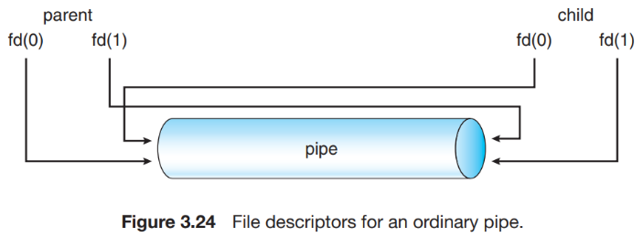***2.5.1) Ordinary Pipes*** : Ordinary pipes allow two processes to communicate in standard producer – consumer fashion: the producer writes to one end of the pipe (the write-end) and the consumer reads from the other end (the read-end). As a result, ordinary pipes are unidirectional, allowing only one-way communication. If two-way communication is required, two pipes must be used, with each pipe sending data in a different direction.

On UNIX systems, ordinary pipes are constructed using the function pipe(int fd[]) This function creates a pipe that is accessed through the int fd[] file descriptors: fd[0] is the read-end of the pipe, and fd[1] is the write-end.

***2.5.2) Named Pipes*** : Ordinary pipes provide a simple mechanism for allowing a pair of processes to communicate. However, ordinary pipes exist only while the processes are communicating with one another. On both UNIX and Windows systems, once the processes have finished communicating and have terminated, the ordinary pipe ceases to exist. Named pipes provide a much more powerful communication tool. Communication can be bidirectional, and no parent–child relationship is required. Once a named pipe is established, several processes can use it for communication. Additionally, named pipes continue to exist after communicating processes have finished.

1. **THREADS**
   1. **Overview** :

A thread is a basic unit of CPU utilization; it comprises a thread ID, a program counter, a register set, and a stack. It shares with other threads belonging to the same process its code section, data section, and other operating-system resources, such as open files and signals. A traditional (or heavyweight) process has a single thread of control. If a process has multiple threads of control, it can perform more than one task at a time.

*A thread is like conveyer belt in the factory. If we provide more conveyer belt more product can be sent to the main unit for packaging purpose.*

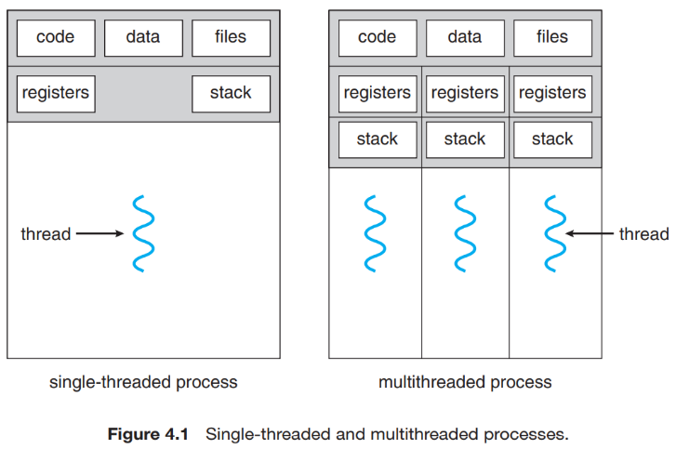*if we provide more thread more data can be sent to the main unit.*

**Example of thread** : A web browser might have one thread display images or text while another thread retrieves data from the network, for example. A word processor may have a thread for displaying graphics, another thread for responding to keystrokes from the user, and a third thread for performing spelling and grammar checking in the background.

**Problem** : A web server accepts client requests for web pages, images, sound, and so forth. A busy web server may have several (perhaps thousands of) clients concurrently accessing it. If the web server ran as a traditional single-threaded process, it would be able to service only one client at a time, and a client might have to wait a very long time for its request to be serviced.

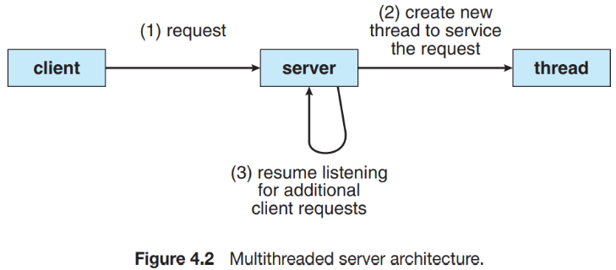**Solution 1 but still time and resource consuming** : When the server receives a request, it creates a separate process to service that request. In fact, this process-creation method was in common use before threads became popular. Process creation is time consuming and resource intensive, however. If the new process will perform the same tasks as the existing process, why incur all that overhead?

**Solution 2 (A perfect solution)** : If the web-server process is multithreaded, the server will create a separate thread that listens for client requests. When a request is made, rather than creating another process, the server creates a new thread to service the request and resume listening for additional requests. This is illustrated in Figure 4.2.

***Benefits*** : Responsiveness, Resource Sharing, Economy, Scalability.

1. **Responsiveness** : For instance, consider what happens when a user clicks a button that results in the performance of a time-consuming operation. A single-threaded application would be unresponsive to the user until the operation had completed. In contrast, if the time-consuming operation is performed in a separate thread, the application remains responsive to the user.
2. **Resource sharing** : Processes can only share resources through techniques such as shared memory and message passing. Such techniques must be explicitly arranged by the programmer. However, threads share the memory and the resources of the process to which they belong by default.
3. **Economy** : Allocating memory and resources for process creation is costly. Because threads share the resources of the process to which they belong, it is more economical to create and context-switch threads.
4. **Scalability** : The benefits of multithreading can be even greater in a multiprocessor architecture, where threads may be running in parallel on different processing cores. A single-threaded process can run on only one processor, regardless how many are available.
   1. 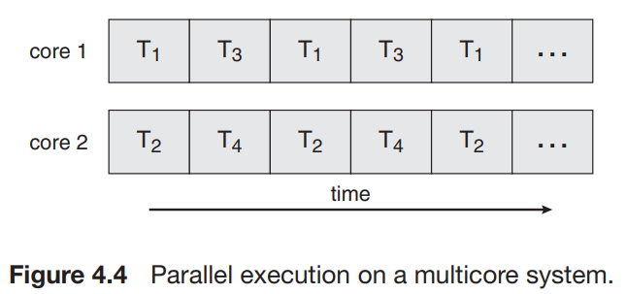**Multicore Programming** :

Consider an application with four threads. On a system with a single computing core, concurrency merely means that the execution of the threads will be interleaved over time (Figure 4.3), because the processing core is capable of executing only one thread at a time. On a system with multiple cores, however, concurrency means that the threads can run in parallel, because the system can assign a separate thread to each core (Figure 4.4).

Notice the distinction between **parallelism** and **concurrency** in this discussion. A system is parallel if it can perform more than one task simultaneously. In contrast, a concurrent system supports more than one task by allowing all the tasks to make progress. Thus, it is possible to have concurrency without parallelism.

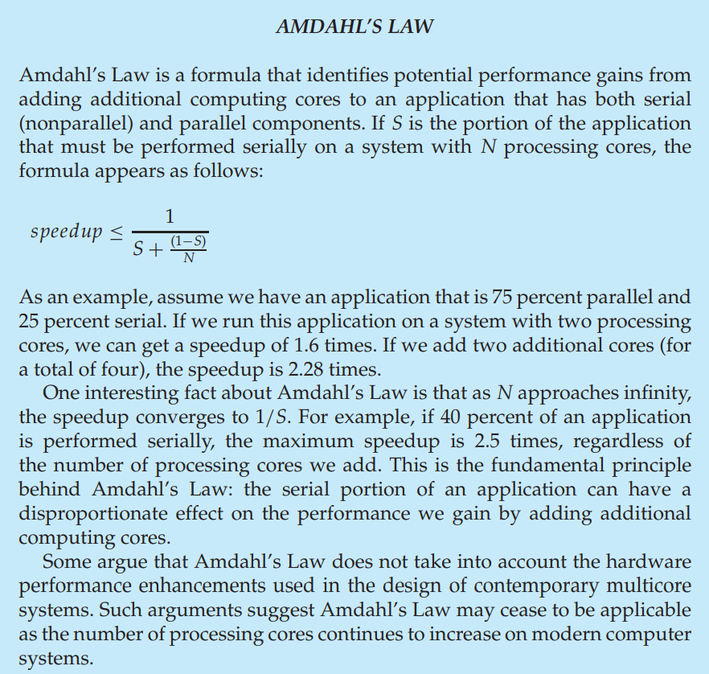In general, five areas present challenges in programming for multicore systems:

1. **Identifying tasks** : This involves examining applications to find areas that can be divided into separate, concurrent tasks.
2. **Balance** : In some instances, a certain task may not contribute as much value to the overall process as other tasks. Using a separate execution core to run that task may not be worth the cost.
3. **Data splitting** : Just as applications are divided into separate tasks, the data accessed and manipulated by the tasks must be divided to run on separate cores.
4. **Data dependency** : The data accessed by the tasks must be examined for dependencies between two or more tasks.
5. **Testing and Debugging** : When a program is running in parallel on multiple cores, many different execution paths are possible. Choose best path for execution.

***Types of Parallelism*** : **Data parallelism** involves the distribution of data across multiple cores and **task parallelism** on the distribution of tasks across multiple cores.

Consider, for example, summing the contents of an array of size N. On a single-core system, one thread would simply sum the elements [0] . . . [N − 1]. On a dual-core system, however, thread A, running on core 0, could sum the elements [0] . . . [N/2 − 1] while thread B, running on core 1, could sum the elements [N/2] . . . [N − 1]. The two threads would be running in parallel on separate computing cores. This is data parallelism. And if this task involves subtraction then one core 1 will be performing sub a – z, and core 2 may be performing a + z, each performed by their own threads.

* 1. **Multithreading model** :

**User mode** : It is normal mode where process has limited access. When program is handling text editor or basic application interface.

**Kernel or system mode** : Kernel mode will handle all the memory, hardware CPU related task. User mode use the functions of kernel mode via system calls.

* User threads are supported above the kernel and are managed without kernel support, whereas kernel threads are supported and managed directly by the operating system by system calls.

|  |  |
| --- | --- |
| ***User Level Thread*** | ***Kernel Level Thread*** |
| User thread are implemented by user processes. | kernel threads are implemented by OS. |
| OS doesn’t recognize user level threads. | Kernel threads are recognized by OS. |
| Implementation of User threads is easy. | Implementation of Kernel thread is complicated. |
| Context switch time is less. | Context switch time is more. |
| Context switch requires no hardware support. | Hardware support is needed. |
| If one user level thread perform blocking operation then entire process will be blocked. | If one kernel thread performs blocking operation then another thread can continue execution. |
| Example : Java thread, POSIX threads. | Example : Window Solaris. |

A relationship must exist between user threads and kernel threads. we look at three common ways of establishing such a relationship :

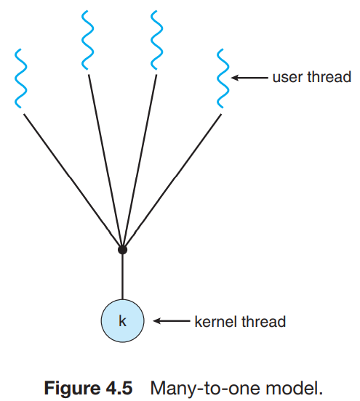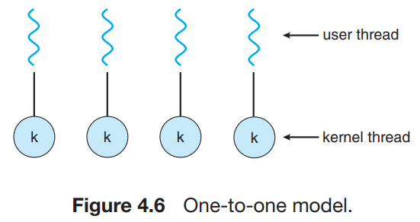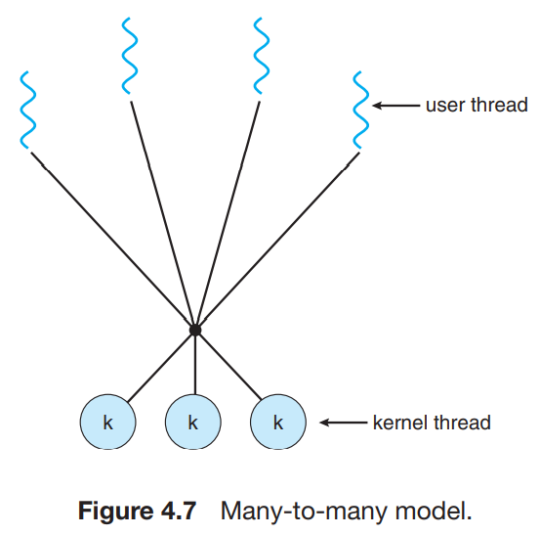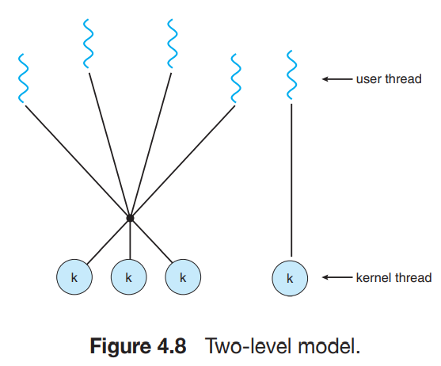

**Many-to-One Model** : The many-to-one model (Figure 4.5) maps many user-level threads to one kernel thread. However, the entire process will block if a thread makes a blocking system call. Also, because only one thread can access the kernel at a time, multiple threads are unable to run in parallel on multicore systems.

**One-to-One Model** : The one-to-one model (Figure 4.6) maps each user thread to a kernel thread. It provides more concurrency than the many-to-one model by allowing another thread to run when a thread makes a blocking system call. It also allows multiple threads to run in parallel on multiprocessors. The only drawback to this model is that creating a user thread requires creating the corresponding kernel thread. Because the overhead of creating kernel threads can burden the performance of an application.

**Many-to-Many Model** : The many-to-many model (Figure 4.7) multiplexes many user-level threads to a smaller or equal number of kernel threads. The number of kernel threads may be specific to either a particular application or a particular machine (an application may be allocated more kernel threads on a multiprocessor than on a single processor).

**Two level model** : One variation on the many-to-many model still multiplexes many user level threads to a smaller or equal number of kernel threads but also allows a user-level thread to be bound to a kernel thread.

Context switches in different scenarios :

1. Procedure call and return.
2. Trap to operating system and return.
3. Save and restore general-purpose registers.
4. Save and restore memory-mapping context.

Switch from one user-level thread to another use-level thread in the same process. (AC)

Switch from one kernel thread to another kernel-thread in the same process. (ABC)

Switch from one kernel thread to another kernel-thread in a different process. (ABCD)

* 1. **Threading issues** :

***3.4.1) The fork() and exec() System Calls*** : If one thread in a program calls fork(), does the new process duplicate all threads, or is the new process single-threaded? Which of the two versions of fork() to use depends on the application. If exec() is called immediately after forking, then duplicating all threads is unnecessary, as the program specified in the parameters to exec() will replace the process. In this instance, duplicating only the calling thread is appropriate. If, however, the separate process does not call exec() after forking, the separate process should duplicate all threads.

**NOTE** : When parent process calls child by fork() system call, the operation (line of code) of child and parents may interleave. So, if child and parent processes contain any printf function then printf function may interleave.

***3.4.2) Signal handling*** : A **signal** is used in UNIX systems to notify a process that a particular event has occurred. A signal may be received either synchronously or asynchronously, depending on the source of and the reason for the event being signaled. All signals, whether synchronous or asynchronous, follow the same pattern:

1. A signal is generated by the occurrence of a particular event.

2. The signal is delivered to a process.

3. Once delivered, the signal must be handled.

**Synchronous Signal** : It include illegal memory access and division by 0. If a running program performs either of these actions, a signal is generated. Synchronous signals are delivered to the same process that performed the operation that caused the signal (that is the reason they are considered synchronous).

**Asynchronous Signal** : When a signal is generated by an event external to a running process, that process receives the signal asynchronously. Examples of such signals include terminating a process with specific keystrokes (such as <ctrl+c>) and having a timer expire. Typically, an asynchronous signal is sent to another process. A signal may be handled by one of two possible handlers:

1. A default signal handler

2. A user-defined signal handler

Every signal has a **default signal handler** that the kernel runs when handling that signal. This default action can be overridden by a **user-defined signal handler** that is called to handle the signal. Signals are handled in different ways. Some signals (such as changing the size of a window) are simply ignored; others (such as an illegal memory access) are handled by terminating the program. Handling signals in single-threaded programs is straightforward: signals are always delivered to a process. However, delivering signals is more complicated in multithreaded programs, where a process may have several threads. Where, then, should a signal be delivered? In general, the following options exist:

1. Deliver the signal to the thread to which the signal applies.

2. Deliver the signal to every thread in the process.

3. Deliver the signal to certain threads in the process.

4. Assign a specific thread to receive all signals for the process.

***3.4.3) Thread Cancellation*** :

**Thread cancellation** involves terminating a thread before it has completed. For example, if multiple threads are concurrently searching through a database and one thread returns the result, the remaining threads might be canceled. Another situation might occur when a user presses a button on a web browser that stops a web page from loading any further. Often, a web page loads using several threads—each image is loaded in a separate thread. When a user presses the stop button on the browser, all threads loading the page are canceled. A thread that is to be canceled is often referred to as the target thread. Cancellation of a target thread may occur in two different scenarios:

1. **Asynchronous cancellation** : One thread immediately terminates the target thread.

2. **Deferred cancellation** : The target thread periodically checks whether it should terminate, allowing it an opportunity to terminate itself in an orderly fashion.

*Problem* : The difficulty with cancellation occurs in situations where resources have been allocated to a canceled thread or where a thread is canceled while in the midst of updating data it is sharing with other threads. This becomes especially troublesome with asynchronous cancellation.

***3.4.4) Thread local storage* :** Threads belonging to a process share the data of the process. Indeed, this data sharing provides one of the benefits of multithreaded programming. However, in some circumstances, each thread might need its own copy of certain data. We will call such data **thread-local storage (or TLS.)** For example, in a transaction-processing system, we might service each transaction in a separate thread. Furthermore, each transaction might be assigned a unique identifier. To associate each thread with its unique identifier, we could use thread-local storage.

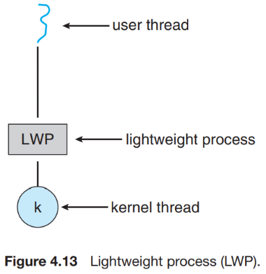

***3.4.5) Scheduler Activations*** : Many systems implementing either the many-to-many or the two-level model place an intermediate data structure between the user and kernel threads. This data structure — typically known as a **lightweight process, or LWP** — is shown in Figure 4.13. To the user-thread library, the LWP appears to be a virtual processor on which the application can schedule a user thread to run. Each LWP is attached to a kernel thread, and it is kernel threads that the operating system schedules to run on physical processors. If a kernel thread blocks (such as while waiting for an I/O operation to complete), the LWP blocks as well. Up the chain, the user-level thread attached to the LWP also blocks.

1. **PROCESS SYNCHRONIZATION**

A **cooperating process** is one that can affect or be affected by other processes executing in the system. Cooperating processes can either directly share a logical address space (that is, both code and data) or be allowed to share data only through files or messages.

* 1. **Background :**

In this chapter, we explain how concurrent or parallel execution can contribute to issues involving the integrity of data shared by several processes. We now return to our consideration of the bounded buffer. As we pointed out, our original solution allowed at most (BUFFER SIZE – 1) items in the buffer at the same time. **Counter** is incremented every time we add a new item to the buffer and is decremented every time, we remove one item from the buffer.

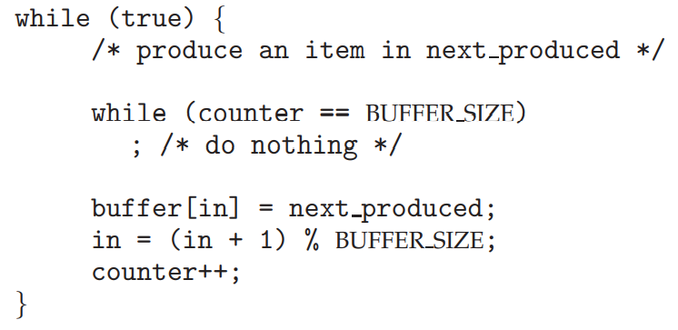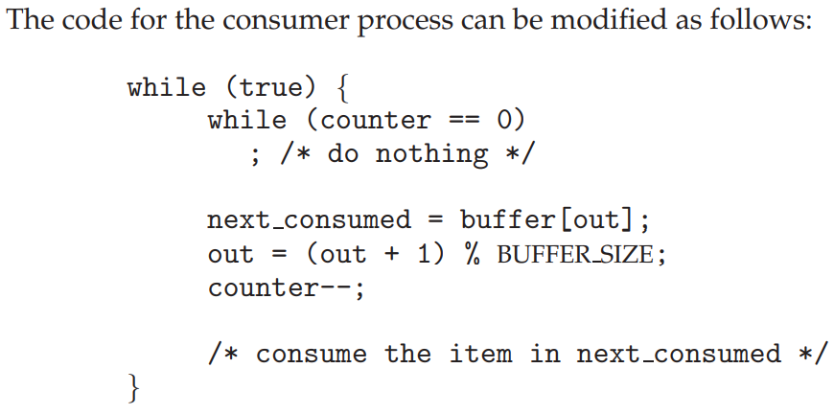

Although the producer and consumer routines shown above are correct separately, they may not function correctly when executed concurrently. As an illustration, suppose that the value of the variable counter is currently 5 and that the producer and consumer processes concurrently execute the statements “counter++” and “counter--”. Following the execution of these two statements, the value of the variable counter may be 4, 5, or 6!

We can show that the value of counter may be incorrect as follows. Note that the statement “counter++” may be implemented in machine language (on a typical machine) as follows:

register1 = counter

register1 = register1 + 1

counter = register1

where register1 is one of the local CPU registers. Similarly, the statement “counter--” is implemented as follows:

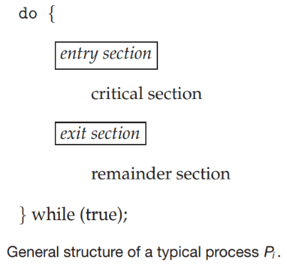register2 = counter

register2 = register2 − 1

counter = register2

One interleaving of the operation is the following:

T0: producer execute register1 = counter {register1 = 5}

T1: producer execute register1 = register1 + 1 {register1 = 6}

T2: consumer execute register2 = counter {register2 = 5}

T3: consumer execute register2 = register2 − 1 {register2 = 4}

T4: producer execute counter = register1 {counter = 6}

T5: consumer execute counter = register2 {counter = 4}

A situation like this, where several processes access and manipulate the same data concurrently and the outcome of the execution depends on the particular order in which the access takes place, is called a **Race condition**. Situations such as the one just described occur frequently in operating systems as different parts of the system manipulate resources. Because of the importance of this issue, we devote a major portion of this chapter to **process synchronization** and coordination among **cooperating processes**.

* 1. **The Critical-Section Problem** :

We begin our consideration of process synchronization by discussing the so called critical-section problem. Consider a system consisting of n processes {P0, P1, ..., Pn−1}. Each process has a segment of code, called a **critical section**, in which the process may be changing common variables, updating a table, writing a file, and so on. *When one process is executing in its critical section, no other process is allowed to execute in its critical section. That is, no two processes are executing in their critical sections at the same time.*

A solution to the critical-section problem must satisfy the following three requirements:

1. **Mutual exclusion** : If process Pi is executing in its critical section, then no other processes can be executing in their critical sections.

2. **Progress** : If no process is executing in its critical section and some processes wish to enter their critical sections, then only those processes that are not executing in their remainder sections can participate in deciding which will enter its critical section next, and this selection cannot be postponed indefinitely. **OR** Progress will not be satisfied when any process which is not interested to enter into the critical section will not allow other interested process to enter into the critical section. **And even if mutual exclusion is not satisfied then progress will defiantly satisfy because any interested process can go to CS independently.**

3. **Bounded waiting** : No process should have to wait forever to enter into the critical section. there should be a boundary on getting chances to enter into the critical section. At a given point in time, many kernel-mode processes may be active in the operating system. As a result, the code implementing an operating system (**kernel code**) is subject to several possible race conditions (adding the file to the list or removing it from the list). If two processes were to open files simultaneously, the separate updates to this list could result in a race condition.

Two general approaches are used to handle critical sections in operating systems : **preemptive kernels** and **nonpreemptive kernels**. A preemptive kernel allows a process to be preempted while it is running in kernel mode. A nonpreemptive kernel does not allow a process running in kernel mode to be preempted; a kernel-mode process will run until it exits kernel mode, blocks, or voluntarily yields control of the CPU. Obviously, a nonpreemptive kernel is essentially free from race conditions on kernel data structures, as only one process is active in the kernel at a time. Now throughout this book we only talk about the preemptive kernels.

* 1. **Peterson’s Solution :**

Next, we illustrate a classic software-based solution to the critical-section problem known as **Peterson’s solution**. Because of the way modern computer architectures perform basic machine-language instructions, such as load and store, there are no guarantees that Peterson’s solution will work correctly on such architectures.

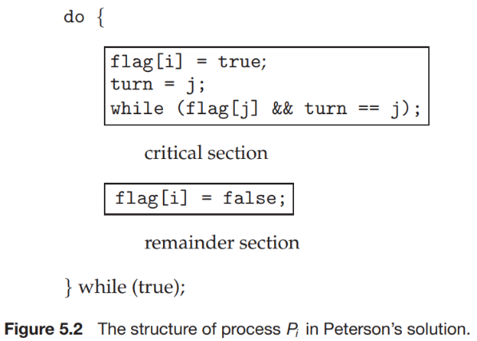The variable turn indicates whose turn it is to enter its critical section. That is, if turn == i, then process Pi is allowed to execute in its critical section. The flag array is used to indicate if a process is ready to enter its critical section. For example, if flag[i] is true, this value indicates that Pi is ready to enter its critical section.

From this code we can certainly say that :

1. **Mutual exclusion is preserved** : we note that each Pi enters its critical section only if either flag[j] == false or turn == i. Also note that, if both processes can be executing in their critical sections at the same time, then flag[0] == flag[1] == true. But both cannot turn flag at the same time there must be some delay between two turn execution. One who sets turn at last cannot go to its critical section.
2. Once Pj exits its critical section, it will reset flag[j] to false, allowing Pi to enter its critical section. If Pj resets flag[j] to true, it must also set turn to i. Thus, since Pi does not change the value of the variable turn while executing the while statement, Pi will enter the critical section (**progress**) after at most one entry by Pj (**bounded waiting**).
   1. **Synchronization Hardware** :

We have just described one software-based solution to the critical-section problem. However, as mentioned, software-based solutions such as Peterson’s are not guaranteed to work on modern computer architectures. In the following discussions, we explore several more solutions to the critical-section problem using techniques. All these solutions are based on the premise of **locking** —that is, protecting critical regions through the use of locks. All below solution are hardware based.

***1st solution*** :

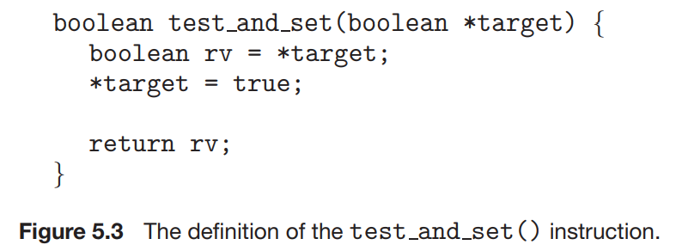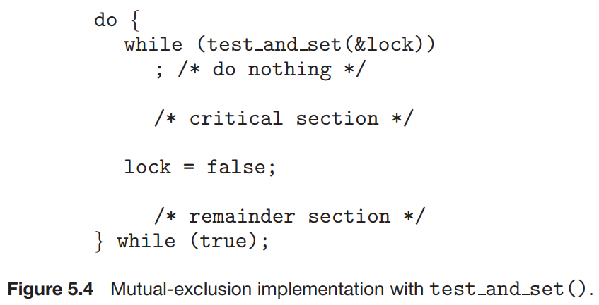

*Explanation* **:** . If the machine supports the test and set() instruction, then we can implement mutual exclusion by declaring a Boolean variable lock, initialized to false.

**Problem :** Unfortunately, this solution is not as feasible in a multiprocessor environment. Disabling interrupts on a multiprocessor can be time consuming, since the message is passed to all the processors. This message passing delays entry into each critical section, and system efficiency decreases.

***2nd Solution*** :

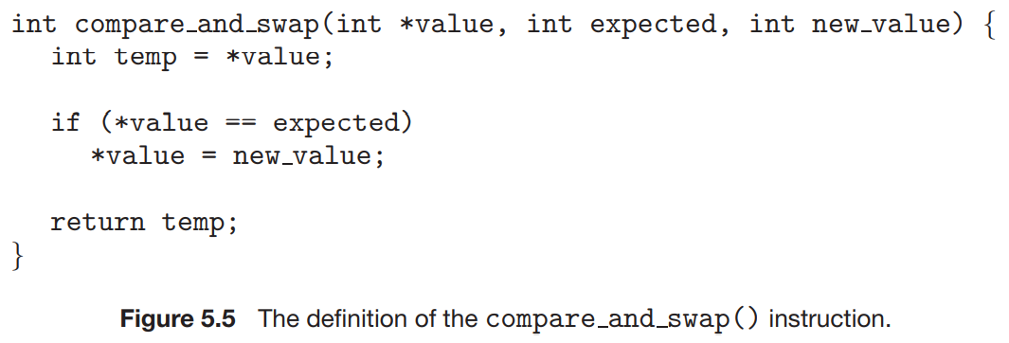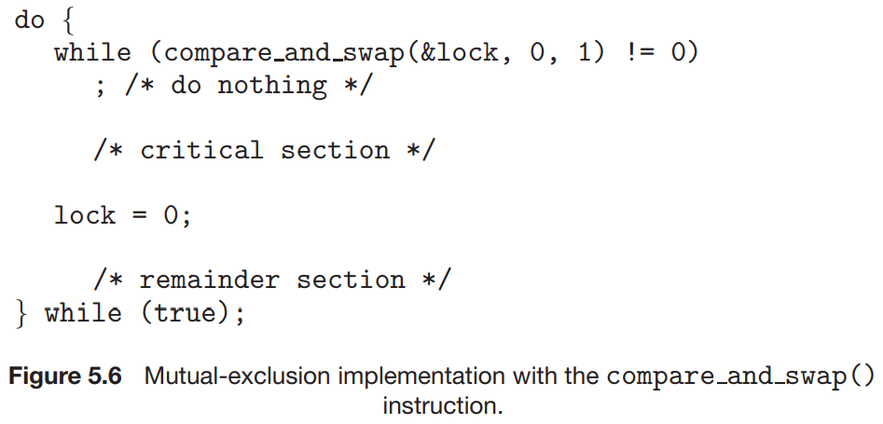

*Explanation* : Mutual exclusion can be provided as follows: a global variable (lock) is declared and is initialized to 0. The first process that invokes compare and swap() will set lock to 1. It will then enter its critical section, because the original value of lock was equal to the expected value of 0. Subsequent calls to compare and swap() will not succeed, because lock now is not equal to the expected value of 0. When a process exits its critical section, it sets lock back to 0, which allows another process to enter its critical section. The structure of process Pi is shown in Figure 5.6.

**Problem :** Although these algorithms satisfy the mutual-exclusion requirement, they do not satisfy the bounded-waiting requirement.

***3rd Solution*** :

**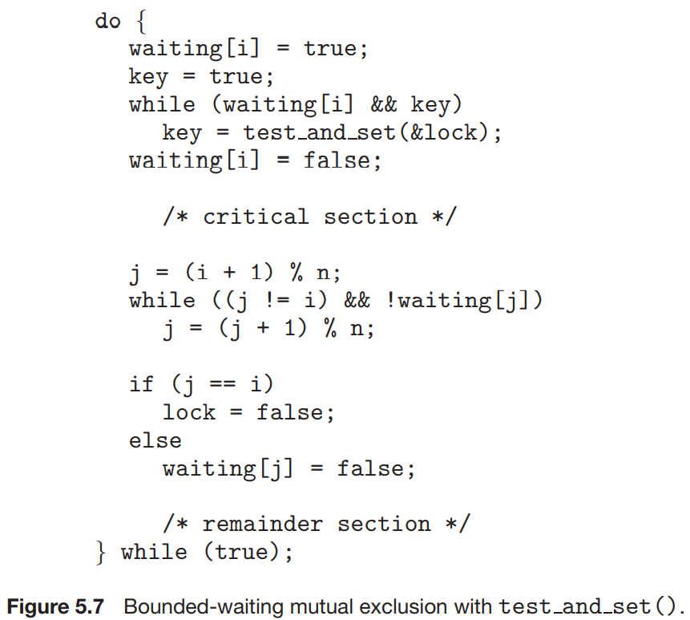***Explanation :* All data structures are initialized to false.

* To prove that the mutual exclusion requirement is met, we note that process Pi can enter its critical section only if either waiting[i] == false or key == false. The value of key can become false only if the test and set() is executed. The first process to execute the test and set() will find key == false; all others must wait. The variable waiting[i] can become false only if another process leaves its critical section; only one waiting[i] is set to false, maintaining the mutual-exclusion requirement.
* To prove that the progress requirement is met, we note that the arguments presented for mutual exclusion also apply here, since a process exiting the critical section either sets lock to false or sets waiting[j] to false. Both allow a process that is waiting to enter its critical section to proceed.
* To prove that the bounded-waiting requirement is met, we note that, when a process leaves its critical section, it scans the array waiting in the cyclic ordering (i + 1, i + 2, ..., n − 1, 0, ..., i − 1). It designates the first process in this ordering that is in the entry section (waiting[j] == true) as the next one to enter the critical section.
  1. **Mutex Locks :**

The term **mutex** is short for **mut**ual **ex**clusion. We use the mutex lock to protect critical regions and thus prevent race conditions. That is, a process must acquire the lock before entering a critical section; it releases the lock when it exits the critical section. The acquire()function acquires the lock, and the release() function releases the lock.

*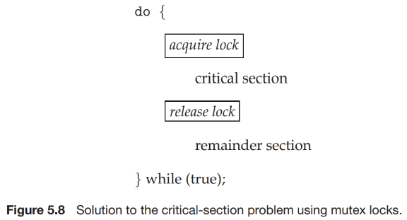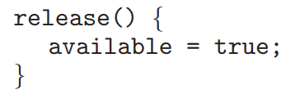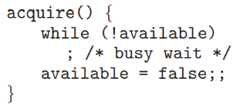Explanation* **:** A mutex lock has a Boolean variable available whose value indicates if the lock is available or not. If the lock is available, a call to acquire() succeeds, and the lock is then considered unavailable. A process that attempts to acquire an unavailable lock is blocked until the lock is released. If mutex lock is used then there is mutual exclusion and there is no race condition.

**Drawback** : The main disadvantage of the implementation given here is that it requires **busy waiting**. While a process is in its critical section, any other process that tries to enter its critical section must loop continuously in the call to acquire(). In fact, this type of mutex lock is also called a **spinlock** because the process “spins” while waiting for the lock to become available. Busy waiting wastes CPU cycles that some other process might be able to use productively.

* 1. **Semaphores :**

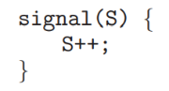we examine a more robust tool that can behave similarly to a mutex lock but can also provide more sophisticated ways for processes to synchronize their activities. A **semaphore** S is an integer variable that, apart from initialization, is accessed only 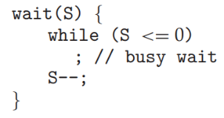through two standard atomic operations: wait() and signal(). The wait() operation was originally termed P (from the Dutch *proberen*, “to test”); signal() was originally called V (from *verhogen*, “to increment”).

***4.6.1) Semaphores Usage* :** The value of a **counting semaphore** can range over an unrestricted domain. The value of a **binary semaphore** can range only between 0 and 1. Thus, binary semaphores behave similarly to mutex locks.

The semaphore is initialized to the number of resources available. Each process that wishes to use a resource performs a wait() operation on the semaphore (thereby decrementing the count). When a process releases a resource, it performs a signal() operation (incrementing the count). When the count for the semaphore goes to 0, all resources are being used. After that, processes that wish to use a resource will block until the count becomes greater than 0.

***4.6.2) Semaphore Implementation :*** Recall that the implementation of mutex locks discussed in Section 5.5 suffers from busy waiting. The definitions of the wait() and signal() semaphore operations just described present the same problem.

**New Solution** :

When a process executes the wait() operation and finds that the semaphore value is not positive, it must wait. However, rather than engaging in busy waiting, the process can block itself. The block operation places a process into a waiting queue associated with the semaphore, and the state of the process is switched to the waiting state. Then control is transferred to the CPU scheduler, which selects another process to execute.

Each semaphore has an integer value and a list of processes list. When a process must wait on a semaphore, it is added to the list of processes. A process that is blocked, waiting on a semaphore S, should be restarted when some other process executes a signal() operation. The process is restarted by a wakeup() operation, which changes the process from the waiting state to the ready state. The process is then placed in the ready queue. If a semaphore value is negative, its magnitude is the number of processes waiting on that semaphore. The block() operation suspends the process that invokes it. The wakeup(P) operation resumes the execution of a blocked process P.

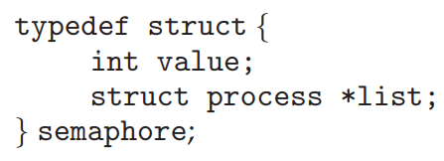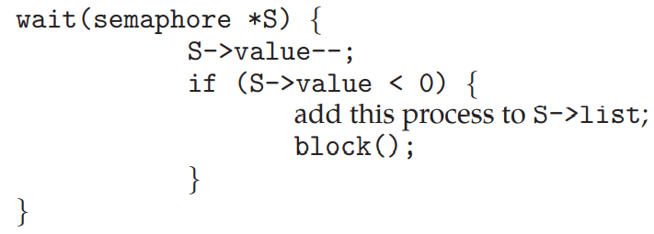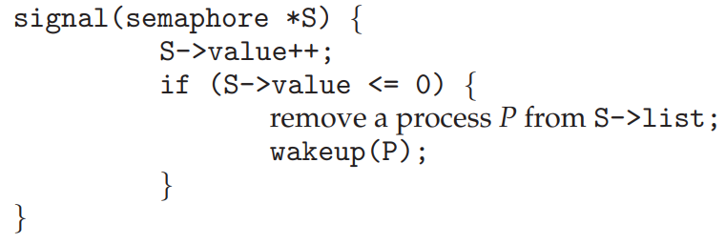

**NOTE :** It is important to admit that we have not completely eliminated busy waiting with this definition of the wait() and signal() operations. Rather, we have moved busy waiting from the entry section to the critical sections of application programs. But we berely encounter busy waiting so the solution is best in that aspect.

***4.6.3) Deadlock, livelock and Starvation*** : Deadlock can be understood by following example : consider a system consisting of two processes, P0 and P1, each accessing two semaphores, S and Q, set to the value 1.

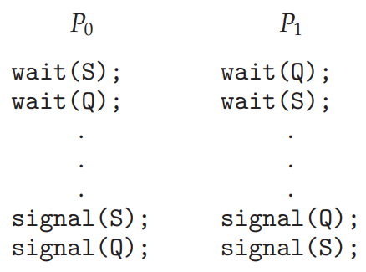Suppose that P0 executes wait(S) and then P1 executes wait(Q). When P0 executes wait(Q), it must wait until P1 executes signal(Q). Similarly, when P1 executes wait(S), it must wait until P0 executes signal(S). Since these signal() operations cannot be executed, P0 and P1 are **deadlocked**. Deadlock can occur even semaphores are used; semaphores cannot prevent deadlock. Semaphore is used for preventing contention. When process do repeated work without any progress it is called **Livelock**. For example, consider two processes tries to acquire two resources if it is not available, they drop all resources. So, process A acquires resource 1 and process B acquires 2. Now they are waiting for 2 and 1 resource respectively. They drop all resources then again acquires two and then again. This process never ends. It is not deadlock clearly this is livelock. Deadlock means some threads are able to make progress while livelock means no threads are able to make progress.

**Starvation or indefinite waiting** : A situation in which processes wait indefinitely within the semaphore waiting list. If live lock then starvation will defiantly occur.

***4.6.4) Priority Inversion*** : A scheduling challenge arises when a higher-priority process needs to read or modify kernel data that are currently being accessed by a lower-priority process—or a chain of lower-priority processes. As an example, assume we have three processes—L, M, and H—whose priorities follow the order L < M < H. Assume that process H requires a semaphore S, which is currently being accessed by process L. Ordinarily, process H would wait for L to finish using resource S. However, now suppose that process M becomes runnable, thereby preempting process L. Indirectly, a process with a lower priority—process M—has affected how long process H must wait for L to relinquish resource S.

Typically, priority inversion is avoided by implementing a **priority-inheritance protocol**. According to this protocol, all processes that are accessing resources needed by a higher-priority process inherit the higher priority until they are finished with the resources in question. Inherit the higher priority means leave the higher priority. In above example L and H will interchange the priority. This is somewhat same as **Priority Donation** where - If a thread or process attempts to acquire a resource (lock) that is currently being held, it donates its effective priority to the holder of that resource.

* 1. **Classic Problems of Synchronization** :

1. ***The Bounded-Buffer Problem or Producer-consumer Problem*** :

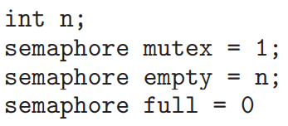

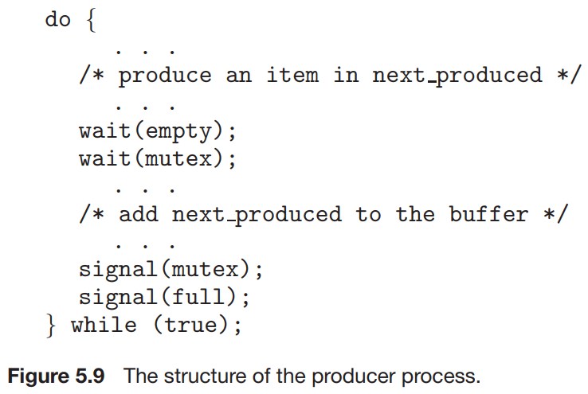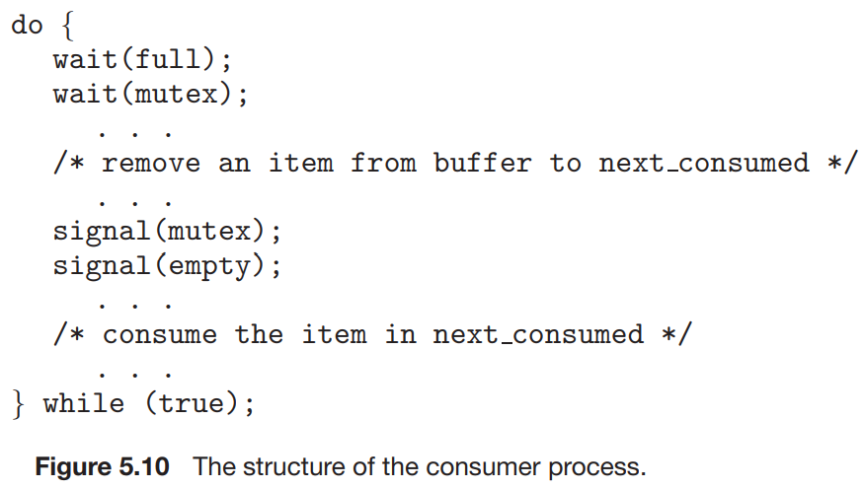

1. ***The Readers –Writers Problem*** : If two readers access the shared data simultaneously, no adverse effects will result. However, if a writer and some other process (either a reader or a writer) access the database simultaneously, chaos may ensue.

The readers–writers problem has several variations, all involving priorities. The simplest one, referred to as the **first readers–writers problem**, requires that no reader be kept waiting unless a writer has already obtained permission to use the shared object. In other words, no reader should wait for other readers to finish simply because a writer is waiting. The **second readers –writers problem** requires that, once a writer is ready, that writer perform its write as soon as possible. In other words, if a writer is waiting to access the object, no new readers may start reading.

*Solution to first reader-writer Problem* : The mutex semaphore is used to ensure mutual exclusion when the variable read count is updated. The read count variable keeps track of how many processes are currently reading the object.

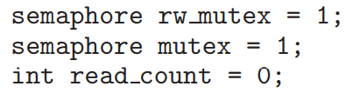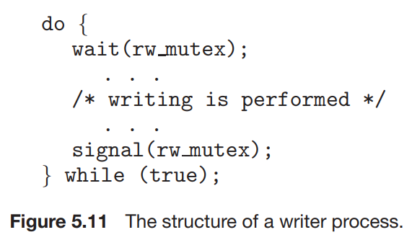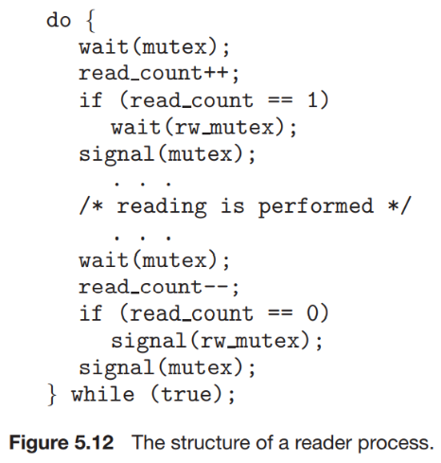

1. ***Dinning Philosopher Problem*** : Consider five philosophers who spend their lives thinking and eating. The philosophers share a circular table surrounded by five chairs, each belonging to one philosopher. In the center of the table is a bowl of rice, and the table is laid with five single chopsticks (Figure 5.13). When a philosopher thinks, she does not interact with her colleagues. From time to time, a philosopher gets hungry and tries to pick up the two chopsticks that are closest to her (the chopsticks that are between her and her left and right neighbors). A philosopher may pick up only one chopstick at a time. Obviously, she cannot pick up a chopstick that is already in the hand of a neighbor.

One simple solution is to represent each chopstick with a semaphore. A philosopher tries to grab a chopstick by executing a wait() operation on that semaphore. She releases her chopsticks by executing the signal() operation on the appropriate semaphores. 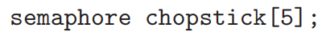where all the elements of chopstick are initialized to 1.

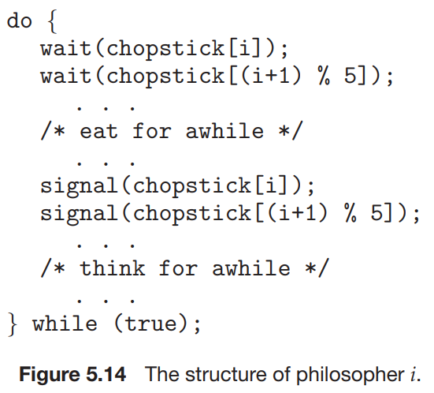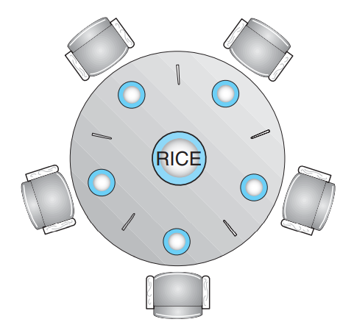

**NOTE** :

1. If fork() is in child process then it returns 0 to child process and non-zero pid of child process is delivered to parent process. N fork() system call creates 2N-1 child processes and 2N total processes.
2. Context switch time is longer for kernel level threads than for user level threads. As User level threads are managed by user and Kernel level threads are managed by OS. There are many overheads involved in Kernel level thread management, which are not present in User level thread management. So, context switch time is longer for kernel level threads than for user level threads.
3. For heaven sack read the question carefully and twice here terms are important like binary semaphores. Especially Not, never, does not (Inversion).

***Question on synchronization*** :

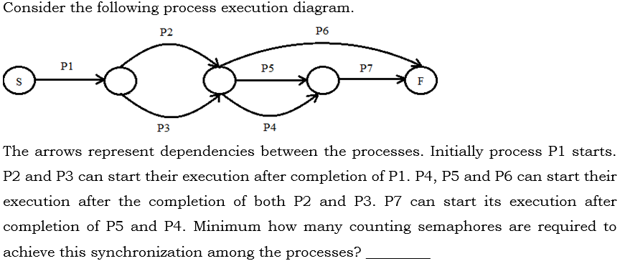

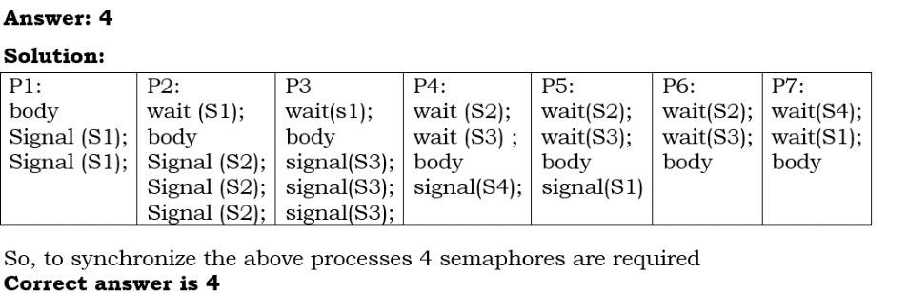

1. **CPU SCHEDULING**
   1. **Basic Concept :**

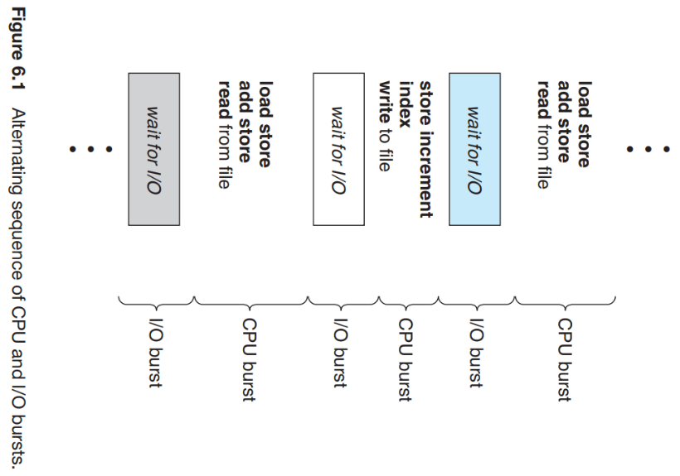In a single-processor system, only one process can run at a time. Others must wait until the CPU is free and can be rescheduled. The objective of multiprogramming is to have some process running at all times, to maximize CPU utilization.

***CPU –I/O Burst Cycle*** : Process execution begins with a CPU burst. That is followed by an I/O burst, which is followed by another CPU burst, then another I/O burst, and so on.

***CPU Scheduler*** : Whenever the CPU becomes idle, the operating system must select one of the processes in the ready queue to be executed. The selection process is carried out by the **short-term scheduler**, or **CPU scheduler**. The scheduler selects a process from the processes in memory that are ready to execute and allocates the CPU to that process.

***Preemptive Scheduling*** : CPU-scheduling decisions may take place under the following four circumstances:

1. When a process switches from the running state to the waiting state (for example, as the result of an I/O request or an invocation of wait() for the termination of a child process)
2. When a process switches from the running state to the ready state (for example, when an interrupt occurs)
3. When a process switches from the waiting state to the ready state (for example, at completion of I/O)
4. When a process terminates

For situations 1 and 4, there is no choice in terms of scheduling. A new process (if one exists in the ready queue) must be selected for execution. There is a choice, however, for situations 2 and 3. When scheduling takes place only under circumstances 1 and 4, we say that the scheduling scheme is **nonpreemptive** or **cooperative**. Otherwise, it is **preemptive**.

**Nonpreemptive or cooperative :** Once the CPU has been allocated to a process, the process keeps the CPU until it releases the CPU either by terminating or by switching to the waiting state. This scheduling method was used by Microsoft Windows in their earlier version. Cooperative scheduling is the only method that can be used on certain hardware platforms, because it does not require the special hardware (for example, a timer - They are so called as they will intterupt the thread of execution after the current instruction completes, and run their code, returning to the next instruction from where it left off when it has finished.) needed for preemptive scheduling.

**Preemptive** : When one process is waiting for I/O then this process must be replace with one of the processes in ready queue for effective performance.

**Problem with preemption** : 1) Preemptive scheduling can result in race conditions when data are shared among several processes. Consider the case of two processes that share data. While one process is updating the data, it is preempted so that the second process can run. The second process then tries to read the data, which are in an inconsistent state.

2) Preemption also affects the design of the operating-system kernel. During the processing of a system call, the kernel may be busy with an activity on behalf of a process. Such activities may involve changing important kernel data (for instance, I/O queues). What happens if the process is preempted in the middle of these changes and the kernel (or the device driver) needs to read or modify the same structure? Chaos ensues.

3) Because interrupts can, by definition, occur at any time, and because they cannot always be ignored by the kernel, the sections of code affected by interrupts must be guarded from simultaneous use. The operating system needs to accept interrupts at almost all times. Otherwise, input might be lost or output overwritten.

***Dispatcher*** : Another component involved in the CPU-scheduling function is the **dispatcher**. The dispatcher is the module that gives control of the CPU to the process selected by the short-term scheduler. This function involves the following:

• Switching context

• Switching to user mode

• Jumping to the proper location in the user program to restart that program

The dispatcher should be as fast as possible, since it is invoked during every process switch. The time it takes for the dispatcher to stop one process and start another running is known as the **dispatch latency**. The records in the any queues are generally **process control blocks (PCBs)** of the processes. When process invokes the exec system call both process identifier and page table entry changes because the process gets a new memory image and hence new page table entries pointing to the new image.

* 1. **Scheduling Criteria** :

Different CPU-scheduling algorithms have different properties, and the choice of a particular algorithm may favor one class of processes over another. The criteria include the following:

• **CPU utilization**. We want to keep the CPU as busy as possible. Conceptually, CPU utilization can range from 0 to 100 percent. In a real system, it should range from 40 percent (for a lightly loaded system) to 90 percent (for a heavily loaded system).

• **Throughput**. If the CPU is busy executing processes, then work is being done. One measure of work is the number of processes that are completed per time unit, called **throughput**.

• **Turnaround time**. From the point of view of a particular process, the important criterion is how long it takes to execute that process. The interval from the time of arrival of a process to the time of completion is the turnaround time. Turnaround time is the sum of the periods spent waiting to get into memory, waiting in the ready queue, executing on the CPU, and doing I/O.

• **Waiting time**. The CPU-scheduling algorithm does not affect the amount of time during which a process executes or does I/O. It affects only the amount of time that a process spends waiting in the ready queue. Waiting time is the sum of the periods spent waiting in the ready queue.

• **Response time**. Another measure is the time from the submission or arrival of a request until the first response is produced. This measure, called response time, is the time it takes to start responding, not the time it takes to output the response.

An accurate illustration should involve many processes, each a sequence of several hundred CPU bursts and I/O bursts. For simplicity, though, we consider only one CPU burst (in milliseconds) per process in our examples. *Our measure of comparison is the average waiting time.*

* 1. **Scheduling Algorithms** :

CPU scheduling deals with the problem of deciding which of the processes in the ready queue is to be allocated the CPU.

***5.3.1) First-Come, First-Served Scheduling*** : By far the simplest CPU-scheduling algorithm is the **first-come, first-served (FCFS)** scheduling algorithm. With this scheme, the process that requests the CPU first is allocated the CPU first. The implementation of the FCFS policy is easily managed with a FIFO queue. When a process enters the ready queue, its PCB is linked onto the tail of the queue. When the CPU is free, it is allocated to the process at the head of the queue. The running process is then removed from the queue.

Consider the following set of processes that arrive at time 0, with the length of the CPU burst given in milliseconds:

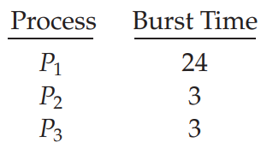 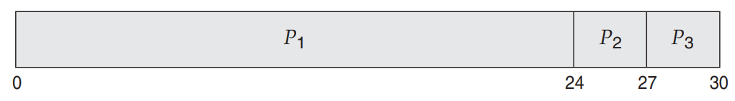 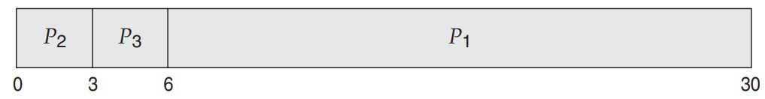

If the processes arrive in the order P1, P2, P3, and are served in FCFS order, we get the result shown in the following **Gantt chart**, which is a bar chart that illustrates a particular schedule, including the start and finish times of each of the participating processes: The waiting time is 0 milliseconds for process P1, 24 milliseconds for process P2, and 27 milliseconds for process P3. Thus, the average waiting time is (0 + 24 + 27)/3 = 17 milliseconds.

If the processes arrive in the order P2, P3, P1, however, the results will be as shown in the following Gantt chart : The average waiting time is now (6 + 0 + 3)/3 = 3 milliseconds. This reduction is substantial. Note also that the FCFS scheduling algorithm is nonpreemptive. **FCFS does not starve process because it is fair algo**.

**Convoy effect** : All the other processes wait for the one big process to get off the CPU. This effect results in lower CPU and device utilization than might be possible if the shorter processes were allowed to go first. For example if we have one CPU-bound process and many I/O-bound processes.

***5.3.2) Shortest-Job-First Scheduling*** : A different approach to CPU scheduling is the **shortest-job-first(SJF)** scheduling algorithm. This algorithm associates with each process the length of the process’s next CPU burst. Note that a more appropriate term for this scheduling method would be the **shortest-next CPU-burst** algorithm, because scheduling depends on the length of the next CPU burst of a process, rather than its total length.

For example : 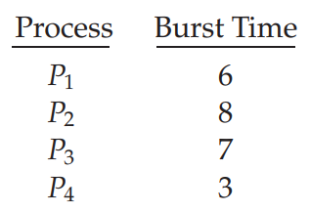 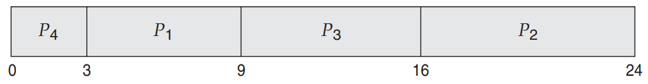

The waiting time is 3 milliseconds for process P1, 16 milliseconds for process P2, 9 milliseconds for process P3, and 0 milliseconds for process P4. Thus, the average waiting time is (3 + 16 + 9 + 0)/4 = 7 milliseconds. By comparison, if we were using the FCFS scheduling scheme, the average waiting time would be 10.25 milliseconds.

*Advantage, problems and solution* : The SJF scheduling algorithm is provably optimal, in that it gives the minimum average waiting time for a given set of processes. Moving a short process before a long one decreases the waiting time of the short process more than it increases the waiting time of the long process.

The real difficulty with the SJF algorithm is knowing the length of the next CPU request. For long-term (job) scheduling in a batch system, In this situation, users are motivated to estimate the process time limit accurately. Although the SJF algorithm is optimal, it cannot be implemented at the level of short-term CPU scheduling. With short-term scheduling, there is no way to know the length of the next CPU burst.

One approach to this problem is to try to approximate SJF scheduling. The next CPU burst is generally predicted as an **exponential average** of the measured lengths of previous CPU bursts. Let tn be the length of the nth CPU burst, and let **τ**n+1 be our predicted value for the next CPU burst. Then, for α, 0 ≤ α ≤ 1, define

**τn+1 = α tn + (1 − α) τn**

The value of tn contains our most recent information, while **τ**n stores the past history. The parameter α controls the relative weight of recent and past history in our prediction.

The SJF algorithm can be either preemptive or nonpreemptive. Preemptive SJF scheduling is sometimes called **shortest-remaining-time-first** scheduling. For example :

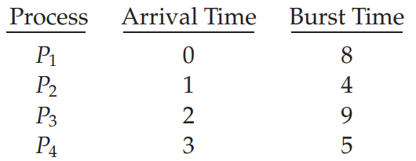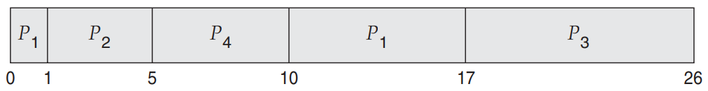

Process P1 is started at time 0, since it is the only process in the queue. Process P2 arrives at time 1. The remaining time for process P1 (7 milliseconds) is larger than the time required by process P2 (4 milliseconds), so process P1 is preempted, and process P2 is scheduled. The average waiting time for this example is [(10 − 1) + (1 − 1) + (17 − 2) + (5 − 3)]/4 = 26/4 = 6.5 milliseconds. Nonpreemptive SJF scheduling would result in an average waiting time of 7.75 milliseconds.

***5.3.3) Priority Scheduling*** : The SJF algorithm is a special case of the general priority-scheduling algorithm. A priority is associated with each process, and the CPU is allocated to the process with the highest priority. Equal-priority processes are scheduled in FCFS order. An SJF algorithm is simply a priority algorithm where the priority (p) is the inverse of the (predicted) next CPU burst. In this text, we assume that low numbers represent high priority. Consider an example :

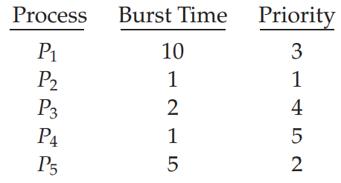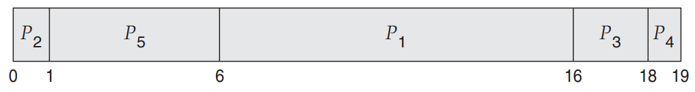

The average waiting time is 8.2 milliseconds.

Priorities can be defined either internally or externally. Priority scheduling can be either preemptive or nonpreemptive. When a process arrives at the ready queue, its priority is compared with the priority of the currently running process. If it is less then preempted if not then it does not affect the current execution.

*Problem* : A major problem with priority scheduling algorithms is **indefinite blocking**, or **starvation**. A process that is ready to run but waiting for the CPU can be considered blocked. A priority scheduling algorithm can leave some low priority processes waiting indefinitely.

*Solution* : A solution to the problem of indefinite blockage of low-priority processes is **aging**. Aging involves gradually increasing the priority of processes that wait in the system for a long time.

***5.3.4) Round-Robin Scheduling*** : The round-robin (RR) scheduling algorithm is designed especially for time-sharing systems. It is similar to FCFS scheduling, but preemption is added to enable the system to switch between processes. A small unit of time, called a **time quantum** or **time slice**, is defined. A time quantum is generally from 10 to 100 milliseconds in length. The ready queue is treated as a circular queue.

If the CPU burst of the currently running process is longer than 1 time quantum, the timer will go off and will cause an *interrupt* to the operating system. A context switch will be executed, and the process will be put at the tail of the ready queue. The CPU scheduler will then select the next process in the ready queue.

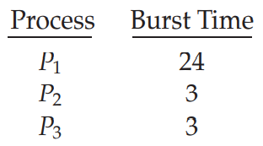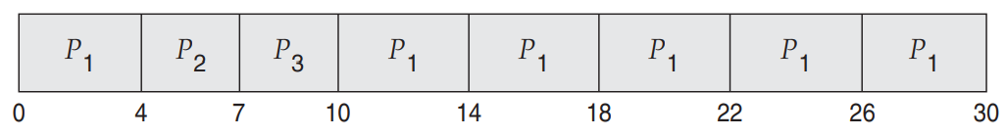

P1 waits for 6 milliseconds (10 - 4), P2 waits for 4 milliseconds, and P3 waits for 7 milliseconds. Thus, the average waiting time is 17/3 = 5.66 milliseconds. The performance of the RR algorithm depends heavily on the size of the time quantum. Turnaround time is difference between completion time and arrival time.

Turnaround time also depends on the size of the time quantum. The average turnaround time can be improved if most processes finish their next CPU burst in a single time quantum. At one extreme, if the time quantum is extremely large, the RR policy is the same as the FCFS policy. In contrast, if the time quantum is extremely small (say, 1 millisecond), the RR approach can result in a large number of context switches. If Process P1 is implementing two thread in round robin fashion and quantum expires and if remaining threads are implemented at user level then OS will not start from 2nd P1’s thread rather it will execute process P2’s threads. *A rule of thumb is that 80 percent of the CPU bursts should be shorter than the time quantum.*

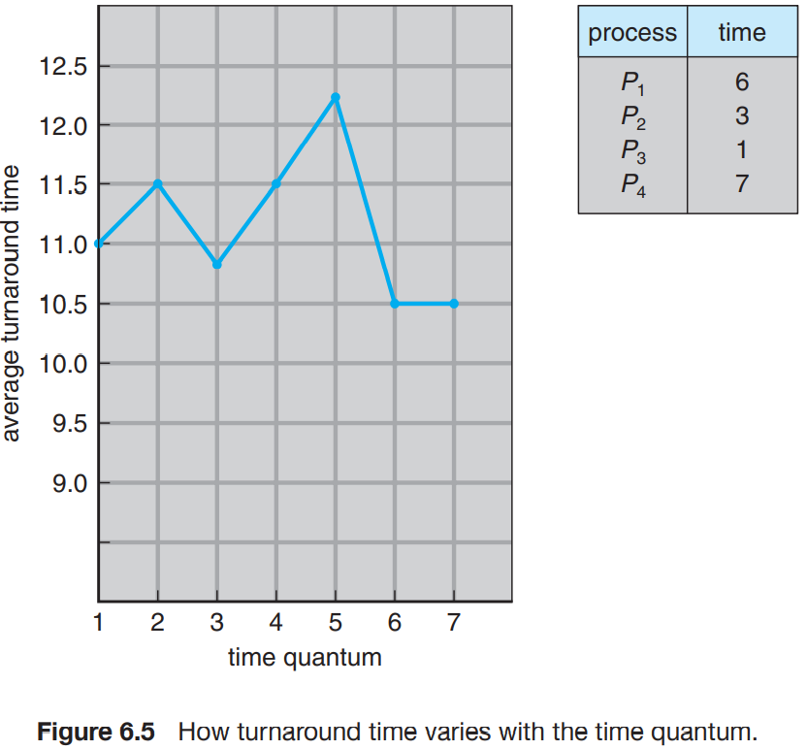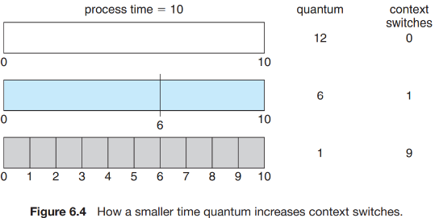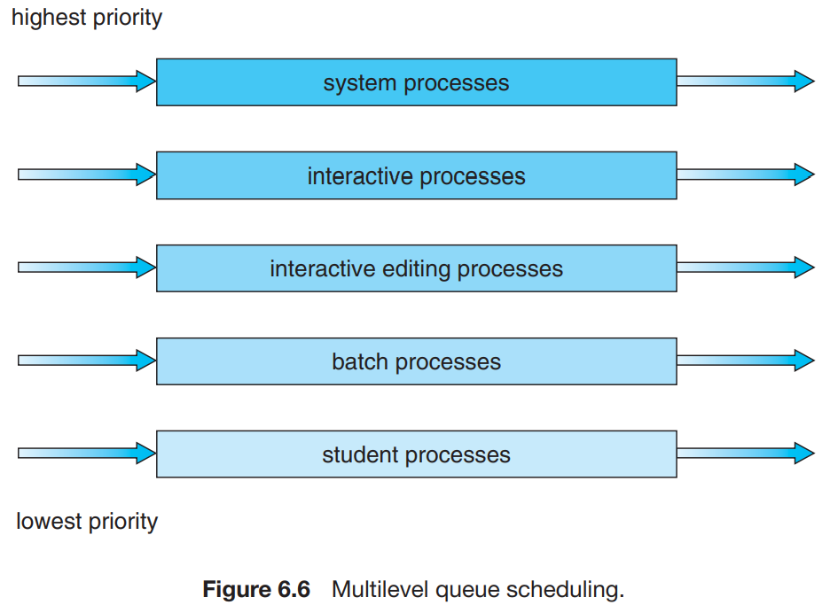

***5.3.5) Multilevel Queue Scheduling*** : A multilevel queue scheduling algorithm partitions the ready queue into several separate queues (Figure 6.6). The processes are permanently assigned to one queue, generally based on some property of the process, such as memory size, process priority, or process type. Each queue has its own scheduling algorithm. Each queue has absolute priority over lower-priority queues. No process in the batch queue, for example, could run unless the queues for system processes, interactive processes, and interactive editing processes were all empty. If an interactive editing process entered the ready queue while a batch process was running, the batch process would be preempted.

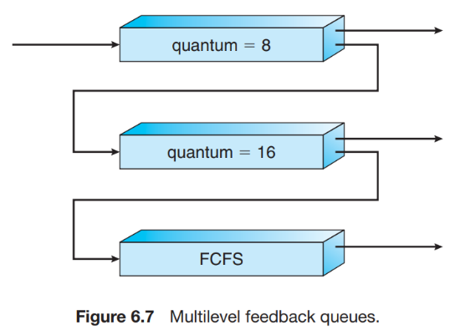***5.3.6) Multilevel Feedback Queue Scheduling*** : The idea is to separate processes according to the characteristics of their CPU bursts. If a process uses too much CPU time, it will be moved to a lower-priority queue. This scheme leaves I/O-bound and interactive processes in the higher-priority queues. In addition, a process that waits too long in a lower-priority queue may be moved to a higher-priority queue. This form of aging prevents starvation. For Example:

A process entering the ready queue is put in queue 0. A process in queue 0 is given a time quantum of 8 milliseconds. If it does not finish within this time, it is moved to the tail of queue 1. If queue 0 is empty, the process at the head of queue 1 is given a quantum of 16 milliseconds. If it does not complete, it is preempted and is put into queue 2. Processes in queue 2 are run on an FCFS basis but are run only when queues 0 and 1 are empty.

There is other type of scheduling algo which is called highest response ratio next scheduling algo which is non-preemptive algo, response ratio = (waiting time + burst time)/ burst time. So after completion of each process calculate this and apply.

* 1. **Thread Scheduling :**

On operating systems that support them, it is kernel-level threads—not processes—that are being scheduled by the operating system. User-level threads are managed by a thread library, and the kernel is unaware of them. To run on a CPU, user-level threads must ultimately be mapped to an associated kernel-level thread, although this mapping may be indirect and may use a lightweight process (LWP).

**Contention Scope** : One distinction between user-level and kernel-level threads lies in how they are scheduled. On systems implementing the many-to-one (Section 4.3.1) and many-to-many (Section 4.3.3) models, the thread library schedules user-level threads to run on an available LWP. This scheme is known as **process contention scope (PCS)**, since competition for the CPU takes place among threads belonging to the same process. (When we say the thread, library schedules user threads onto available LWPs, we do not mean that the threads are actually running on a CPU. That would require the operating system to schedule the kernel thread onto a physical CPU.) To decide which kernel-level thread to schedule onto a CPU, the kernel uses **system-contention scope (SCS)**.

* 1. **Multiple-Processor Scheduling** :

Our discussion thus far has focused on the problems of scheduling the CPU in a system with a single processor. If multiple CPUs are available, load sharing becomes possible—but scheduling problems become correspondingly more complex.

***5.5.1) Approaches to Multiple-Processor Scheduling*** : One approach to CPU scheduling in a multiprocessor system has all scheduling decisions, I/O processing, and other system activities handled by a single processor—the master server. The other processors execute only user code. This **asymmetric multiprocessing** is simple because only one processor accesses the system data structures, reducing the need for data sharing. A second approach uses **symmetric multiprocessing (SMP)**, where each processor is self-scheduling. All processes may be in a common ready queue, or each processor may have its own private queue of ready processes.

***5.5.2) Processor Affinity*** : Consider what happens to cache memory when a process has been running on a specific processor. The data most recently accessed by the process populate the cache for the processor. As a result, successive memory accesses by the process are often satisfied in cache memory. Now consider what happens if the process migrates to another processor. The contents of cache memory must be invalidated for the first processor, and the cache for the second processor must be repopulated. This is known as **processor affinity**—that is, a process has an affinity for the processor on which it is currently running.

When an operating system has a policy of attempting to keep a process running on the same processor—but not guaranteeing that it will do so—we have a situation known as **soft affinity**. Here, the operating system will attempt to keep a process on a single processor, but it is possible for a process to migrate between processors. In contrast, some systems provide system calls that support **hard affinity**, thereby allowing a process to specify a subset of processors on which it may run.

***5.5.3) Soft and hard real time operating system :***

* **Soft Real Time Operating System** :

Soft real time OS is a type of OS where certain deadlines may be missed, they will respond at a time t=0+. Soft real time systems are not constrained to extreme rules. The critical time of the soft real time may be delayed to some extent. The expected latency between the tasks and time constraints may be deviated.

The preemption period for a soft real time task is about few milliseconds.

*Examples* :

Digital camera, mobile phones, online database etc.

* **Hard Real Time Operating System** :

Hard real time OS is a type of OS we can predict the deadline, they will respond at a time t=0. Hard real time systems are constrained to predicted time constraints, deadlines and latency.

*Examples* :

Air bag control in cars, anti-lock brake, engine control system etc.

The preemption period for hard real time system is almost less than few microseconds.

Jitter MEANS timing error in task, hence A hard real-time operating system has less jitter than a soft real-time operating system.

1. **DEADLOCKS**

A process requests resources; if the resources are not available at that time, the process enters a waiting state. Sometimes, a waiting process is never again able to change state, because the resources it has requested are held by other waiting processes. This situation is called a **deadlock**.

*“When two trains approach each other at a crossing, both shall come to a full stop and neither shall start up again until the other has gone.”*

* 1. **System Model :**

A system consists of a finite number of resources to be distributed among a number of competing processes. The resources may be partitioned into several types (or classes), each consisting of some number of identical instances. CPU cycles, files, and I/O devices (such as printers and DVD drives) are examples of resource types. If a system has two CPUs, then the resource type CPU has two instances. Similarly, the resource type printer may have five instances.

If a process requests an instance of a resource type, the allocation of any instance of the type should satisfy the request. If it does not, then the instances are not identical, and the resource type classes have not been defined properly. For example, a system may have two printers. These two printers may be defined to be in the same resource class if no one cares which printer prints which output. However, if one printer is on the ninth floor and the other is in the basement, then people on the ninth floor may not see both printers as equivalent, and separate resource classes may need to be defined for each printer.

Under the normal mode of operation, a process may utilize a resource in only the following sequence:

1. **Request**. The process requests the resource. If the request cannot be granted immediately (for example, if the resource is being used by another process), then the requesting process must wait until it can acquire the resource.

2. **Use**. The process can operate on the resource (for example, if the resource is a printer, the process can print on the printer).

3. **Release**. The process releases the resource.

**A set of processes is in a deadlocked state when every process in the set is waiting for an event that can be caused only by another process in the set.** The resources may be either physical resources (for example, printers, tape drives, memory space, and CPU cycles) or logical resources (for example, semaphores, mutex locks, and files).

To illustrate a deadlocked state, consider a system with three CD RW drives. Suppose each of three processes holds one of these CD RW drives. If each process now requests another drive, the three processes will be in a deadlocked state. Each is waiting for the event “CD RW is released,” which can be caused only by one of the other waiting processes. This example illustrates a deadlock involving the same resource type. Deadlocks may also involve different resource types. For example, consider a system with one printer and one DVD drive. Suppose that process Pi is holding the DVD and process Pj is holding the printer. If Pi requests the printer and Pj requests the DVD drive, a deadlock occurs.

* 1. **Deadlock Characterization** :

***6.2.1) Necessary Conditions :*** A deadlock situation can arise if the following four conditions hold simultaneously in a system:

1. **Mutual exclusion**. At least one resource must be held in a non-sharable mode; that is, only one process at a time can use the resource. If another process requests that resource, the requesting process must be delayed until the resource has been released.

2. **Hold and wait**. A process must be holding at least one resource and waiting to acquire additional resources that are currently being held by other processes.

3. **No preemption**. Resources cannot be preempted; that is, a resource can be released only voluntarily by the process holding it, after that process has completed its task.

4. **Circular wait**. A set {P0, P1, ..., Pn} of waiting processes must exist such that P0 is waiting for a resource held by P1, P1 is waiting for a resource held by P2, ..., Pn−1 is waiting for a resource held by Pn, and Pn is waiting for a resource held by P0.

***6.2.2) Resource-Allocation Graph*** : Deadlocks can be described more precisely in terms of a directed graph called a **system resource-allocation graph**. This graph consists of a set of vertices V and a set of edges E. The set of vertices V is partitioned into two different types of nodes: P = {P1, P2, ..., Pn}, the set consisting of all the active processes in the system, and R = {R1, R2, ..., Rm}, the set consisting of all resource types in the system.

A directed edge from process Pi to resource type Rj is denoted by Pi → Rj ; it signifies that process Pi has requested an instance of resource type Rj and is currently waiting for that resource. A directed edge from resource type Rj to process Pi is denoted by Rj → Pi ; it signifies that an instance of resource type Rj has been allocated to process Pi. A directed edge Pi → Rj is called a **request edge**; a directed edge Rj → Pi is called an **assignment edge**.

Pictorially, we represent each process Pi as a circle and each resource type Rj as a rectangle. Since resource type Rj may have more than one instance, we represent each such instance as a dot within the rectangle.

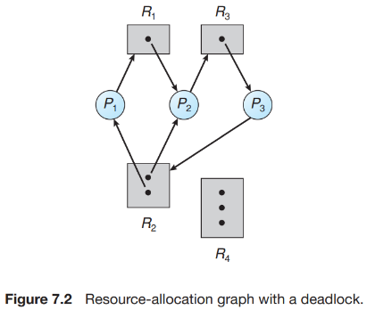At this point, two minimal cycles exist in the system:

P1 → R1 → P2 → R3 → P3 → R2 → P1

P2 → R3 → P3 → R2 → P2

Processes P1, P2, and P3 are deadlocked. Process P2 is waiting for the resource R3, which is held by process P3. Process P3 is waiting for either process P1 or process P2 to release resource R2. In addition, process P1 is waiting for process P2 to release resource R1.

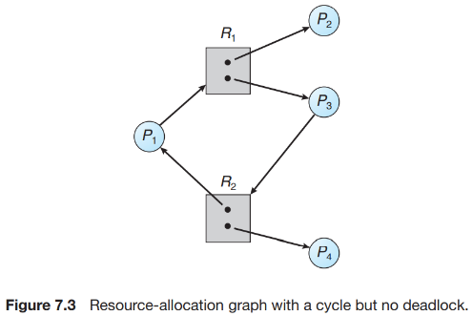

In this example, we also have a cycle: P1 → R1 → P3 → R2 → P1

However, there is no deadlock. Observe that process P4 may release its instance of resource type R2. That resource can then be allocated to P3, breaking the cycle.

*In summary, if a resource-allocation graph does not have a cycle, then the system is not in a deadlocked state. If there is a cycle, then the system may or may not be in a deadlocked state. This observation is important when we deal with the deadlock problem.*

* 1. **Methods for Handling Deadlocks** :

Generally speaking, we can deal with the deadlock problem in one of three ways:

• We can use a protocol to prevent or avoid deadlocks, ensuring that the system will never enter a deadlocked state.

• We can allow the system to enter a deadlocked state, detect it, and recover.

• We can ignore the problem altogether and pretend that deadlocks never occur in the system.

To ensure that deadlocks never occur, the system can use either a deadlock prevention or a deadlock-avoidance scheme.

**Deadlock prevention** provides a set of methods to ensure that at least one of the necessary conditions (Section 6.2.1) cannot hold. These methods prevent deadlocks by constraining how requests for resources can be made.

**Deadlock avoidance** requires that the operating system be given additional information in advance concerning which resources a process will request and use during its lifetime. With this additional knowledge, the operating system can decide for each request whether or not the process should wait.

* 1. **Deadlock Prevention** :

By ensuring that at least one of these conditions cannot hold, we can prevent the occurrence of a deadlock.

***6.4.1) Mutual Exclusion*** : The mutual exclusion condition must hold. That is, at least one resource must be non-sharable. Sharable resources, in contrast, do not require mutually exclusive access and thus cannot be involved in a deadlock. Read-only files are a good example of a sharable resource.

***6.4.2) Hold and Wait*** : To ensure that the hold-and-wait condition never occurs in the system, we must guarantee that, whenever a process requests a resource, it does not hold any other resources. One protocol that we can use requires each process to request and be allocated all its resources before it begins execution. Second protocol that before it can request any additional resources, it must release all the resources that it is currently allocated.

*Illustration of both protocol* : To illustrate the difference between these two protocols, we consider a process that copies data from a DVD drive to a file on disk, sorts the file, and then prints the results to a printer. If all resources must be requested at the beginning of the process, then the process must initially request the DVD drive, disk file, and printer. It will hold the printer for its entire execution, even though it needs the printer only at the end. The second method allows the process to request initially only the DVD drive and disk file. It copies from the DVD drive to the disk and then releases both the DVD drive and the disk file. The process must then request the disk file and the printer. After copying the disk file to the printer, it releases these two resources and terminates.

*Disadvantages of both protocol* : Resource utilization may be low, since resources may be allocated but unused for a long period. Starvation is possible.

***6.4.3) No Preemption*** : The third necessary condition for deadlocks is that there be no preemption of resources that have already been allocated. To ensure that this condition does not hold, we can use the following protocol. If a process is holding some resources and requests another resource that cannot be immediately allocated to it (that is, the process must wait), then all resources the process is currently holding are preempted.

***6.4.4) Circular Wait*** : The fourth and final condition for deadlocks is the circular-wait condition. One way to ensure that this condition never holds is to impose a total ordering of all resource types and to require that each process requests resources in an increasing order of enumeration. we define a one-to-one function F: R → N, where N is the set of natural numbers. For example, if the set of resource types R includes tape drives, disk drives, and printers, then the function F might be defined as follows: F(tape drive) = 1, F(disk drive) = 5, F(printer) = 12.

First Strategy : A process that wants to use the tape drive and printer at the same time must first request the tape drive and then request the printer. Give each resource a distinct number, and never ask for a resource with a lower number than the one you just asked for.

Second Strategy : A process requesting an instance of resource type Rj must have released any resources Ri such that F(Ri) ≥ F(Rj).

* 1. **Deadlock Avoidance :**

In previous session we have discuss about the prevention form deadlock by ensuring that at least one of the necessary conditions for deadlock cannot occur. An alternative method for avoiding deadlocks is to require additional information about how resources are to be requested. With this knowledge of the complete sequence of requests and releases for each process, the system can decide for each request whether or not the process should wait in order to avoid a possible future deadlock.

The resource allocation **state** is defined by the number of available and allocated resources and the maximum demands of the processes.

***6.5.1) Safe State*** : A state is safe if the system can allocate resources to each process (up to its maximum) in some order and still avoid a deadlock. More formally, a system is in a safe state only if there exists a **safe sequence.** Means there also exists a sequence which leads to deadlock in safe state. In an unsafe state, the operating system cannot prevent processes from requesting resources in such a way that a deadlock occurs. The behavior of the processes controls unsafe states.

***6.5.2) Resource-Allocation-Graph Algorithm*** : In addition to the request and assignment edges already described, we introduce a new type of edge, called a **claim edge**. A claim edge Pi → Rj indicates that process Pi may request resource Rj at some time in the future. This edge resembles a request edge in direction but is represented in the graph by a dashed line. When process Pi requests resource Rj , the claim edge Pi → Rj is converted to a request edge. Similarly, when a resource Rj is released by Pi , the assignment edge Rj → Pi is reconverted to a claim edge Pi → Rj .

Now suppose that process Pi requests resource Rj . The request can be granted only if converting the request edge Pi → Rj to an assignment edge Rj → Pi does not result in the formation of a cycle in the resource-allocation graph. We check for safety by using a cycle-detection algorithm. An algorithm for detecting a cycle in this graph requires an order of n2 operations, where n is the number of processes in the system.

If the graph contains no cycles ⟹ no deadlock.  
If the graph contains a cycle  ⟹ if only one instance per resource type, then deadlock.

  if several instances per resource type, possibility of deadlock.

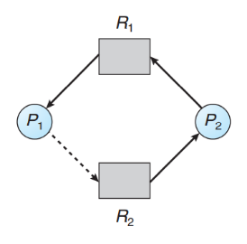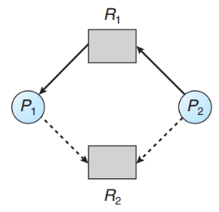**Example** :

To illustrate this algorithm, we consider the resource-allocation graph of Figure 7.7. Suppose that P2 requests R2. Although R2 is currently free, we cannot allocate it to P2, since this action will create a cycle in the graph (Figure 7.8). A cycle, as mentioned, indicates that the system is in an unsafe state. If P1 requests R2, and P2 requests R1, then a deadlock will occur.

**Disadvantage** : Not applicable to a resource allocation system with multiple instances of each resource type.

***6.5.3) Banker’s Algorithm*** : Banker algorithm prevents deadlock. Because before allocating any request of process, it find the virtual safe sequence in the system by virtually allocating the request. If it finds that there exists a safe sequence then it allocates that request to process. Otherwise reject that request. So overall at all time system in safe state. Several data structures must be maintained to implement the banker’s algorithm. We need the following data structures, where n is the number of processes in the system and m is the number of resource types:

• **Available**. A vector of length m indicates the number of available resources of each type. If Available[j] equals k, then k instances of resource type Rj are available.

• **Max**. An n × m matrix defines the maximum demand of each process. If Max[i][j] equals k, then process Pi may request at most k instances of resource type Rj .

• **Allocation**. An n × m matrix defines the number of resources of each type currently allocated to each process. If Allocation[i][j] equals k, then process Pi is currently allocated k instances of resource type Rj .

• **Need**. An n × m matrix indicates the remaining resource need of each process. If Need[i][j] equals k, then process Pi may need k more instances of resource type Rj to complete its task. Note that Need[i][j] equals Max[i][j] − Allocation[i][j].

*Algorithm (Safe state check) :* **O(mn2)**

1. Let Work and Finish be vectors of length m and n, respectively. Initialize Work = Available and Finish[i] = false for i = 0, 1, ..., n−1.

2. Find an index i such that both

a. Finish[i] == false

b. Needi ≤ Work

If no such i exists, go to step 4.

3. Work = Work + Allocationi, Finish[i] = true Go to step 2.

4. If Finish[i] == true for all i, then the system is in a safe state.

*Resource-Request Algorithm* : Next, we describe the algorithm for determining whether requests can be safely granted. Let Requesti be the request vector for process Pi . Need[i][j] = k means, k instances of resource Rj is needed to complete the execution. And requesti [j] means a small step to compete, If Requesti [j] == k, then process Pi wants k instances of resource type Rj . When a request for resources is made by process Pi , the following actions are taken:

1. If Requesti ≤ Needi , go to step 2. Otherwise, raise an error condition, since the process has exceeded its maximum claim.

2. If Requesti ≤ Available, go to step 3. Otherwise, Pi must wait, since the resources are not available.

3. Have the system pretend to have allocated the requested resources to process Pi by modifying the state as follows:

Available = Available – Requesti ;

Allocationi = Allocationi + Requesti ;

Needi = Needi – Requesti ;

If the resulting resource-allocation state is safe, the transaction is completed, and process Pi is allocated its resources. However, if the new state is unsafe, then Pi must wait for Requesti , and the old resource-allocation state is restored.

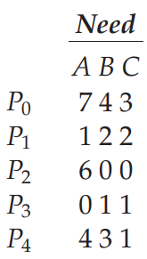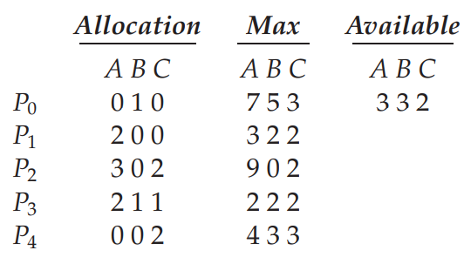*Example* : To illustrate the use of the banker’s algorithm, consider a system with five processes P0 through P4 and three resource types A, B, and C. Resource type A has ten instances, resource type B has five instances, and resource type C has seven instances. Suppose that, at time T0, the following snapshot of the system has been taken:

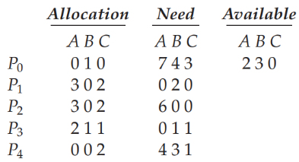Suppose now that process P1 requests one additional instance of resource type A and two instances of resource type C, so Request1 = (1,0,2).

1st run resource-request algorithm, if resource is granted then check safety algorithm to check whether state is safe. We then pretend that this request has been fulfilled, and we arrive at the following new state:

* 1. **Deadlock Detection** :

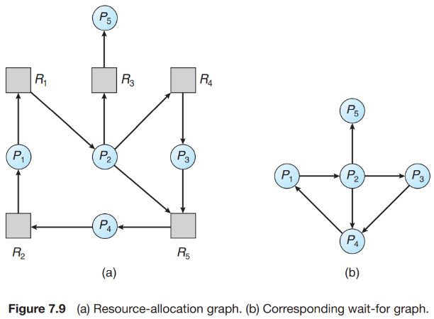***6.6.1) Single Instance of Each Resource Type*** : If all resources have only a single instance, then we can define a deadlock detection algorithm that uses a variant of the resource-allocation graph, called a **wait-for graph**. We obtain this graph from the resource-allocation graph by removing the resource nodes and collapsing the appropriate edges. More precisely, an edge from Pi to Pj in a wait-for graph implies that process Pi is waiting for process Pj to release a resource that Pi needs.

As before, a deadlock exists in the system if and only if the wait-for graph contains a cycle. To detect deadlocks, the system needs to maintain the wait-for graph and periodically invoke an algorithm that searches for a cycle in the graph. **O(n2)**

**Disadvantage of wait for graph :** Not applicable to a resource-allocation system with multiple instances of each resource type.

***6.6.2) Several Instances of a Resource Type*** : Date structure used in this algorithm is given below :

• **Available**. A vector of length m indicates the number of available resources of each type.

• **Allocation**. An n × m matrix defines the number of resources of each type currently allocated to each process.

• **Request**. An n × m matrix indicates the current request of each process. If Request[i][j] equals k, then process Pi is requesting k more instances of resource type Rj .

*Algorithm* : **O(mn2)**

1. Let **Work** and **Finish** be vectors of length m and n, respectively. Initialize Work = Available. For i = 0, 1, ..., n–1, if Allocationi != 0, then Finish[i] = false. Otherwise, Finish[i] = true.

2. Find an index i such that both

a. Finish[i] == false

b. Requesti ≤ Work If no such i exists, go to step 4.

3. Work = Work + Allocationi

Finish[i] = true Go to step 2.

4. If Finish[i] == false for some i, 0 ≤ i < n, then the system is in a deadlocked state. Moreover, if Finish[i] == false, then process Pi is deadlocked.

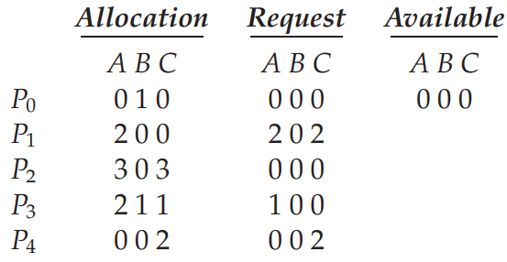*Example* :

We consider a system with five processes P0 through P4 and three resource types A, B, and C. Resource type A has seven instances, resource type B has two instances, and resource type C has six instances. Suppose that, at time T0, we have the following resource-allocation state:

We claim that the system is not in a deadlocked state. Indeed, if we execute our algorithm, we will find that the sequence results in Finish[i] == true for all i.

Suppose now that process P2 makes one additional request for an instance of type C. We claim that the system is now deadlocked.

***6.6.3) Detection-Algorithm Usage*** : Invoking the deadlock-detection algorithm for every resource request will incur considerable overhead in computation time. A less expensive alternative is simply to invoke the algorithm at defined intervals.

* 1. **Recovery from Deadlock** :

There are two options for breaking a deadlock. One is simply to abort one or more processes to break the circular wait. The other is to preempt some resources from one or more of the deadlocked processes.

***6.7.1) Process Termination*** :

• **Abort all deadlocked processes**. This method clearly will break the deadlock cycle, but at great expense. The deadlocked processes may have computed for a long time, and the results of these partial computations must be discarded and probably will have to be recomputed later.

• **Abort one process at a time until the deadlock cycle is eliminated**. This method incurs considerable overhead, since after each process is aborted, a deadlock-detection algorithm must be invoked to determine whether any processes are still deadlocked.

*Problem* : Aborting a process may not be easy. If the process was in the midst of updating a file, terminating it will leave that file in an incorrect state. For example, printer printing file and suddenly stops because of process termination it will print half page.

***6.7.2) Resource Preemption*** : If preemption is required to deal with deadlocks, then three issues need to be addressed:

1. **Selecting a victim**. Which resources and which processes are to be preempted? As in process termination, we must determine the order of preemption to minimize cost. Cost factors may include such parameters as the number of resources a deadlocked process is holding and the amount of time the process has thus far consumed.

2. **Rollback**. If we preempt a resource from a process, what should be done with that process? Clearly, it cannot continue with its normal execution; it is missing some needed resource. We must roll back the process to some safe state and restart it from that state.

Since, in general, it is difficult to determine what a safe state is, the simplest solution is a total rollback: abort the process and then restart it. Although it is more effective to roll back the process only as far as necessary to break the deadlock, this method requires the system to keep more information about the state of all running processes.

3. **Starvation**. It may happen that the same process is always picked as a victim. As a result, this process never completes its designated task, a starvation situation any practical system must address. Clearly, we must ensure that a process can be picked as a victim only a (small) finite number of times.

* In First Come First Serve(FCFS) if a process with a very large Burst Time comes before other processes, the other process will have to wait for a long time but it is clear that other process will definitely get their chance to execute, so it will not suffer from starvation.
* In Round Robin there is a fixed time quant and every process will get their chance to be executed, so no starvation is here.
* In Priority based scheduling if higher priority process keep on coming then low priority process will suffer from starvation.
* In Shortest Job First(SJF) if process with short process time keep on coming continuously then process with higher burst time will do wait and suffer from starvation.
* In Shortest remaining time first(SRTF) process with shortest burst time will execute first because of this process with high burst time may suffer from starvation.

1. **MAIN MEMORY**

In this chapter we will study a detailed description of various ways of organizing memory hardware. We explore various techniques of allocating memory to processes and how paging works in contemporary computer systems.

* 1. **Background :**

In this chapter, we will ignore **how** a program generates a memory address. We are interested only in the sequence of memory addresses generated by the running program. Main memory and the registers built into the processor itself are the only general-purpose storage that the CPU can access directly. If the data are not in memory, they must be moved there before the CPU can operate on them. And for faster memory access we introduce **Cache** in CPU.

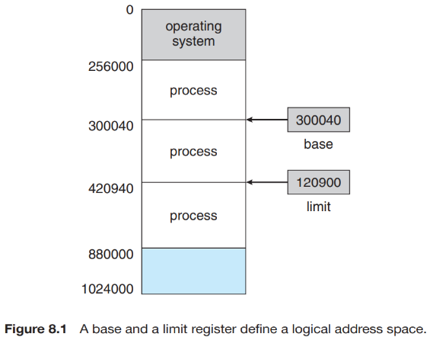Not only are we concerned with the relative speed of accessing physical memory, but we also must ensure correct operation. On multiuser systems, we must additionally protect user processes from one another. This protection must be provided by the hardware because the operating system doesn’t usually intervene between the CPU and its memory accesses (because of the resulting performance penalty). We can provide this protection by using two registers, usually a base and a limit, as illustrated in Figure 8.1. The **base register** holds the smallest legal physical memory address; the **limit register** specifies the size of the range.

For example, if the base register holds 300040 and the limit register is 120900, then the program can legally access all addresses from 300040 through 420939 (inclusive).

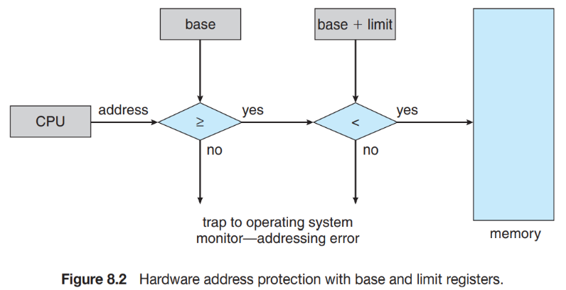Any attempt by a program executing in user mode to access operating-system memory or other users’ memory results in a trap to the operating system, which treats the attempt as a fatal error (Figure 8.2). This scheme prevents a user program from (accidentally or deliberately) modifying the code or data structures of either the operating system or other users.

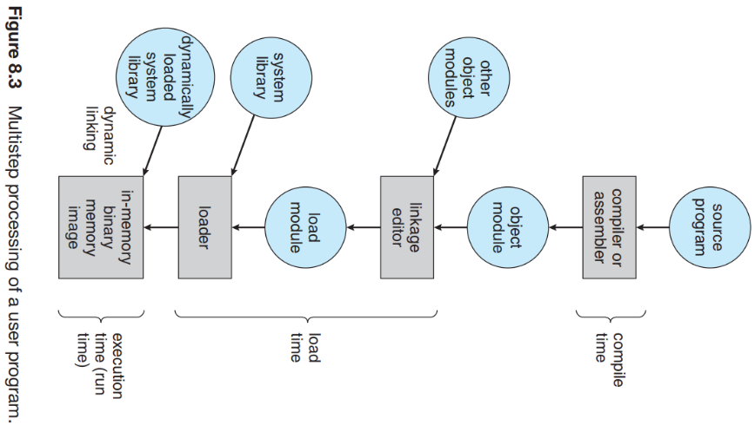***7.1.1) Address Binding*** : The processes on the disk that are waiting to be brought into memory for execution form the **input queue**. You will see later how a user program actually places a process in physical memory. In most cases, a user program goes through several steps—some of which may be optional—before being executed (Figure 8.3). Addresses may be represented in different ways during these steps. Addresses in the source program are generally symbolic (such as the variable count). A compiler typically **binds** these symbolic addresses to relocatable addresses (such as “14 bytes from the beginning of this module”). The linkage editor or loader in turn *binds* the relocatable addresses to absolute addresses (such as 74014). *Each binding is a mapping from one address space to another.* The binding of instructions and data to memory addresses can be done at any step along the way:

1) **Compile Time** : If you know at compile time where the process will reside in memory, then **absolute code** can be generated.

2) **Load Time** : If it is not known at compile time where the process will reside in memory, then the compiler must generate **relocatable code**.

3) **Execution Time** : If the process can be moved during its execution from one memory segment to another, then binding must be delayed until run time.

***7.1.2) Logical Versus Physical Address Space*** : An address generated by the CPU is commonly referred to as a **logical address (Virtual Address)**, whereas an address seen by the memory unit—that is, the one loaded into the **memory-address register** of the memory—is commonly referred to as a **physical address**. The compile-time and load-time address-binding methods generate identical logical and physical addresses. However, the execution-time address binding scheme results in differing logical and physical addresses. The run-time mapping from virtual to physical addresses is done by a hardware 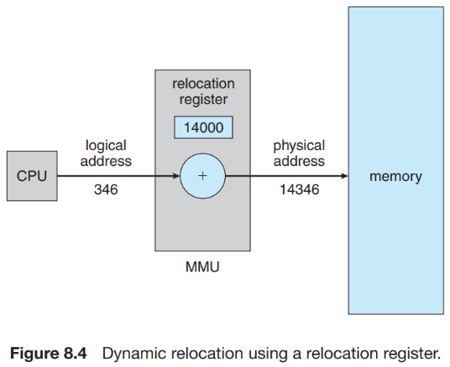device called the **memory-management unit (MMU).** The user program generates only logical addresses and thinks that the process runs in locations 0 to max. However, these logical addresses must be mapped to physical addresses (in the range R + 0 to R + max for a base value R) before they are used. For example, If the base is at 14000, then an attempt by the user to address location 0 is dynamically relocated to location 14000; an access to location 346 is mapped to location 14346. *Here relocation register simply another name for base register.*

***7.1.3) Dynamic Loading*** : With dynamic loading, a routine is not loaded until it is called. All routines are kept on disk in a relocatable load format. Here routine means process, when a routine needs to call another routine, the calling routine first checks to see whether the other routine has been loaded. If it has not, the **relocatable linking loader** is called to load the desired routine into memory and to update the program’s address tables to reflect this change. Then control is passed to the newly loaded routine. This method is particularly useful when large amounts of code are needed to handle infrequently occurring cases, such as error routines.

***7.1.4) Dynamic Linking and Shared Libraries*** : Dynamically linked libraries are system libraries that are linked to user programs when the programs are run. Some operating systems support only static linking, in which system libraries are treated like any other object module and are combined by the loader into the binary program image. With dynamic linking, A library may be replaced by a new version, and all programs that reference the library will automatically use the new version. Without dynamic linking, all such programs would need to be relinked to gain access to the new library.

Other programs linked before the new library was installed will continue using the older library. This system is also known as **shared libraries**. Unlike dynamic loading, dynamic linking and shared libraries generally require help from the operating system. DLL takes more time in program setup (in loading and linking phase to set up the global offset table and load and link the required libraries).

* 1. **Swapping** :

A process must be in memory to be executed. A process, however, can be swapped temporarily out of memory to a backing store and then brought back into memory for continued execution (Figure 8.5).

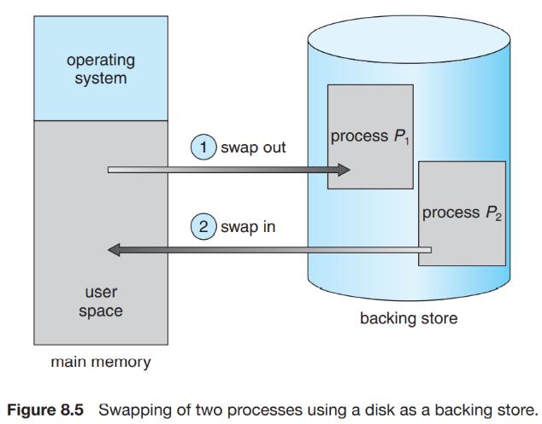***7.2.1) Standard Swapping*** : Standard swapping involves moving processes between main memory and a backing store. The backing store is commonly a fast disk.

*Complete process execution* :

The system maintains a ready queue consisting of all processes whose memory images are on the backing store or in memory and are ready to run. Whenever the CPU scheduler decides to execute a process, it calls the dispatcher. The dispatcher checks to see whether the next process in the queue is in memory. If it is not, and if there is no free memory region, the dispatcher swaps out a process currently in memory and swaps in the desired process. It then reloads registers and transfers control to the selected process.

The context-switch time in such a swapping system is fairly high. Notice that the major part of the swap time is transfer time. The total transfer time is directly proportional to the amount of memory swapped. Swapping is constrained by other factors as well. If we want to swap a process, we must be sure that it is completely idle. Of particular concern is any pending I/O. A process may be waiting for an I/O operation when we want to swap that process to free up memory. Another variation involves swapping portions of processes—rather than entire processes—to decrease swap time (Virtual memory).

* 1. **Contiguous Memory Allocation** :

The main memory must accommodate both the operating system and the various user processes. We therefore need to allocate main memory in the most efficient way possible. This section explains one early method, contiguous memory allocation. The memory is usually divided into two partitions: one for the resident operating system and one for the user processes. We can place the operating system in either low memory or high memory.

*Problem* : The major factor affecting this decision is the location of the interrupt vector. Since the interrupt vector is often in low memory, programmers usually place the operating system in low memory as well. And we usually want several user processes to reside in memory at the same time. We therefore need to consider how to allocate available memory to the processes that are in the input queue waiting to be brought into memory.

*Solution* : In **contiguous memory allocation**, each process is contained in a single section of memory that is contiguous to the section containing the next process.

***7.3.1) Memory Protection*** : We can prevent a process from accessing memory it does not own by combining two ideas previously discussed. When the CPU scheduler selects a process for execution, the dispatcher loads the relocation and limit registers with the correct values as part of the context switch.

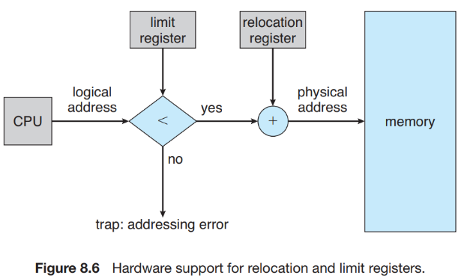The relocation-register scheme provides an effective way to allow the operating system’s size to change dynamically. This flexibility is desirable in many situations. For example, the operating system contains code and buffer space for device drivers. If a device driver (or other operating-system service) is not commonly used, we do not want to keep the code and data in memory, as we might be able to use that space for other purposes. Such code is sometimes called **transient operating-system code**; it comes and goes as needed.

***7.3.2) Memory Allocation*** : One of the simplest methods for allocating memory is to divide memory into several fixed-sized **partitions**. Each partition may contain exactly one process. Thus, the degree of multiprogramming is bound by the number of partitions. In this **multiple partition method**, when a partition is free, a process is selected from the input queue and is loaded into the free partition.

In the **variable-partition** scheme, the operating system keeps a table indicating which parts of memory are available and which are occupied. Initially, all memory is available for user processes and is considered one large block of available memory, a **hole**. Eventually, as you will see, memory contains a set of holes of various sizes. This procedure is a particular instance of the general **dynamic storage allocation** problem, which concerns how to satisfy a request of size n from a list of free holes. There are many solutions to this problem. One of three solution is given below :

• **First fit**. Allocate the first hole that is big enough. Searching can start either at the beginning of the set of holes or at the location where the previous first-fit search ended. We can stop searching as soon as we find a free hole that is large enough.

• **Best fit**. Allocate the smallest hole that is big enough. We must search the entire list, unless the list is ordered by size. This strategy produces the smallest leftover hole.

• **Worst fit**. Allocate the largest hole. Again, we must search the entire list, unless it is sorted by size. This strategy produces the largest leftover hole, which may be more useful than the smaller leftover hole from a best-fit approach.

• **Next fit**. Next fit is a modified version of 'first fit'. It begins from where the last request swapped in and then it searches next first fit.

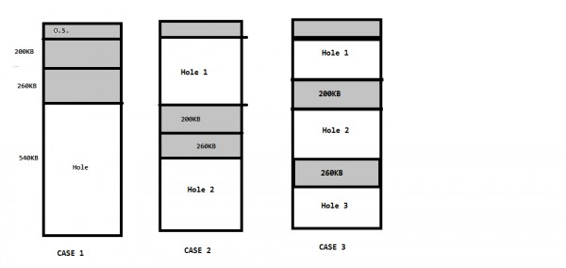

***Example*** : A 2048Kbyte memory is managed using variable partitions but no compaction. It currently has two partitions of sizes 840Kbyte and 518Kbyte respectively. The smallest allocation request in Kbyte that could be denied is for

***Answer*** : No compaction means that partitions may have space in between. It can be scatter across 2048 memory.

See all possible cases are given. Minimum gape happens at case 3 and also when all three partition are of equal size. 231Kbyte.

***7.3.3) Fragmentation*** : Both the first-fit and best-fit strategies for memory allocation suffer from **external fragmentation**. As processes are loaded and removed from memory, the free memory space is broken into little pieces. External fragmentation exists when there is enough total memory space to satisfy a request but the available spaces are not contiguous: storage is fragmented into a large number of small holes.

With fixed sized partition approach, the memory allocated to a process may be slightly larger than the requested memory. The difference between these two numbers is **internal fragmentation**—unused memory that is internal to a partition.

Solution : One solution to the problem of external fragmentation is **compaction**. The goal is to shuffle the memory contents so as to place all free memory together in one large block. The simplest compaction algorithm is to move all processes toward one end of memory; all holes move in the other direction, producing one large hole of available memory. This scheme can be expensive.

Another possible solution to the external-fragmentation problem is to permit the logical address space of the processes to be noncontiguous, thus allowing a process to be allocated physical memory wherever such memory is available. Two complementary techniques achieve this solution: segmentation (Section 8.4) and paging (Section 8.5). These techniques can also be combined.

* 1. 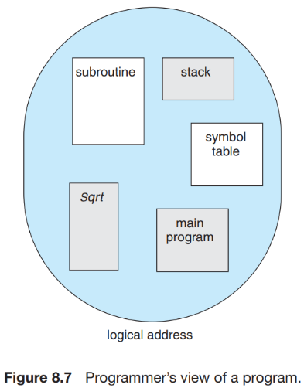**Segmentation** :

As we’ve already seen, the user’s view of memory is not the same as the actual physical memory. What if the hardware could provide a memory mechanism that mapped the programmer’s view to the actual physical memory? When writing a program, a programmer thinks of it as a main program with a set of methods, procedures, or functions. It may also include various data structures: objects, arrays, stacks, variables, and so on. Each of these modules or data elements is referred to by name. She is not concerned with whether the stack is stored before or after the Sqrt () function. Elements within a segment are identified by their offset from the beginning of the segment: the first statement of the program, the seventh stack frame entry in the stack, the fifth instruction of the Sqrt (), and so on.

**Segmentation** is a memory-management scheme that supports this programmer view of memory. Each segment has a name and a length. The addresses specify both the segment name and the offset within the segment. Thus, a logical address consists of a two tuple: <Segment number, offset> **or** <s, d>.

This mapping is affected by a **segment table**. Each entry in the segment table has a **segment base** and a **segment limit**. The segment base contains the starting physical address where the segment resides in memory, and the segment limit specifies the length of the segment.

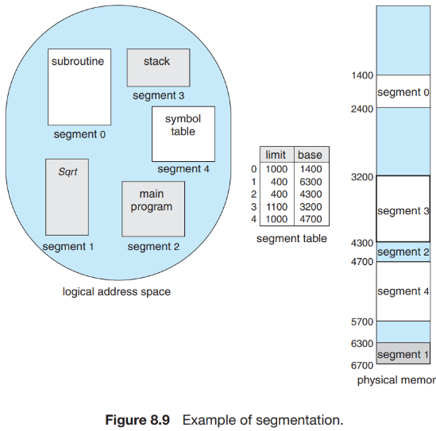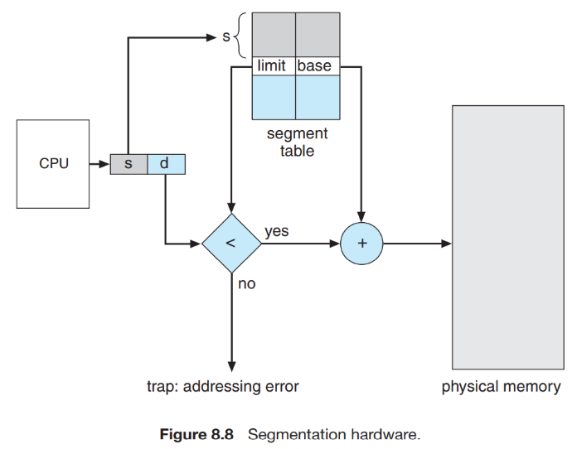

* 1. **Paging** :

Segmentation has disadvantage of compaction (high overhead and although it is solution to the external fragmentation but whenever used it is problem) and external fragmentation.

***7.5.1) Basic Method*** : The basic method for implementing paging involves breaking physical memory into fixed-sized blocks called **frames** and breaking logical memory into blocks of the same size called **pages**. When a process is to be executed, its pages are loaded into any available memory frames from their source (a file system or the backing store). The backing store is divided into fixed-sized blocks that are the same size as the memory frames or clusters of multiple frames. Because of paging virtual address can have more size than physical address space.

Every address generated by the CPU is divided into two parts: a **page number (p)** and a **page offset (d).** The page number is used as an index into a page table. The page table contains the base address of each page in physical memory. This base address is combined with the page offset to define the physical memory address that is sent to the memory unit.

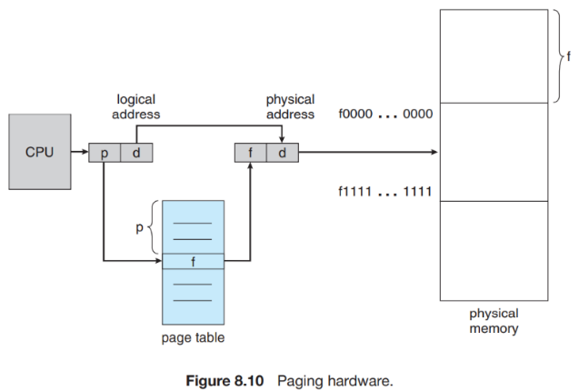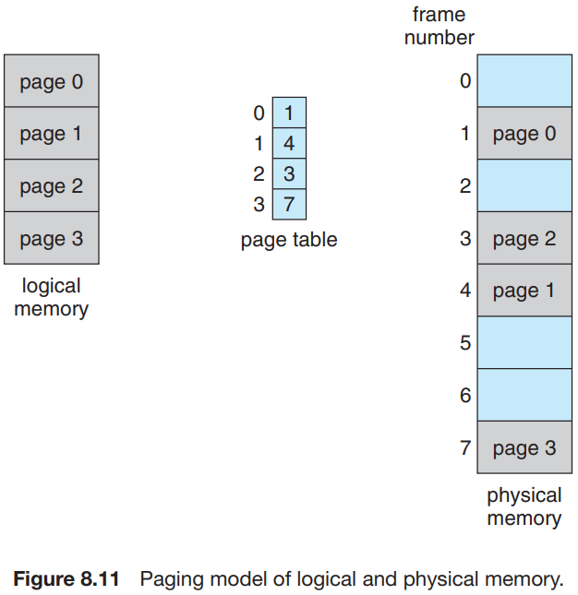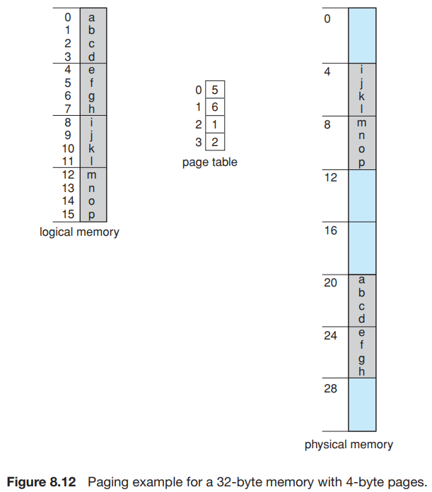

The page size (like the frame size) is defined by the hardware. The size of a page is a power of 2, depending upon computer architecture. If the size of the logical address space is 2m, and a page size is 2n bytes, then the high-order m − n bits of a logical address designate the page number, and the n low-order bits designate the page offset. where p is an index into the page table and d is the displacement within the page.

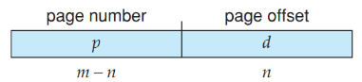 Page Table Entry Size=Number of bits for frame+Other information(process bit id+extra bit)

For concrete example, consider n= 2 and m = 4. Using a page size of 4 bytes and a physical memory of 32 bytes (8 pages), Logical address 0 is page 0, offset 0. Indexing into the page table, we find that page 0 is in frame 5. Thus, logical address 0 maps to physical address 20 [= (5 × 4) + 0]. Logical address 3 (page 0, offset 3) maps to physical address 23 [= (5 × 4) + 3].

When we use a paging scheme, we have no external fragmentation: any free frame can be allocated to a process that needs it. However, we may have some internal fragmentation. Notice that frames are allocated as units. If the memory requirements of a process do not happen to coincide with page boundaries, the last frame allocated may not be completely full. Today, pages typically are between 4 KB and 8 KB in size, and some systems support even larger page sizes.

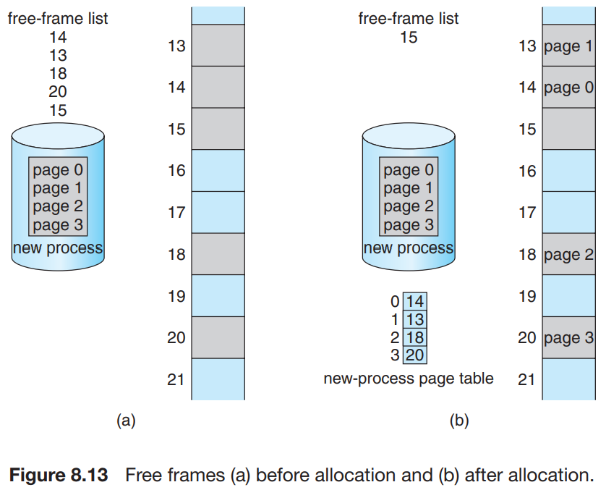When a process arrives in the system to be executed, its size, expressed in pages, is examined. Each page of the process needs one frame. Thus, if the process requires n pages, at least n frames must be available in memory. If n frames are available, they are allocated to this arriving process. The first page of the process is loaded into one of the allocated frames, and the frame number is put in the page table for this process. The next page is loaded into another frame, its frame number is put into the page table, and so on (Figure 8.13). Since the operating system is managing physical memory, it must be aware of the allocation details of physical memory—which frames are allocated, which frames are available, how many total frames there are, and so on. This information is generally kept in a data structure called a **frame table**. The frame table has one entry for each physical page frame. The operating system maintains a copy of the page table for each process, just as it maintains a copy of the instruction counter and register contents.

***7.5.2) Hardware Support*** : The hardware implementation of the page table can be done in several ways. In the simplest case, the page table is implemented as a set of dedicated **registers**. These registers should be built with very high-speed logic to make the paging-address translation efficient.

The use of registers for the page table is satisfactory if the page table is reasonably small (for example, 256 entries). Most contemporary computers, however, allow the page table to be very large (for example, 1 million entries). For these machines, the use of fast registers to implement the page table is not feasible. Rather, the page table is kept in main memory, and a **page-table base register (PTBR)** points to the page table.

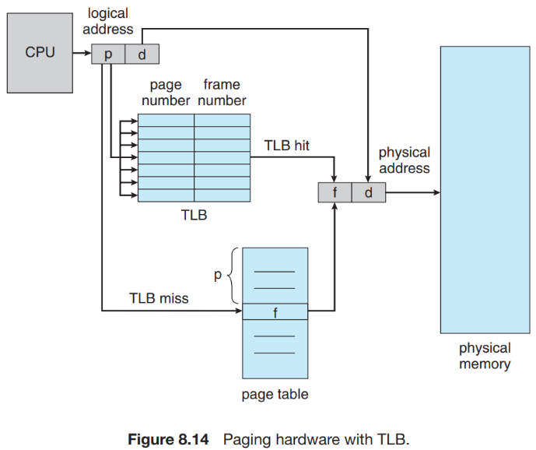*Problem with above approach* : If we want to access location i, we must first index into the page table, using the value in the PTBR offset by the page number for i. This task requires a memory access. It provides us with the frame number, which is combined with the page offset to produce the actual address. We can then access the desired place in memory. With this scheme, two memory accesses are needed to access a byte (one for the page-table entry, one for the byte). Thus, memory access is slowed by a factor of 2.

*Solution (***Translation look aside buffer***)* : The standard solution to this problem is to use a special, small, fast lookup hardware cache called a **translation look-aside buffer (TLB**). The TLB is associative, high-speed memory. Each entry in the TLB consists of two parts: a key (or tag) and a value. The TLB contains only a few of the page-table entries. When a logical address is generated by the CPU, its page number is presented to the TLB. If the page number is found, its frame number is immediately available and is used to access memory. As just mentioned, these steps are executed as part of the instruction pipeline within the CPU, adding no performance penalty compared with a system that does not implement paging.

If the page number is not in the TLB (known as a TLB miss), a memory reference to the page table must be made. Depending on the CPU, this may be done automatically in hardware or via an interrupt to the operating system. If the TLB is already full of entries, an existing entry must be selected for replacement. Furthermore, some TLBs allow certain entries to be **wired down**, meaning that they cannot be removed from the TLB. Typically, TLB entries for key kernel code are wired down.

Some TLBs store **address-space identifiers (ASIDs**) in each TLB entry. An ASID uniquely identifies each process and is used to provide address-space protection for that process. When the TLB attempts to resolve virtual page numbers, it ensures that the ASID for the currently running process matches the ASID associated with the virtual page. If the ASIDs do not match, the attempt is treated as a **TLB miss**.

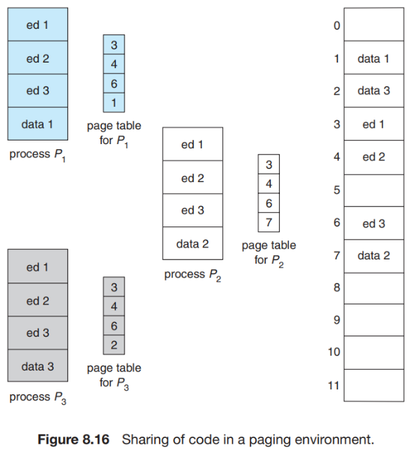***7.5.3) Protection*** : One additional bit is generally attached to each entry in the page table: a **valid–invalid** bit. When this bit is set to valid, the associated page is in the process’s logical address space and is thus a legal (or valid) page. When the bit is set to invalid, the page is not in the process’s logical address space.

***7.5.4) Shared Pages*** : An advantage of paging is the possibility of sharing common code. Consider a system that supports 40 users, each of whom executes a text editor. If the text editor consists of 150 KB of code and 50 KB of data space, we need 8,000 KB to support the 40 users. If the code is **reentrant code** (or **pure code**), however, it can be shared, as shown in Figure 8.16. Here, we see three processes sharing a three-page editor—each page 50 KB in size (the large page size is used to simplify the figure). Each process has its own data page.

Thus, to support 40 users, we need only one copy of the editor (150 KB), plus 40 copies of the 50 KB of data space per user. The total space required is now 2,150 KB instead of 8,000 KB—a significant savings.

* 1. **Structure of the Page Table :**

***7.6.1) Hierarchical Paging :*** For example, consider a system with a 32-bit logical address space. If the page size in such a system is 4 KB (212), then a page table may consist of up to 1 million entries (232/212). Assuming that each entry consists of 4 bytes, each process may need up to 4 MB of physical address space for the page table alone. Clearly, we would not want to allocate the page table contiguously in main memory. One simple solution to this problem is to divide the page table into smaller pieces.

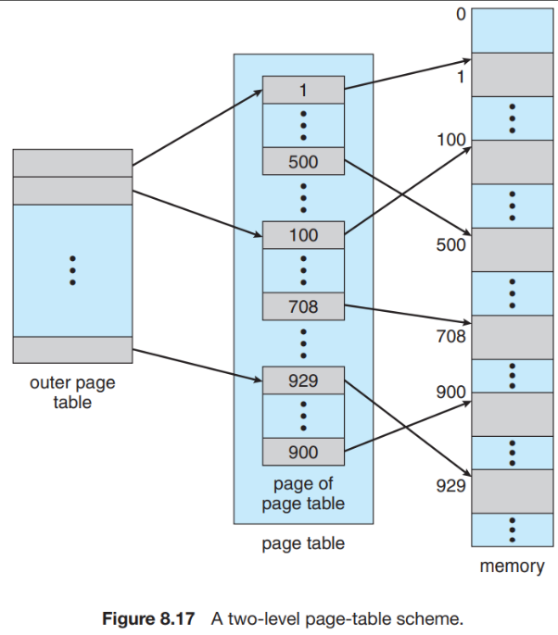One way is to use a two-level paging algorithm, in which the page table itself is also paged (Figure 8.17). For example, consider again the system with a 32-bit logical address space and a page size of 4 KB. A logical address is divided into a page number consisting of 20 bits and a page offset consisting of 12 bits. Because we page the page table, the page number is further divided into a 10-bit page number and a 10-bit page offset. Thus, a logical address is as follows:

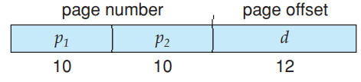 this scheme is also known as a **forward-mapped page table**.

*More on multipaging* : we can page the outer page table, giving us a three-level paging scheme. Suppose that the outer page table is made up of standard-size pages (210 entries, or 212 bytes). In this case, a 64-bit address space is still daunting: The outer page table is still 234 (232x4B) bytes (16 GB) in size. If 2 level paging is used with no page faults then we need to excess memory three times (One for 1st level page second for 2nd level page now we have got address so we can excess the correct memory location which result in another memory excess).

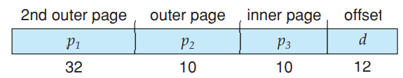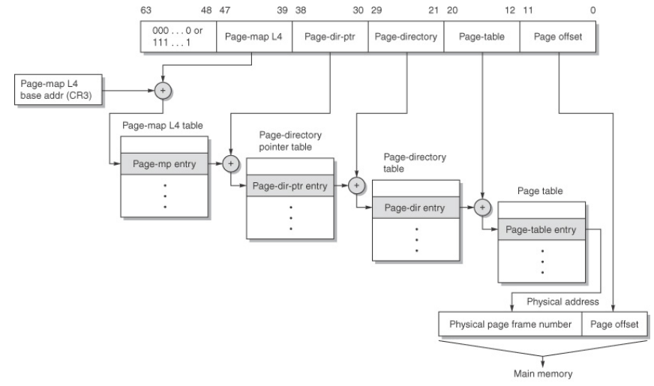

*Example* :

1. Consider a three-level page table to translate a 39-bit virtual address to a physical address as shown below :

The page size is 4KB and page table entry size at every level is 8 bytes. A process P is currently using 2GB virtual memory which is mapped to 2GB of physical memory. The minimum amount of memory required for the page table of P across all levels is _____ KB.

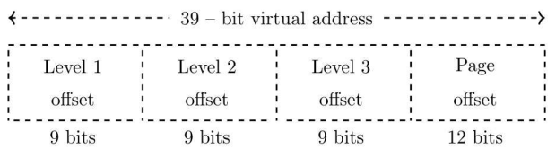

**Answer** : page size = frame size. So, process p is using 2GB of its VM. These VM have 2GB/4KB = 219 pages. But level three-page table has only 29 entries. So, one-page table of level 3 can point to 29 pages of VM only, So, we need 210 level 3 page tables of process P. So, at level-3, we have 210 page tables, So, we need 210 entries in Level-2 But level 2 page table has only 29 entries, so, one-page table of level 2 can only point to 29 page tables of level-3, so, we need 2 level-2 page tables. So, we need 1 level-1 page table to point to level-2 page tables. So, in total we need (1 + 2 + 210 ) page tables, and each page table size is 4KB. So, the answer is 4108KB.

**Common mistake** : do not consider page size while solving paging question like (2GB/ 4KB) x 8 B = 4 MB which is wrong. Remember that the Core reason why we use multilevel paging in pace of single level paging is that we want to reduce size of page table by taking advantage of unused space of process and making most entries in the outer level page table as invalid entries.

1. 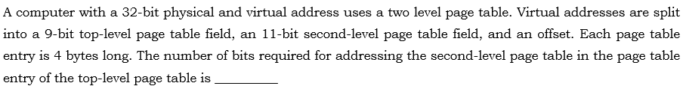

**Answer** :

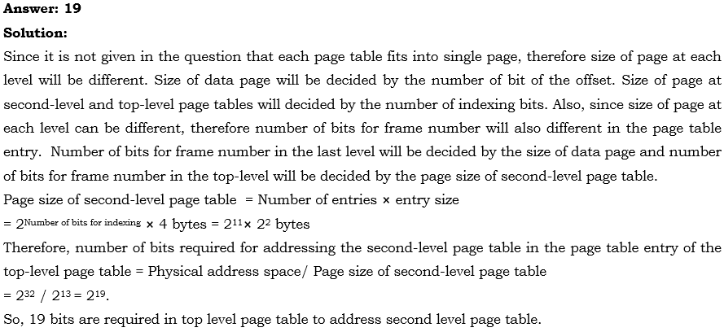

1. A processor uses 30-bit physical address and 32-bit virtual address. We subdivide the virtual address into 4 segments as follows:



We use a 3-level page table, such that the first 10-bit are for the first level and so on. Each page table entry is of size 4 bytes. The number of bits required for addressing the next level page table(or page frame) in the page table entry of the first, second and third level page tables are respectively. (This is very easy)

**Answer** :

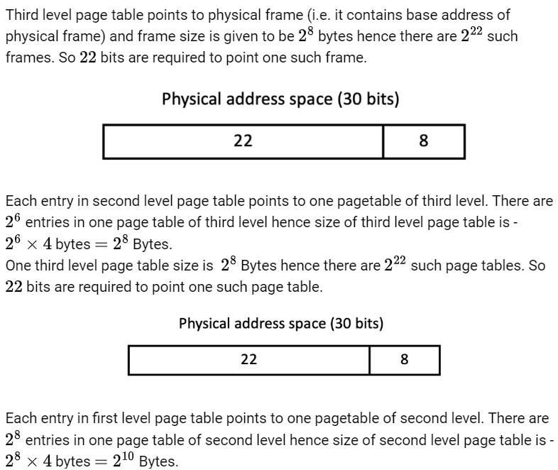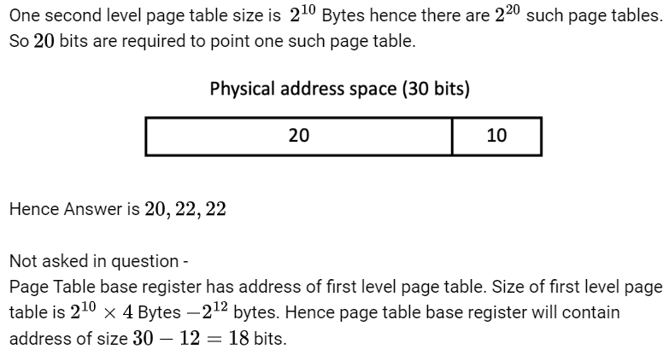

***7.6.2) Hashed Page Tables*** : A common approach for handling address spaces larger than 32 bits is to use a hashed page table, with the hash value being the virtual page number. Each entry in the hash table contains a linked list of elements that hash to the same location (to handle collisions). Each element consists of three fields: (1) the virtual page number, (2) the value of the mapped page frame, and (3) a pointer to the next element in the linked list. The algorithm works as follows: The virtual page number in the virtual address is hashed into the hash table. The virtual page number is compared with field 1 in the first element in the linked list. If there is a match, the corresponding page frame (field 2) is used to form the desired physical address. If there is no match, subsequent entries in the linked list are searched for a matching virtual page number.

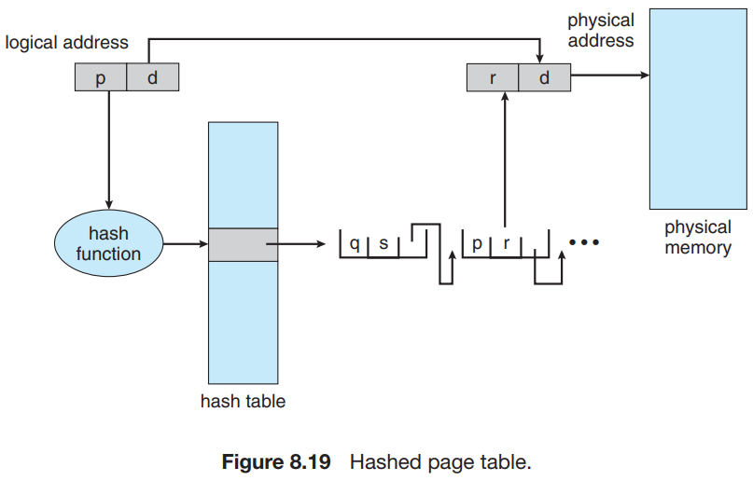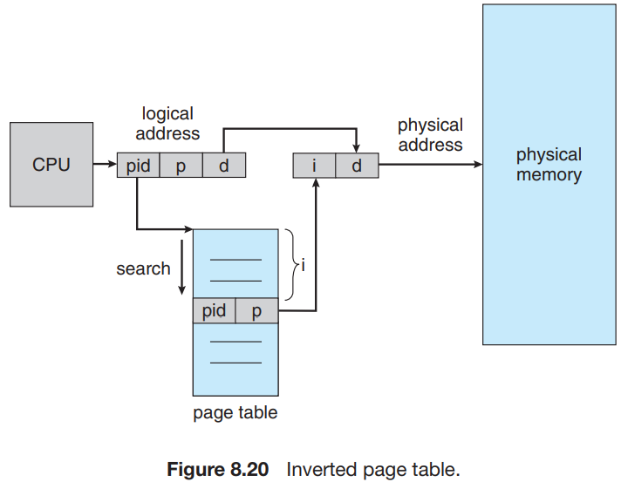

An inverted page table is one of the techniques to structure a page table, where the table is indexed by the actual frame number in the physical memory. Number of entries in inverted page table = Number of frames in main memory. In inverted page table size of the page table is depends upon the number of frames in the memory. Searching is based on (process id+p). And corresponding page frame is extracted from the physical memory after adding offset.

***7.6.3) Segmented paging*** : *Segmented paging* is a scheme that implements the combination of segmentation and paging. Disadvantage is internal fragmentation.

Segment no. = number of segments per process

Page No. = page id = number of pages per segment

Offset = page offset not segment offset

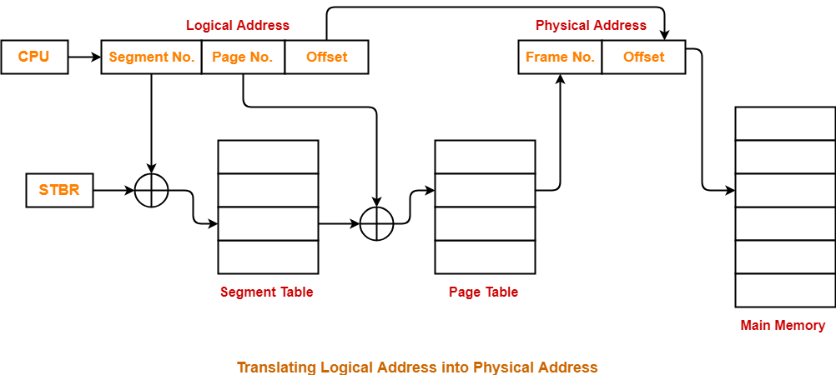

1. **VIRTUAL MEMORY**

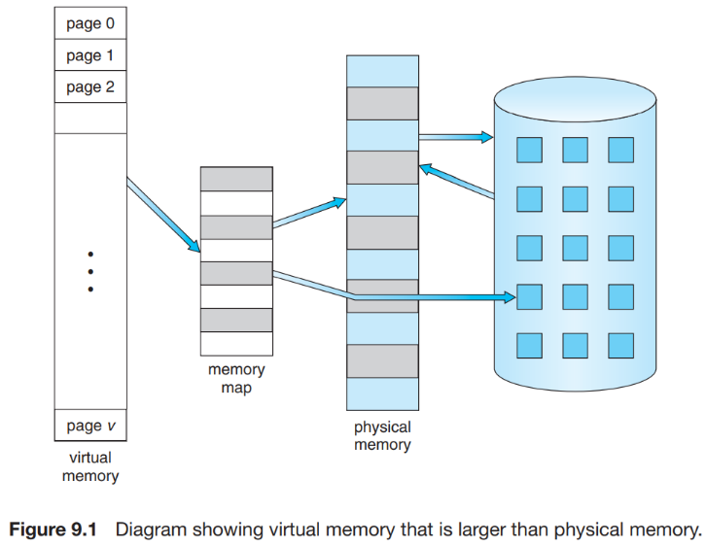Every strategy tends to require that an entire process be in memory before it can execute. Virtual memory is a technique that allows the execution of processes that are not completely in memory. One major advantage of this scheme is that programs can be larger than physical memory.

* 1. **Background :**

The requirement that instructions must be in physical memory to be executed seems both necessary and reasonable; but it is also unfortunate, since it limits the size of a program to the size of physical memory. in many cases, the entire program is not needed. For instance, consider the following:

• Programs often have code to handle unusual error conditions. Since these errors seldom, if ever, occur in practice, this code is almost never executed.

• An assembler symbol table may have room for 3,000 symbols, although the average program has less than 200 symbols.

*Benefits* : • A program would no longer be constrained by the amount of physical memory that is available.

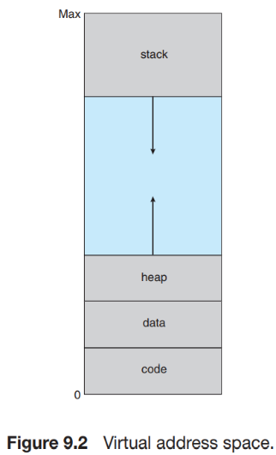Arrow shows the direction in which it may increase it’s size.The large blank space (or hole) between the heap and the stack is part of the virtual address space but will require actual physical pages only if the heap or stack grows. Virtual address spaces that include holes are known as **sparse address spaces**. Using a sparse address space is beneficial because the holes can be filled as the stack or heap segments grow or if we wish to dynamically link libraries (or possibly other shared objects) during program execution. we discuss implementing virtual memory through **demand paging**.

* 1. **Demand Paging :**

Suppose a program starts with a list of available options from which the user is to select. Loading the entire program into memory results in loading the executable code for all options, regardless of whether or not an option is ultimately selected by the user. An alternative strategy is to load pages only as they are needed. This technique is known as *demand paging* and is commonly used in virtual memory systems. With demand-paged virtual memory, pages are loaded only when they are demanded during program execution. Pages that are never accessed are thus never loaded into physical memory. A demand-paging system is similar to a paging system with swapping (Figure 9.4) where processes reside in secondary memory (usually a disk).We thus use “**pager**,” rather than “**swapper**,” in connection with demand paging. A *swapper* manipulates entire processes, whereas a *pager* is concerned with the individual pages of a process.

**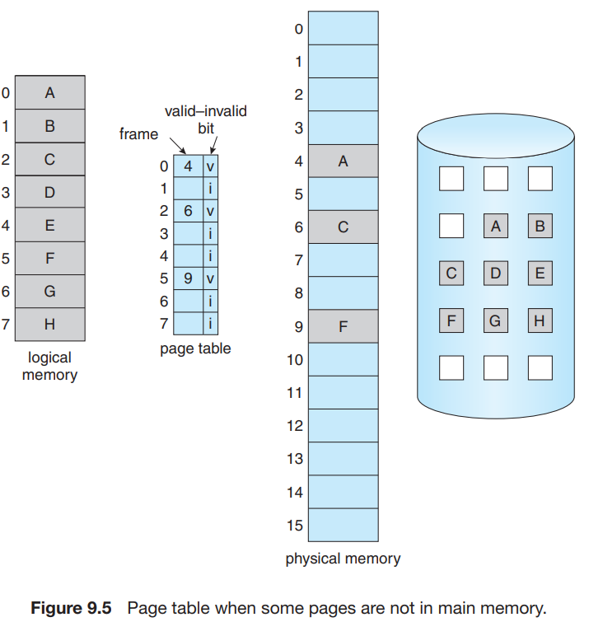*8.2.1) Basic Concept*** : When a process is to be swapped in, the pager guesses which pages will be used before the process is swapped out again. Instead of swapping in a whole process, the pager brings only those pages into memory. With this scheme, we need some form of hardware support to distinguish between the pages that are in memory and the pages that are on the disk. The *valid–invalid bit scheme* described in previous section can be used for this purpose. When this bit is set to “valid,” the associated page is both legal and in memory. If the bit is set to “invalid,” the page either is not valid (that is, not in the logical address space of the process) or is valid but is currently on the disk. There are also other bit such as present bit which tells us that after checking validity that page is present in main memory or not.

Consider one scenario, Page table contains 1024 entries. And let’s say one process is made of 512 pages. Now, those 512 entries should be present in page table. And remaining 512 pages are not pages of that process but it does not means those pages are not valid. They are valid for other processes.

But what happens if the process tries to access a page that was not brought into memory? Access to a page marked invalid causes a **page fault**. The paging hardware, in translating the address through the page table, will notice that the invalid bit is set, causing a trap to the operating system. This trap is the result of the operating system’s failure to bring the desired page into memory.

After this page is brought into memory, the process continues to execute, faulting as necessary until every page that it needs is in memory. At that point, it can execute with no more faults. This scheme is **pure demand paging** : never bring a page into memory until it is required.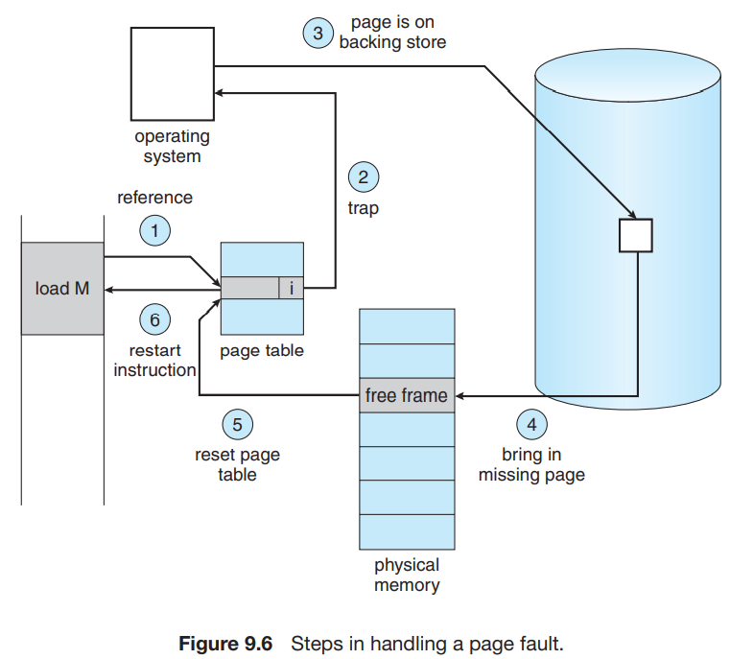 This may result in more page faults as some programs could access several new pages of memory with each instruction execution. Fortunately, analysis of running processes shows that this behavior is exceedingly unlikely. Programs tend to have **locality of reference.**

The hardware to support demand paging is the same as the hardware for paging and swapping:

• **Page table**. This table has the ability to mark an entry invalid through a valid–invalid bit or a special value of protection bits.

• **Secondary memory**. This memory holds those pages that are not present in main memory. The secondary memory is usually a high-speed disk. It is known as the swap device, and the section of disk used for this purpose is known as **swap space**. Swap is used for saving process data.

A crucial requirement for demand paging is the ability to restart any instruction after a page fault. Because we save the state (registers, condition code, instruction counter) of the interrupted process when the page fault occurs, we must be able to restart the process in *exactly* the same place and state, except that the desired page is now in memory and is accessible. Demand paging can bring entire process into memory at load time(for smaller processes).

Restarting the whole process can be costly, This problem can be solved in two different ways : 1) The microcode computes and attempts to access both ends of both blocks. 2) The other solution uses temporary registers to hold the values of overwritten locations.

***8.2.2) Performance of Demand Paging*** : Demand paging can significantly affect the performance of a computer system. To see why, let’s compute the effective access time for a demand-paged memory. For most computer systems, the **memory-access time**, denoted ma, ranges from 10 to 200 nanoseconds. Let p be the probability of a page fault (0 ≤ p ≤ 1). We would expect p to be close to zero—that is, we would expect to have only a few page faults. The effective access time is then effective access time = (1 − p) × ma + p × page fault time

With an average page-fault service time of 8 milliseconds and a memory access time of 200 nanoseconds, the effective access time in nanoseconds is

effective access time = (1 − p) × (200) + p (8 milliseconds) = (1 − p) × 200 + p × 8,000,000 = 200 + 7,999,800 × p.

We see, then, that the effective access time is directly proportional to the page-fault rate. If one access out of 1,000 causes a page fault, the effective access time is 8.2 microseconds. The computer will be slowed down by a factor of 40 because of demand paging!

* 1. **Copy-on-Write** :

Recall that the fork() system call creates a child process that is a duplicate of its parent. Traditionally, fork() worked by creating a copy of the parent’s address space for the child, duplicating the pages belonging to the parent. However, considering that many child processes invoke the exec() system call immediately after creation, the copying of the parent’s address space may be unnecessary. Instead, we can use a technique known as **copy-on-write**, which works by allowing the parent and child processes initially to share the same pages. These shared pages are marked as copy-on-write pages, meaning that if either process writes to a shared page, a copy of the shared page is created.

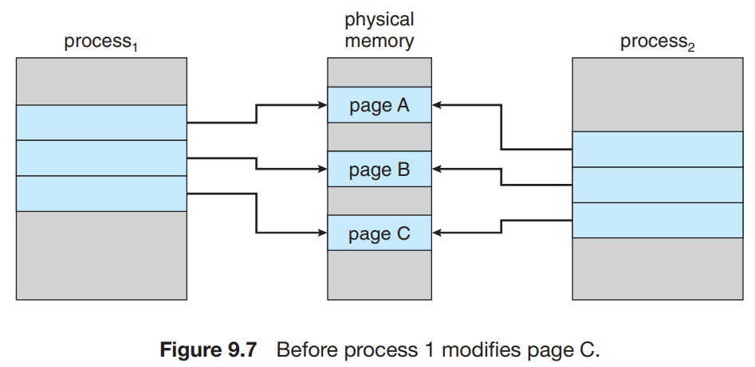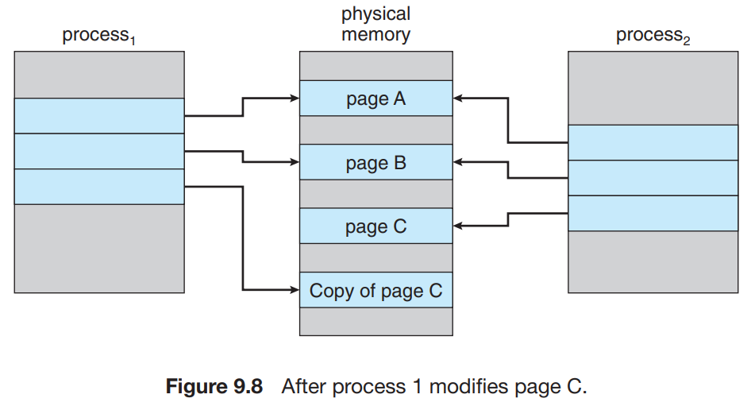

* 1. **Page Replacement** :

If a process of ten pages actually uses only half of them, then demand paging saves the I/O necessary to load the five pages that are never used. We could also increase our degree of multiprogramming by running twice as many processes. Thus, if we had forty frames, we could run eight processes, rather than the four that could run if each required ten frames (five of which were never used). If we increase our degree of multiprogramming, we are **over-allocating memory** (While a user process is executing, a page fault occurs. The operating system determines where the desired page is residing on the disk but then finds that there are no free frames on the free-frame list; all memory is in use).

*Solution* : 1) The operating system has several options at this point. It could terminate the user process, 2) The operating system could instead swap out a process, freeing all its frames and reducing the level of multiprogramming. Second solution is most promising and we will discuss more on this in our next sessions.

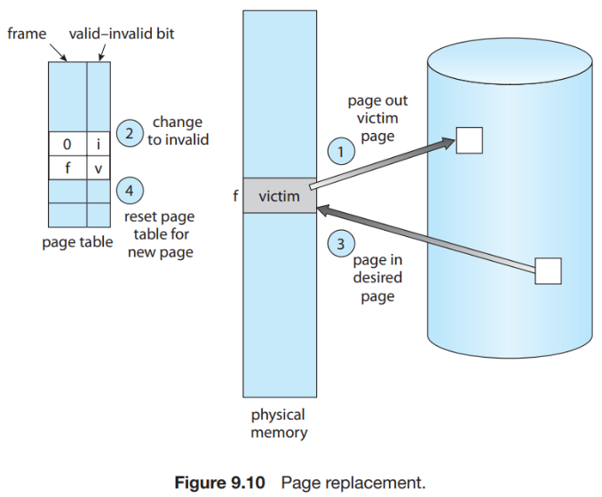***8.4.1) Basic Page Replacement*** : We modify the page-fault service routine to include page replacement :

1. Find the location of the desired page on the disk.

2. Find a free frame:

a. If there is a free frame, use it.

b. If there is no free frame, use a page-replacement algorithm to select a victim frame.

c. Write the victim frame to the disk; change the page and frame tables accordingly.

3. Read the desired page into the newly freed frame; change the page and frame tables.

4. Continue the user process from where the page fault occurred.

*Problem* : Notice that, if no frames are free, **two**-page transfers (one out and one in) are required. This situation effectively doubles the page-fault service time and increases the effective access time accordingly.

*Solution* : We can reduce this overhead by using a modify bit (or dirty bit). If the bit is set, we know that the page has been modified since it was read in from the disk. In this case, we must write the page to the disk. If the modify bit is not set, however, the page has not been modified since it was read into memory. In this case, we need not write the memory page to the disk: it is already there.

But if we have multiple processes in memory, we must decide how many frames to allocate to each process (**frame-allocation algorithm**); and when page replacement is required, we must select the frames that are to be replaced (**page-replacement algorithm**). We evaluate an algorithm by running it on a particular string of memory references and computing the number of page faults. The string of memory references is called a **reference string**.

*Consideration* : First, for a given page size (and the page size is generally fixed by the hardware or system), we need to consider only the page number, rather than the entire address. Second, if we have a reference to a page p,then any references to page p that immediately follow will never cause a page fault.

*For example*, if we trace a particular process, we might record the following address sequence: 0100, 0432, 0101, 0612, 0102, 0103, 0104, 0101, 0611, 0102, 0103, 0104, 0101, 0610, 0102, 0103, 0104, 0101, 0609, 0102, 0105. At 100 bytes per page, this sequence is reduced to the following reference string: 1, 4, 1, 6, 1, 6, 1, 6, 1, 6, 1. Similarly we consider 7, 0, 1, 2, 0, 3, 0, 4, 2, 3, 0, 3, 2, 1, 2, 0, 1, 7, 0, 1 as reference string for a memory with three frames in whole revision.

**NOTE** : As the number of frames available increases, the number of page faults decreases. Adding physical memory increases the number of frames.

***8.4.2) FIFO Page Replacement*** : When a page must be replaced, the oldest page is chosen.

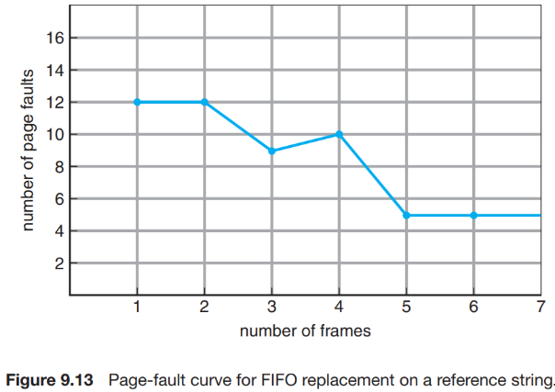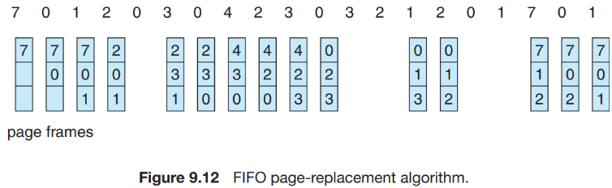

Consider the following reference string: 1, 2, 3, 4, 1, 2, 5, 1, 2, 3, 4, 5. Figure 9.13 shows the curve of page faults for this reference string versus the number of available frames. Notice that the number of faults for four frames (ten) is greater than the number of faults for three frames (nine)! This effect know as **Belady’s anomaly**. Which says for some page-replacement algorithms, the page-fault rate may increase as the number of allocated frames increases.

8***.4.3) Optimal Page Replacement*** : One result of the discovery of Belady’s anomaly was the search for an optimal page-replacement algorithm—the algorithm that has the lowest page-fault rate of all algorithms and will never suffer from Belady’s anomaly. *Rule* : Replace the page that will not be used for the longest period of time.

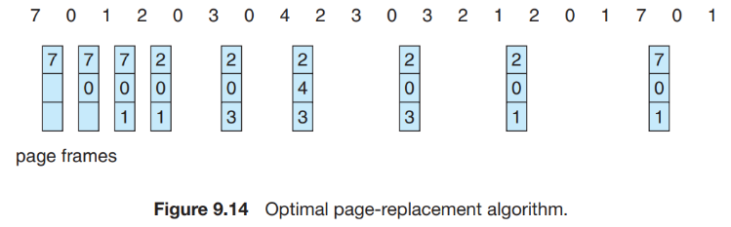*Disadvantage* : Unfortunately, the optimal page-replacement algorithm is difficult to implement, because it requires future knowledge of the reference string.

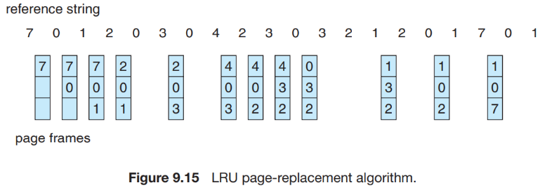***8.4.4) LRU Page Replacement*** : If we use the recent past as an approximation of the near future, then we can replace the page that has not been used for the longest period of time. This approach is the **least recently used (LRU)** algorithm.

*Problem* : The major problem is how to implement LRU replacement. The problem is to determine an order for the frames defined by the time of last use.

*Solution* : • **Counters**. In the simplest case, we associate with each page-table entry a time-of-use field and add to the CPU a logical clock or counter. The clock is incremented for every memory reference.

• **Stack**. Another approach to implementing LRU replacement is to keep a stack of page numbers. Whenever a page is referenced, it is removed from the stack and put on the top.

Like optimal replacement, LRU replacement does not suffer from Belady’s anomaly. Belady’s anomaly only exists in FIFO and Random page replacement. Both belong to a class of page-replacement algorithms, called **stack algorithms**, that can never exhibit Belady’s anomaly. A *stack algorithm* is an algorithm for which it can be shown that the set of pages in memory for n frames is always a *subset* of the set of pages that would be in memory with n + 1 frames. There is also most recently used page replacement algo which replaces page that is used recently means just before the current page.

***8.4.5) LRU-Approximation Page Replacement (Circular Clock Algorithm)*** : The reference bit for a page is set by the hardware whenever that page is referenced (either a read or a write to any byte in the page).

**1) Additional-Reference-Bits Algorithm** : We can gain additional ordering information by recording the reference bits at regular intervals. We can keep an 8-bit byte for each page in a table in memory. A timer interrupt transfers control to the operating system. The operating system shifts the reference bit for each page into the high-order bit of its 8-bit byte, shifting the other bits right by 1 bit and discarding the low-order bit. For example, A page with a history register value of 11000100 has been used more recently than one with a value of 01110111.

**2) Second-Chance Algorithm** : When a page has been selected, however, we inspect its reference bit. If the value is 0, we proceed to replace this page; but if the reference bit is set to 1, we give the page a second chance and move on to select the next FIFO page. When a page gets a second chance, its reference bit is cleared, and its arrival time is reset to the current time. One way to implement the second-chance algorithm (sometimes referred to as the clock algorithm) is as a circular queue.

***8.4.6) Counting-Based Page Replacement*** : • The **least frequently used (LFU)** page-replacement algorithm requires that the page with the smallest count be replaced. • The **most frequently used (MFU)** page-replacement algorithm is based on the argument that the page with the smallest count was probably just brought in and has yet to be used.

* 1. **Allocation of Frames** :

We turn next to the issue of allocation. How do we allocate the fixed amount of free memory among the various processes? If we have 93 free frames and two processes, how many frames does each process get?

1. Minimum Number of Frames : One reason for allocating at least a minimum number of frames involves performance. Obviously, as the number of frames allocated to each process decreases, the page-fault rate increases, slowing process execution.
2. Allocation Algorithms : The easiest way to split m frames among n processes is to give everyone an equal share, m/n frames (ignoring frames needed by the operating system for the moment). For instance, if there are 93 frames and five processes, each process will get 18 frames. The three leftover frames can be used as a free-frame buffer pool. This scheme is called equal allocation.

we can use proportional allocation, in which we allocate available memory to each process according to its size. Let the size of the virtual memory for process pi be si , and define S = ∑ si . Then, if the total number of available frames is m, we allocate ai frames to process pi , where ai is approximately ai = si/S × m. Of course, we must adjust each ai to be an integer that is greater than the minimum number of frames required by the instruction set, with a sum not exceeding m. With proportional allocation, we would split 62 frames between two processes, one of 10 pages and one of 127 pages, by allocating 4 frames and 57 frames, respectively, since 10/137 × 62 ≈ 4, and 127/137 × 62 ≈ 57.

* 1. **Thrashing** :

Consider any process that does not have “enough” frames. If the process does not have the number of frames it needs to support pages in active use, it will quickly page-fault. At this point, it must replace some page. However, since all its pages are in active use, it must replace a page that will be needed again right away. Consequently, it quickly faults again, and again, and again, replacing pages that it must bring back in immediately.

This high paging activity is called **thrashing**. A process is thrashing if it is spending more time paging than executing.

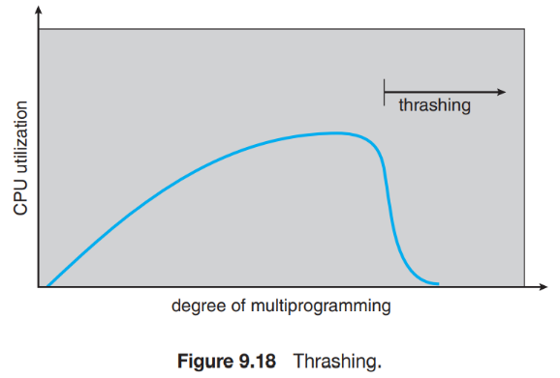***8.6.1) Cause of Thrashing*** : Consider the following scenario, which is based on the actual behavior of early paging systems. The operating system monitors CPU utilization. If CPU utilization is too low, we increase the degree of multiprogramming by introducing a new process to the system. Now suppose that a process enters a new phase in its execution and needs more frames. It starts faulting and taking frames away from other processes. These processes need those pages, however, and so they also fault, taking frames from other processes. These faulting processes must use the paging device to swap pages in and out. As they queue up for the paging device, the ready queue empties. As processes wait for the paging device, CPU utilization decreases.

The CPU scheduler sees the decreasing CPU utilization and increases the degree of multiprogramming as a result. The new process tries to get started by taking frames from running processes, causing more page faults and a longer queue for the paging device. As a result, CPU utilization drops even further, and the CPU scheduler tries to increase the degree of multiprogramming even more. Thrashing has occurred, and system throughput plunges. The page fault rate increases tremendously. As a result, the effective memory-access time increases. No work is getting done, because the processes are spending all their time paging.

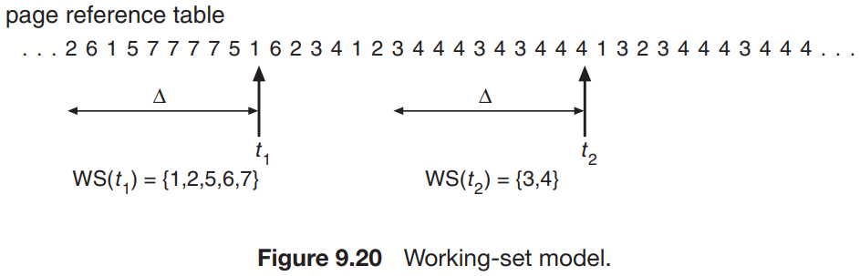*Problem with thrashing* : To prevent thrashing, we must provide a process with as many frames as it needs. But how do we know how many frames it “needs”?

*Solution* : **Working set model** (**Locality model**) will help in this case. The locality model states that, as a process executes, it moves from locality to locality. For example, when a function is called, it defines a new locality. In this locality, memory references are made to the instructions of the function call, its local variables, and a subset of the global variables. When we exit the function, the process leaves this locality, since the local variables and instructions of the function are no longer in active use. We may return to this locality later. Localities are defined by the program structure and its data structures.

***8.6.2) Working-Set Model*** : As mentioned, the working-set model is based on the assumption of locality. This model uses a parameter, ∆, to define the working-set window. The idea is to examine the most recent ∆ page references. The set of pages in the most recent ∆ page references is the working set (Figure 9.20). For example, given the sequence of memory references shown in Figure 9.20, if ∆ = 10 memory references, then the working set at time t1 is {1, 2, 5, 6, 7}. By time t2, the working set has changed to {3, 4}.

If we compute the working-set size, WSSi , for each process in the system, we can then consider that D = ∑ WSSi , where D is the total demand for frames. Each process is actively using the pages in its working set. Thus, process i needs WSSi frames. If the total demand is greater than the total number of available frames (D > m), thrashing will occur, because some processes will not have enough frames.

*Working* : If the sum of the working-set sizes increases, exceeding the total number of available frames, the operating system selects a process to suspend. The process’s pages are written out (swapped), and its frames are reallocated to other processes. The suspended process can be restarted later.

***8.6.3) Another Strategy (Page-Fault Frequency)*** : If the actual page-fault rate exceeds the upper limit, we allocate the process another frame. If the page-fault rate falls below the lower limit, we remove a frame from the process. Thus, we can directly measure and control the page-fault rate to prevent thrashing.

* 1. **Allocating Kernel Memory** :

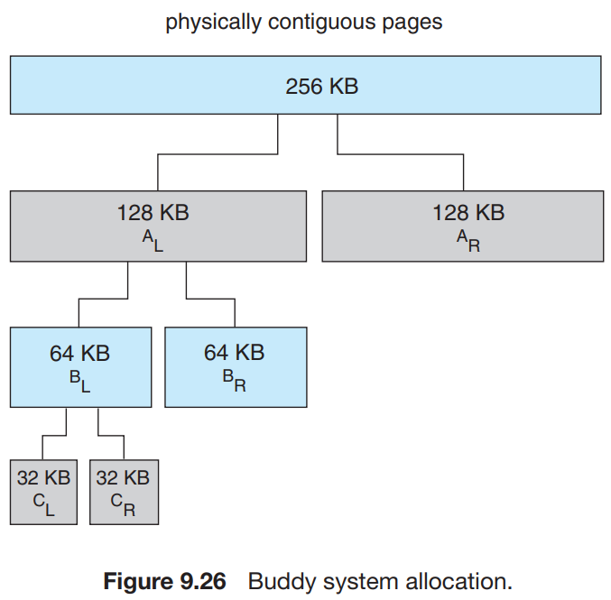When a process running in user mode requests additional memory, pages are allocated from the list of free page frames maintained by the kernel. Kernel memory is often allocated from a free-memory pool different from the list used to satisfy ordinary user-mode processes. We examine two strategies for managing free memory that is assigned to kernel processes: the “buddy system” and slab allocation.

The **buddy system** allocates memory from a fixed-size segment consisting of physically contiguous pages. Memory is allocated from this segment using a power-of-2 allocator, which satisfies requests in units sized as a power of 2 (4 KB, 8 KB, 16 KB, and so forth). A request in units not appropriately sized is rounded up to the next highest power of 2. For example, a request for 11 KB is satisfied with a 16-KB segment.

Let’s consider a simple example. Assume the size of a memory segment is initially 256 KB and the kernel requests 21 KB of memory. The segment is initially divided into two buddies—which we will call AL and AR—each 128 KB in size. And again divided into two and so on till 32KB. Because 21 KB cannot be fit into 16KB.

An advantage of the buddy system is how quickly adjacent buddies can be combined to form larger segments using a technique known as **coalescing**. In Figure 9.26, for example, when the kernel releases the CL unit it was allocated, the system can coalesce CL and CR into a 64-KB segment. This segment, BL, can in turn be coalesced with its buddy BR to form a 128-KB segment. Ultimately, we can end up with the original 256-KB segment.

***Question on paging and virtual memory*** :

1. 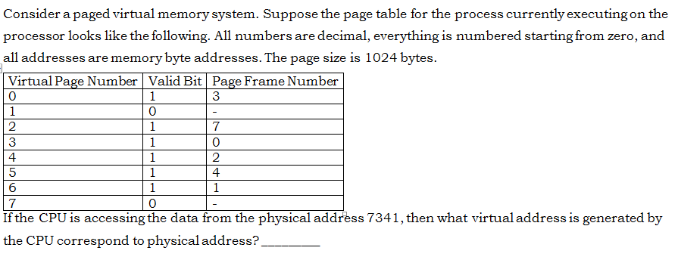

**Answer** : 2221 = 2 * 1024 + 173 , so the page number is 2 and the offset is 173. The page table shows that page 2 is resident in frame 7, so the physical address would be 7 * 1024 + 173 = 7341.

1. **MASS STORAGE STRUCTURE**
   1. **Overview of Mass Storage Structure :**

***9.1.1) Magnetic Disk*** : Magnetic disks provide the bulk of secondary storage for modern computer systems.

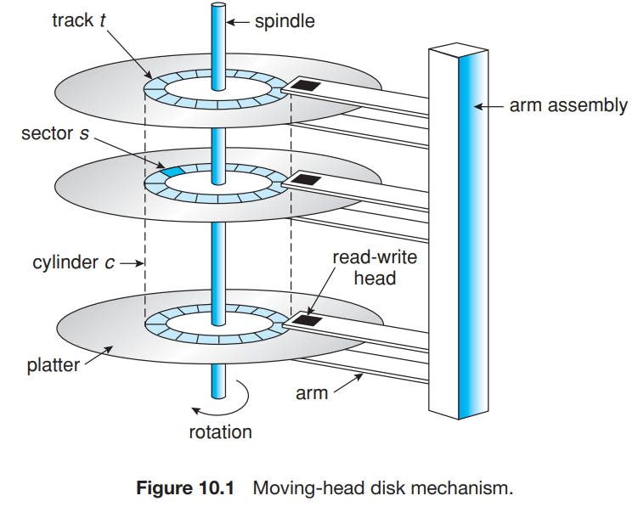**Transfer Rate** : the rate at which data flow between the drive and the computer.

**Positioning Time** OR **Random Access Time** : Consists of two parts : **Seek Time** : The time necessary to move the disk arm to the desired cylinder.

**Rotational Latency** : The time necessary for the desired sector to rotate under the disk head. Also, average rotational latency is equal to half of the rotational latency.

Although the disk platters are coated with a thin protective layer, the head will sometimes damage the magnetic surface. This accident is called a **head crash**. A disk drive is attached to a computer by a set of wires called an **I/O bus**.

**Average Latency** **= 0.5 * (60 / RPM)**

***9.1.2) Solid State Disk*** : An SSD is nonvolatile memory (Permanent storage) that is used like a hard drive. There are many variations of this technology, from DRAM with a battery to allow it to maintain its state in a power failure through flash-memory technologies like single-level cell (SLC) and multilevel cell (MLC) chips.

SSDs have the same characteristics as traditional hard disks but can be more reliable because they have no moving parts and faster because they have no seek time or latency. In addition, they consume less power.

One use for SSDs is in storage arrays, where they hold file-system metadata that require high performance. SSDs are also used in some laptop computers to make them smaller, faster, and more energy-efficient.

***9.1.3) Magnetic Tapes*** : Magnetic tape was used as an early secondary-storage medium. Although it is relatively permanent and can hold large quantities of data, its access time is slow compared with that of main memory and magnetic disk.

* 1. **Disk Structure** :

Sector 0 is the first sector of the first track on the outermost cylinder. The mapping proceeds in order through that track, then through the rest of the tracks in that cylinder, and then through the rest of the cylinders from outermost to innermost. The farther a track is from the center of the disk, the greater its length, so the more sectors it can hold. As we move from outer zones to inner zones, the number of sectors per track decreases. Tracks in the outermost zone typically hold 40 percent more sectors than do tracks in the innermost zone. The drive increases its rotation speed as the head moves from the outer to the inner tracks to keep the same rate of data moving under the head. Alternatively, the disk rotation speed can stay constant; in this case, the density of bits decreases from inner tracks to outer tracks to keep the data rate constant.

* With **Constant Linear Velocity, CLV**, the density of bits is uniform from cylinder to cylinder. Because there are more sectors in outer cylinders, the disk spins slower when reading those cylinders, causing the rate of bits passing under the read-write head to remain constant. This is the approach used by modern CDs and DVDs.
* With **Constant Angular Velocity, CAV**, the disk rotates at a constant angular speed, with the bit density decreasing on outer cylinders. (These disks would have a constant number of sectors per track on all cylinders.)

**NOTE** :

1. Data are being written out by cylinder and not by platter.
2. No of track = Recording width / inner space between track.

Recording width = (Outer Diameter - Inner Diameter )/2 .

1. **Total time** = **Waiting time** (Seek time + average latency) + **Data transfer time.**

Note here that waiting time = seek time + average latency it is not multiplication.

* 1. 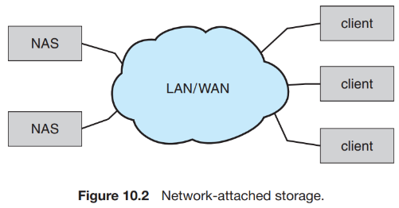**Disk Attachment** :

Computers access disk storage in two ways. One way is via I/O ports (or **host-attached storage**); this is common on small systems. The other way is via a **remote host** in a distributed file system; this is referred to as **network-attached storage.**

***9.3.1) Host-Attached Storage*** : Host-attached storage is storage accessed through local I/O ports. These ports use several technologies. The typical desktop PC uses an I/O bus architecture called IDE or ATA. A wide variety of storage devices are suitable for use as host-attached storage. Among these are hard disk drives, RAID arrays, and CD, DVD, and tape drives.

***9.3.2) Network-Attached Storage*** : A network-attached storage (NAS) device is a special-purpose storage system that is accessed remotely over a data network (Figure 10.2).

***9.3.3)*** ***Storage-Area Network*** (**SAN**) : One drawback of network-attached storage systems is that the storage I/O operations consume bandwidth on the data network, thereby increasing the latency of network communication.

*Facts* : Spooling (simultaneous peripheral operations online) is a technique in which an intermediate device such as disk is interposed between process and low speed i/o device. For ex. in printer if a process attempts to print a document but printer is busy printing another document, the process, instead of waiting for printer to become available, write its output to disk. When the printer become available the data on disk is printed. Spooling allows process to request operation from peripheral device without requiring that the device be ready to service the request.

* 1. **Disk Scheduling** :

For magnetic disks, the access time has two major components, as mentioned in Previous Section, *Seek time* and *Rotational Latency*. Whenever a process needs I/O to or from the disk, it issues a system call to the operating system. The request specifies several pieces of information:

• Whether this operation is input or output

• What the disk address for the transfer is

• What the memory address for the transfer is

• What the number of sectors to be transferred is

If the desired disk drive and controller are available, the request can be serviced immediately. If the drive or controller is busy, any new requests for service will be placed in the queue of pending requests for that drive.

***9.4.1) FCFS Scheduling*** : Consider, for example, a disk queue with requests for I/O to blocks on cylinders 98, 183, 37, 122, 14, 124, 65, 67, for a total head movement of 640 cylinders.

***9.4.2) SSTF Scheduling*** : It seems reasonable to service all the requests close to the current head position before moving the head far away to service other requests. This assumption is the basis for the **shortest-seek-time-first** (SSTF) algorithm. The SSTF algorithm selects the request with the least seek time from the current head position. For our example request queue, the closest request to the initial head position (53) is at cylinder 65. Once we are at cylinder 65, the next closest request is at cylinder 67. From there, the request at cylinder 37 is closer than the one at 98, so 37 is served next. This scheduling method results in a total head movement of only 236 cylinders. When difference in seek becomes same move towards smaller

*Problem* : SSTF scheduling is essentially a form of shortest-job-first (SJF) scheduling; and like SJF scheduling, it may cause starvation of some requests. Remember that requests may arrive at any time. Suppose that we have two requests in the queue, for cylinders 14 and 186, and while the request from 14 is being serviced, a new request near 14 arrives. This new request will be serviced next, making the request at 186 waits.

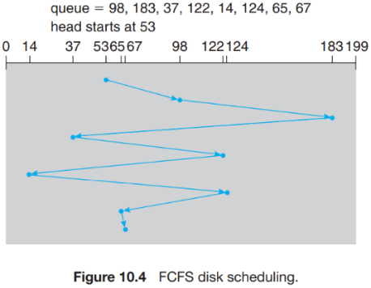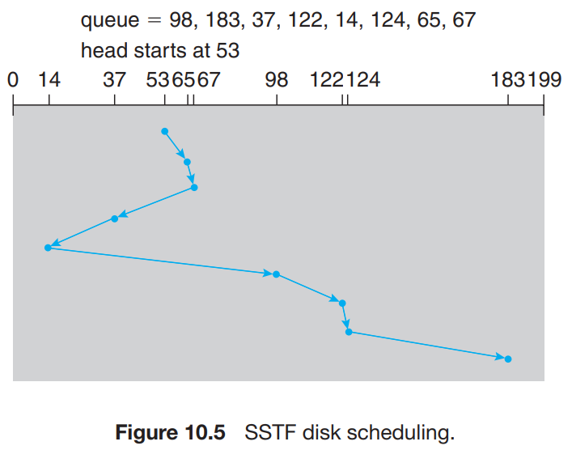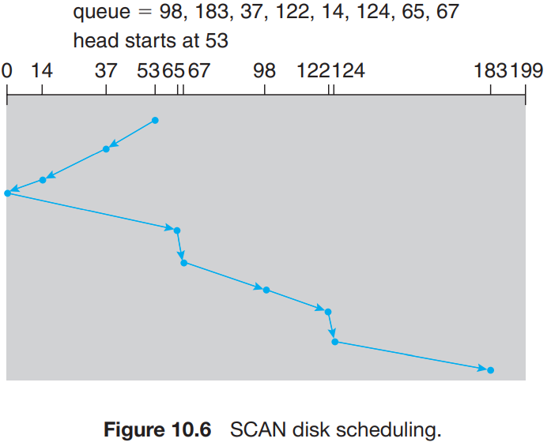

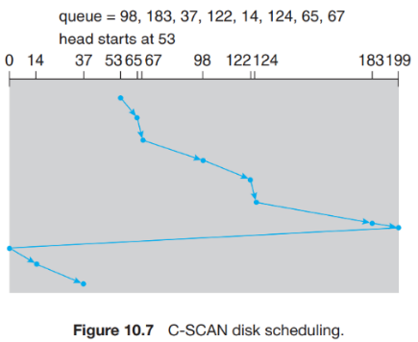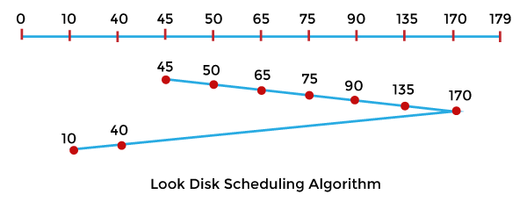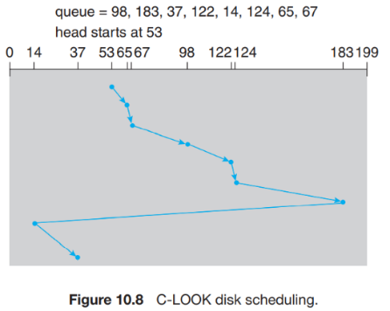

***9.4.3) SCAN Scheduling*** : In the SCAN algorithm, the disk arm starts at one end of the disk and moves toward the other end, servicing requests as it reaches each cylinder, until it gets to the other end of the disk. At the other end, the direction of head movement is reversed, and servicing continues. This scheduling is also known as **Elevator Scheduling**. TS or HM = 53 to 0 + 0 to last request

***9.4.4) C-SCAN Scheduling*** : Circular SCAN (C-SCAN) scheduling is a variant of SCAN designed to provide a more uniform wait time. Total seek or head moment = 53 to 199 + 199 to 0 + 0 to 37.

***9.4.5) Selection of a Disk-Scheduling Algorithm*** : Given so many disk-scheduling algorithms, how do we choose the best one? SSTF is common and has a natural appeal because it increases performance over FCFS. SCAN and C-SCAN perform better for systems that place a heavy load on the disk, because they are less likely to cause a starvation problem.

In all disk-scheduling algorithms header stops scanning disk when it reaches last remain request. Note that here last means not last in request sequence.

***Question*** :

* What happens when you start your computer or when you powered the system?

I. Bootstrap loader is loaded from the disk.

II. Kernel is loaded onto the memory.

III. Firmware ROM loads boot block.

**Answer** :

When the start button is pressed following sequence of events occurs

• CPU fetches the instruction into RAM from the BIOS which is stored in ROM.

• BIOS does some basic checks to make sure that all the components of computer are working properly.

• The BIOS then starts the boot sequence and will look for Kernel.

• BIOS will fetch operating system from the hard drive and load into the RAM.

• The BIOS then transfers control to the operating system.

1. **FILE SYSTEM IMPLEMENTATION**
   1. **File System Structure** :

Disks provide most of the secondary storage on which file systems are maintained. Two characteristics make them convenient for this purpose :

1. A disk can be rewritten in place; it is possible to read a block from the disk, modify the block, and write it back into the same place.

2. A disk can access directly any block of information it contains. Thus, it is simple to access any file either sequentially or randomly, and switching from one file to another requires only moving the read–write heads and waiting for the disk to rotate.

To improve I/O efficiency, I/O transfers between memory and disk are performed in units of blocks. Each block has one or more sectors. **File systems** provide efficient and convenient access to the disk by allowing data to be stored, located, and retrieved easily. It offers two design problem : 1) The first problem is defining how the file system should look to the user. This include file arrangement in window desktop for example. 2) The second problem is creating algorithms and data structures to map the logical file system onto the physical secondary-storage devices.

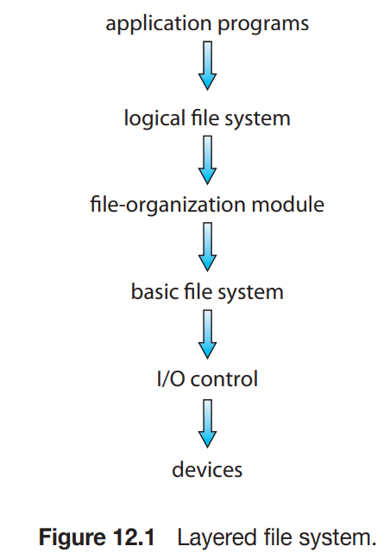The file system itself is generally composed of many different levels. Each level in the design uses the features of lower levels to create new features for use by higher levels.

* The **I/O control** level consists of device drivers and interrupt handlers to transfer information between the main memory and the disk system. A device driver can be thought of as a translator. Its input consists of high-level commands such as “retrieve block 123.” Its output consists of low-level, hardware-specific instructions that are used by the hardware controller. The device driver usually writes specific bit patterns to special locations in the I/O controller’s memory to tell the controller which device location to act on and what actions to take.
* The **basic file system** needs only to issue generic commands to the appropriate device driver to read and write physical blocks on the disk. Each physical block is identified by its numeric disk address (for example, drive 1, cylinder 73, track 2, sector 10). This layer also manages the memory buffers and caches that hold various file-system, directory, and data blocks.
* The **file-organization module** knows about files and their logical blocks, as well as physical blocks. By knowing the type of file allocation used and the location of the file, the file-organization module can translate logical block addresses to physical block addresses for the basic file system to transfer.
* Finally, the **logical file system** manages metadata information. Metadata includes all of the file-system structure except the actual data (or contents of the files).
  1. **File-System Implementation** :

In this section, we delve into the structures and operations used to implement file-system operations.

***10.2.1) Overview*** : Several on-disk and in-memory structures are used to implement a file system. These structures vary depending on the operating system and the file system, but some general principles apply.

1. **On disk**, the file system may contain information about how to boot an operating system stored there, the total number of blocks, the number and location of free blocks, the directory structure, and individual files.

• A **boot control block** (per volume) can contain information needed by the system to boot an operating system from that volume. If the disk does not contain an operating system, this block can be empty.

• A **volume control block** (per volume) contains volume (or partition) details, such as the number of blocks in the partition, the size of the blocks, a free-block count and free-block pointers, and a free-FCB count and FCB pointers.

• A directory structure (per file system) is used to organize the files.

• A per-file FCB contains many details about the file. It has a unique identifier number to allow association with a directory entry.

1. The **in-memory** information is used for both file-system management and performance improvement via caching.

• An in-memory mount table contains information about each mounted volume.

• An in-memory directory-structure cache holds the directory information of recently accessed directories.

• The system-wide open-file table contains a copy of the FCB of each open file, as well as other information.

• The per-process open-file table contains a pointer to the appropriate entry in the system-wide open-file table, as well as other information.

• Buffers hold file-system blocks when they are being read from disk or written to disk.

*Working* : To create a new file, an application program calls the logical file system. The logical file system knows the format of the directory structures. To create a new file, it allocates a new FCB. (Alternatively, if the file-system implementation creates all FCBs at file-system creation time, an FCB is allocated from the set of free FCBs.) The system then reads the appropriate directory into memory, updates it with the new file name and FCB, and writes it back to the disk.

* 1. **Allocation Methods** :

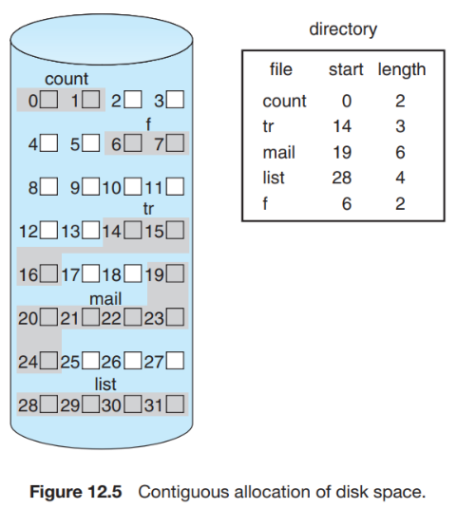The main problem is how to allocate space to these files so that disk space is utilized effectively and files can be accessed quickly.

***10.3.1) Contiguous Allocation*** : Contiguous allocation requires that each file occupy a set of contiguous blocks on the disk. Contiguous allocation of a file is defined by the disk address and length (in block units) of the first block. If the file is n blocks long and starts at location b, then it occupies blocks b, b + 1, b + 2, ..., b + n − 1. The directory entry for each file indicates the address of the starting block and the length of the area allocated for this file (Figure 12.5). When head movement is needed (from the last sector of one cylinder to the first sector of the next cylinder), the head need only move from one track to the next. Thus, the number of disk seeks required for accessing contiguously allocated files is minimal, as is seek time when a seek is finally needed.

* *Problem 1*: How to satisfy a request of size n from a list of free holes.

*Solution* : Neither first fit nor best fit is clearly best in terms of storage utilization, but first fit is generally faster.

* *Problem 2* : All these algorithms suffer from the problem of external fragmentation. As files are allocated and deleted, the free disk space is broken into little pieces. External fragmentation exists whenever free space is broken into chunks.

*Solution* : One strategy for preventing loss of significant amounts of disk space to external fragmentation is to copy an entire file system onto another disk. The original disk is then freed completely, creating one large contiguous free space.

* *Problem 3* : Another problem with contiguous allocation is determining how much space is needed for a file. When the file is created, the total amount of space it will need must be found and allocated. How does the creator (program or person) know the size of the file to be created?

*Solution* : Some operating systems use a modified contiguous-allocation scheme. Here, a contiguous chunk of space is allocated initially. Then, if that amount proves not to be large enough, another chunk of contiguous space, known as an extent, is added.

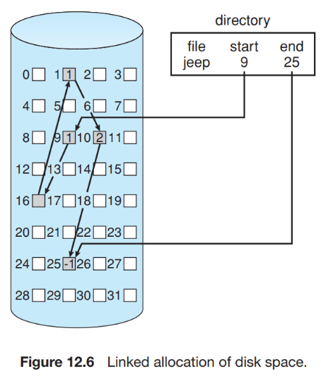

***10.3.2) Linked Allocation (no external fragmentation)*** : Linked allocation solves all problems of contiguous allocation. The directory contains a pointer to the first and last blocks of the file. For example figure 12.6. To create a new file, we simply create a new entry in the directory. With linked allocation, each directory entry has a pointer to the first disk block of the file. This pointer is initialized to null (the end-of-list pointer value) to signify an empty file.

*Disadvantage* :

• To find the ith block of a file, we must start at the beginning of that file and follow the pointers until we get to the ith block. Each access to a pointer requires a disk read, and some require a disk seek.

• Another disadvantage is the space required for the pointers.

*Solution* : The usual solution to this problem is to collect blocks into multiples, called **clusters**, and to allocate clusters rather than blocks. Clusters are made up off blocks. Pointers then use a much smaller percentage of the file’s disk space. The cost of this approach is an increase in internal fragmentation

• Consider what would happen if a pointer were lost or damaged. A bug in the operating-system software or a disk hardware failure might result in picking up the wrong pointer.

*Solution* : The table has one entry for each disk block and is indexed by block number. The FAT is used in much the same way as a linked list. The directory entry contains the block number of the first block of the file. The table entry indexed by that block number contains the block number of the next block in the file. This chain continues until it reaches the last block, which has a special end-of-file value as the table entry.

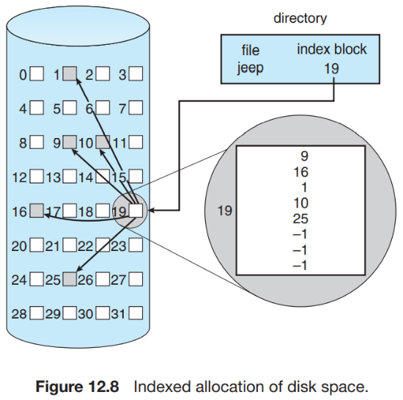

***10.3.3) Indexed Allocation*** : Linked allocation solves the external-fragmentation and size-declaration problems of contiguous allocation. However, in the absence of a FAT, linked allocation cannot support efficient direct access, since the pointers to the blocks are scattered with the blocks themselves all over the disk and must be retrieved in order. Indexed allocation solves this problem by bringing all the pointers together into one location: the index block. Each file has its own index block, which is an array of disk-block addresses. The ith entry in the index block points to the ith block of the file.

Mechanisms for “how large the index block should be” purpose include the following :

• **Linked scheme** : An index block is normally one disk block. Thus, it can be read and written directly by itself. To allow for large files, we can link together several index blocks.

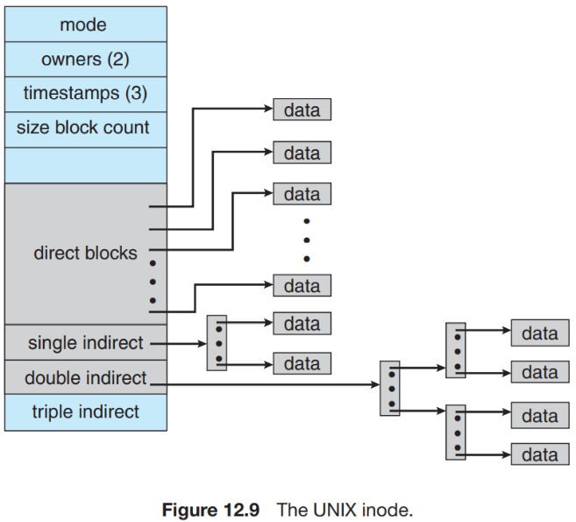• **Multilevel index** : A variant of linked representation uses a first-level index block to point to a set of second-level index blocks, which in turn point to the file blocks.

• **Combined scheme** : Another alternative, used in UNIX-based file systems, is to keep the first, say, 15 pointers of the index block in the file’s inode. The first 12 of these pointers point to **direct blocks**; that is, they contain addresses of blocks that contain data of the file. Thus, the data for small files (of no more than 12 blocks) do not need a separate index block. If the block size is 4 KB, then up to 48 KB of data can be accessed directly. The next three pointers point to **indirect blocks**. The first points to a **single indirect block**, which is an index block containing not data but the addresses of blocks that do contain data. The second points to a **double indirect block**, which contains the address of a block that contains the addresses of blocks that contain pointers to the actual data blocks. The last pointer contains the address of a **triple indirect block**.

*Example* : Consider a secondary storage system of size 2TB, with 512-byte sized blocks. Assume that the file system uses a multilevel i-node data structure to track data blocks of a file. The i-node has 64 bytes of space available to store pointers to data blocks, including a single indirect block, a double indirect block, and several direct blocks. What is the maximum file size (in KB) that can be stored in such a file system?

*Answer* :

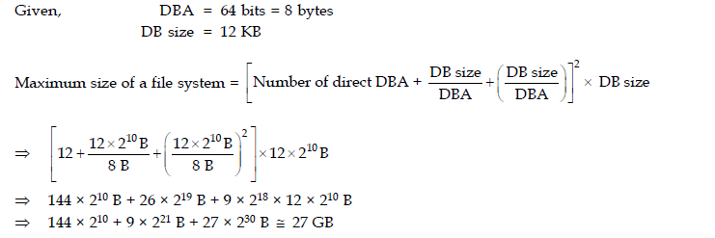

Number of data blocks = 2^41/2^9 = 2^32, so 32 bits or 4 bytes are required to store the number of a data block. Number of data block pointers in the inode = 64/4 = 16, of which 14 are direct blocks. The single indirect block stores pointers to 512/4 = 128 data blocks. The double indirect block points to 128 single indirect blocks, which in turn point to 128 data blocks each.

So, the total number of data blocks in a file can be 14+ 128 + 128*128 = 16526, and the maximum file size is 16526*512 bytes or (16526*512)/1024 = 8263 Kbytes. Now, see if one want to find the byte in position 13423826 then we will check stepwise. First multiply direct DBA*DB size if this value is more than 13423826 then our byte is in direct block which requires one excess of disk. If size is it is less then we go to single indirect and again check if 13423826 is less then single indirect if it is then out type is in single indirect we need 2 disk excess (1st for index + 2nd for data excess) and similar.

* 1. **Free Space Management** :

To keep track of free disk space, the system maintains **a free-space list**. The free-space list records all free device blocks. To create a file, we search the free-space list for the required amount of space and allocate that space to the new file. This space is then removed from the free-space list. When a file is deleted, its space is added to the free-space list.

***10.4.1) Bit vector*** : Frequently, the free-space list is implemented as a **bitmap** or **bit vector**. Each block is represented by 1 bit. If the block is free, the bit is 1; if the block is allocated, the bit is 0.

For example, consider a disk where blocks 2, 3, 4, 5, 8, 9, 10, 11, 12, 13, 17, 18, 25, 26, and 27 are free and the rest of the blocks are allocated. The free-space bitmap would be 001111001111110001100000011100000 ...

Another example, A 1-TB disk with 4-KB blocks would require 32 MB (240 / 212 = 228 bits = 225 bytes = 32 MB) to store its bitmap.

***10.4.2) Linked list*** : Another approach to free-space management is to link together all the free blocks, keeping a pointer to the first free block in a special location in the file system and caching it in memory. This first block contains a pointer to the next free block, and so on. This scheme is not efficient; to traverse the list, we must read each block, which requires substantial I/O time on HDDs.

***10.4.3) Grouping*** : A modification of the free-list approach stores the addresses of n free blocks in the first free block. The first n−1 of these blocks are actually free. The last block contains the addresses of another n free blocks, and so on. The addresses of a large number of free blocks can now be found quickly, unlike the situation when the standard linked-list approach is used.

***10.4.4) Counting*** : Rather than keeping a list of n free block addresses, we can keep the address of the first free block and the number (n) of free contiguous blocks that follow the first block. Each entry in the free-space list then consists of **a device address** and **a count.**

1. **FILE SYSTEM INTERFACE**
   1. **Access Method :**

Files Stores information. The information in the file can be accessed in several ways. Some systems provide only one access method for files. Others (such as mainframe operating systems) support many access methods.

***11.1.1) Sequential Access*** : Information in the file is processed in order, one record after the other. Such a file can be reset to the beginning, and on some systems, a program may be able to skip forward or backward n records for some integer n.

***11.1.2) Direct Access*** : Another method is direct access (or relative access). Here, a file is made up of fixed-length logical records that allow programs to read and write records rapidly in no particular order. we may read block 14, then read block 53, and then write block 7. There are no restrictions on the order of reading or writing for a direct-access file.

For the direct-access method, the file operations must be modified to include the block number as a parameter. Thus, we have read(n), where n is the block number, rather than read next(), and same for write command. The block number provided by the user to the operating system is normally a **relative block number**. A relative block number is an index relative to the beginning of the file. The use of relative block numbers allows the operating system to decide where the file should be placed (called the *allocation problem*) and helps to prevent the user from accessing portions of the file system that may not be part of her file.

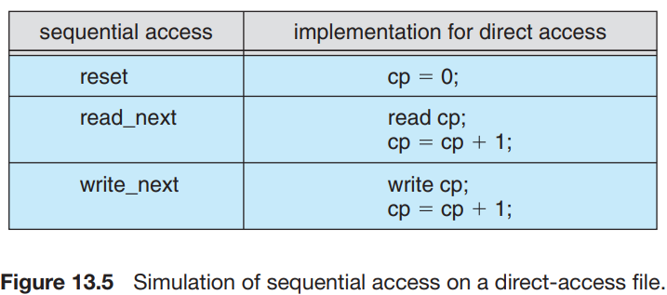

We can easily simulate sequential access on a direct-access file by simply keeping a variable cp that defines our current position, as shown in Figure 13.5. Simulating a direct-access file on a sequential-access file, however, is extremely inefficient and clumsy.

* 1. **Directory Structure** :

The directory can be viewed as a symbol table that translates file names into their file control blocks. The organization must allow us to insert entries, to delete entries, to search for a named entry, and to list all the entries in the directory. The most common scheme to defining the logical structure of a directory is as follows :

***11.2.1) Single-level directory*** : A single-level directory has significant limitations, however, when the number of files increases or when the system has more than one user. Since all files are in the same directory, they must have unique names.

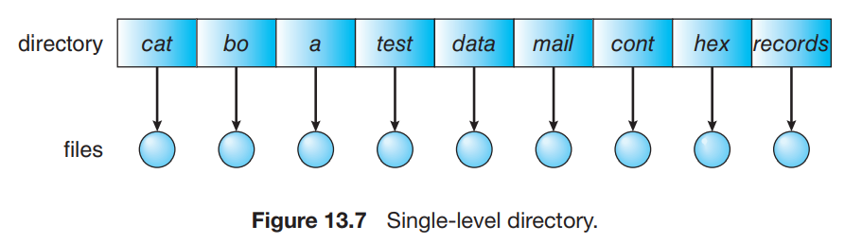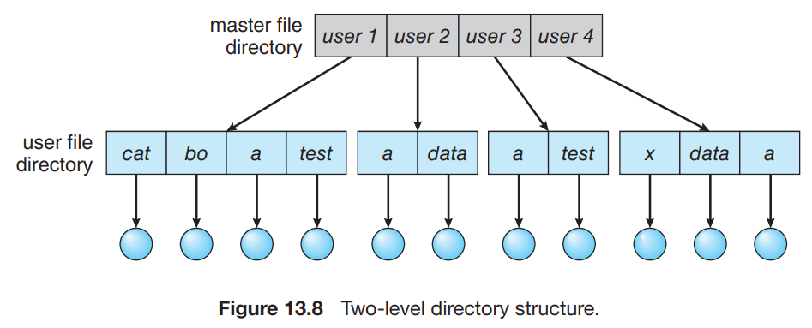

***11.2.2) Two level Directory*** : To eliminate confusion between same names of directory, solution is to create a separate directory for each user. In the two-level directory structure, each user has his own **user file directory** (UFD). The UFDs have similar structures, but each list only the files of a single user. When a user job starts or a user logs in, the system’s **master file directory** (MFD) is searched. A user name and a file name define a **path name**. For example, if user A wishes to access her own test file named test.txt, she can simply refer to test.txt.

***11.2.3) Tree-Structured directory*** : This is natural generalization of two level directory. The tree has a root directory, and every file in the system has a unique path name.

In normal use, each process has a **current directory**. The current directory should contain most of the files that are of current interest to the process. When reference is made to a file, the current directory is searched. If a file is needed that is not in the current directory, then the user usually must either specify a path name or change the current directory to be the directory holding that file.

Path names can be of two types: **absolute** and **relative**. In UNIX and Linux, an absolute path name begins at the root (which is designated by an initial “/”) and follows a path down to the specified file, giving the directory names on the path. A relative path name defines a path from the current directory.

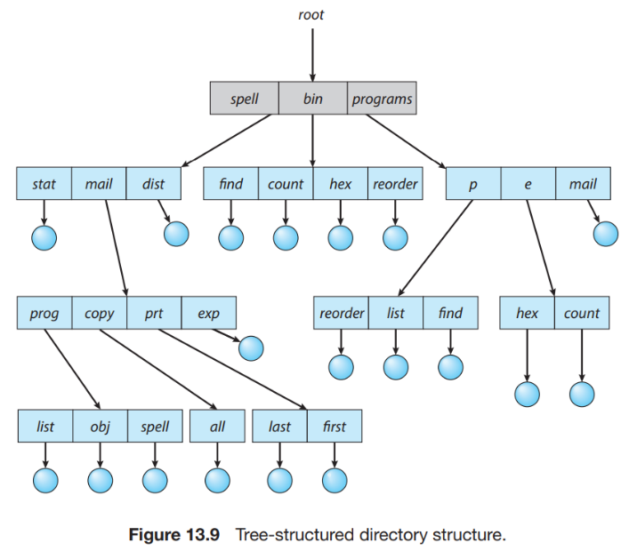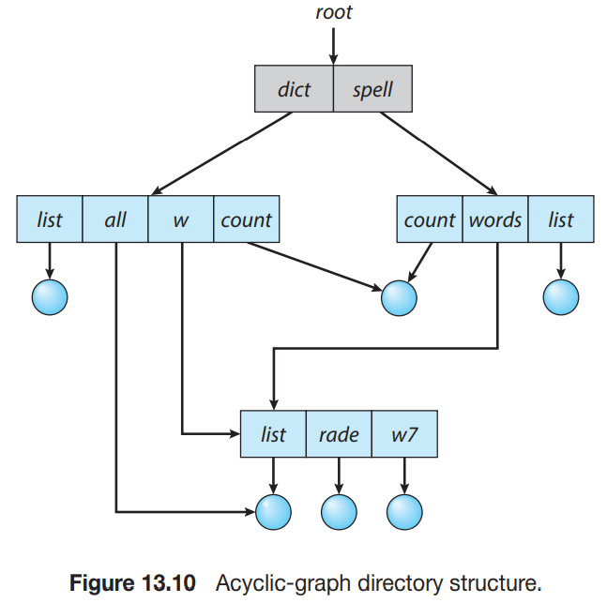

***11.2.4) Acyclic-Graph Directories*** : An acyclic graph— that is, a graph with no cycles—allows directories to share subdirectories and files (Figure 13.10). The same file or subdirectory may be in two different directories. The acyclic graph is a natural generalization of the tree structured directory scheme.

It is important to note that a shared file (or directory) is not the same as two copies of the file. With two copies, each programmer can view the copy rather than the original, but if one programmer changes the file, the changes will not appear in the other’s copy. With a shared file, only one actual file exists, so any changes made by one person are immediately visible to the other.

Shared files and subdirectories can be implemented in several ways. A common way, exemplified by UNIX systems, is to create a new directory entry called a **link**. A link is effectively a pointer to another file or subdirectory. Another common approach to implementing shared files is simply to duplicate all information about them in both sharing directories. Thus, both entries are identical and equal.

***11.2.5) General Graph Directory*** : A serious problem with using an acyclic-graph structure is ensuring that there are no cycles. The primary advantage of an acyclic graph is the relative simplicity of the algorithms to traverse the graph and to determine when there are no more references to a file.

If cycles are allowed to exist in the directory, we likewise want to avoid searching any component twice, for reasons of correctness as well as performance. A similar problem exists when we are trying to determine when a file can be deleted.

**Garbage collection** involves traversing the entire file system, marking everything that can be accessed. Then, a second pass collects everything that is not marked onto a list of free space. (A similar marking procedure can be used to ensure that a traversal or search will cover everything in the file system once and only once.) Garbage collection for a disk-based file system, however, is extremely time consuming and is thus seldom attempted. Garbage collection is necessary only because of possible cycles in the graph. Thus, an acyclic-graph structure is much easier to work with. The difficulty is to avoid cycles as new links are added to the structure.

***Question on Memory Management*** :

1. Consider a paging system that uses 1-level page table residing in main memory and a TLB for address translation. Each main memory access takes 100 ns and TLB lookup takes 20 ns. Each page transfer to/from the disk takes 5000 ns. Assume that the TLB hit ratio is 95%, page fault rate is 10%. Assume that for 20% of the total page faults, a dirty page has to be written back to disk before the required page is read from disk. TLB update time is negligible. The average memory access time in ns (round off to 1 decimal places) is ___________ . Note - This question was Numerical Type.

*154.5*

*155*

*755*

*725*

**Answer** : effective memory access time =

0.95(20+100)+0.05{0.90(20+100+100)+0.10[0.80(20+100+5000+100)+0.20(20+100+5000+5000+100)]}

=155.0 ns

Explanation:

If there is a TLB hit, you just need to access the memory. If there is a miss 1 TLB lookup was wasted,

You need to lookup the page table for the entry and then access the required location, requiring 2 memory accesses - Assuming No Page fault occurs.

If there is a page fault, Then 1 memory access was wasted (you can only know that the page is not present in memory by checking the corresponding page entry in the page table). 80 % of the time, you'll only be fetching a page from secondary storage which takes 5000 ns, 20% of the time, you'll need to write a dirty page back to disk and bring the page (which caused the page fault) back to main memory, requiring 5000+5000 ns

1. A file system with a one-level directory structure is implemented on a disk with disk block size of 4K bytes. The disk is used as follows:

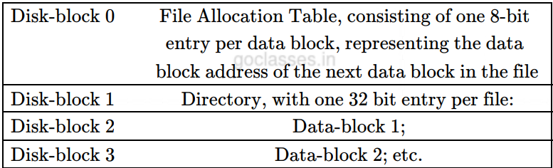

a. What is the maximum possible number of files?

b. What is the maximum possible file size in blocks.

**Answer** :

a. *Maximum possible number of files*: As per question, 32 bits (or 4Bytes) are required per file. And there is only one block to store this, ie the Disk block 1, which is of size 4KB. So, number of files possible is 4KB/4 Bytes = 1K files possible.

b. *Max file size*: As per question the Disk Block Address (FAT entry gives DBA) is of 8 bits. So, ideally the max file size should be 28 = 256 Block size. But question makes it clear that two blocks, DB0 and DB1, stores control information. So. effectively we have 256 – 2 = 254 blocks with us and the max file size should be = 254 x size of one block = 254x4 KB = 1016 KB.

1. A file currently has 5 blocks, from block 0 to block 4. Assume that its FCB and directory are already in memory. There are a few more assumptions as shown blow:

• In the contiguous allocation case, the directory entry has a start pointer and a length value.

• In the linked allocation, a directory entry has a start pointer and an end pointer.

• In the FAT allocation, the FAT table is in memory and a directory entry has a start pointer to the FAT table.

• In the case of the indexed allocation, the index block is in memory and is large enough for further expansion.

How many disk I/O operations (i.e., reads and writes) are required for contiguous, linked, FAT, and indexed (single-level) allocation strategies, if block 2 to be removed. Assume that the directory and index will not be written back to disk after this insertion is done.

**Answer :**

• *Contiguous Allocation*: The contiguous allocation knows the location of the first block (i.e., block 0), and can easily locate block 2. Because the allocation has to be contiguous, block 3 and block 4 have to be moved one block forward. In this case, for each of block 3 and block 4, one read and one write are needed, and four I/O operations are needed. If the directory has to be saved back to disk because the length has changed, one more I/O operation is needed.

• *Linked Allocation*: To access block 2, the system has to (1) read in block 0 to obtain the address of block 1; (2) read block 1 to obtain the address of block 2; (3) read block 2 to obtain the address of block 3; and (4) replace the address field in block 1 with the address of block 3, and write block 1 back to disk. This is exactly the same as updating a link list. Therefore, we need 3 reads and 1 write. no need to update directory for this case.

• *FAT*: This only requires an update the pointer in FAT. One may have to write the portion of the FAT back to disk, and this requires one more disk operation.

• *Index Allocation*: For the indexed allocation, because the index is already in memory, all block numbers starting with block 3 in the index block are moved forward. In this case, no I/O operation is needed. If the index block has to be written back to disk, one write is needed.

**Note** :

1. Sets and way in cache or TBL.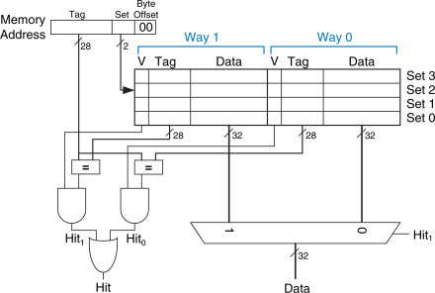
2. Total rows in Page Table is equal to 2^(total bit in virtual page-offset) in case of direct addressing.
3. 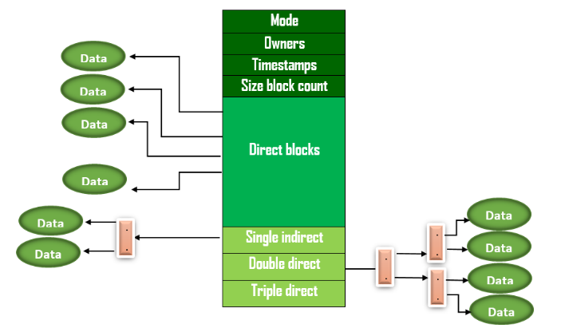
4. In case of big calculation select most dominating term for example : (1+2^7+2^14) = approx. 2^14
5. Read the question and understand each and every word.
6. **Dirty**:- Dirty bit is used for whenever a page has been modifying and we try to replace it and then this has to be written back so it write-back or leave it. Therefore, dirty bit is used for write-back policy.

**R/W**:- R/W is used for page protection.

**Reference**:- It says which page has not referred recently. Hence it is used for page replacement policy.

**Valid**:- It says whether the page you are looking for it present in MM or not. If not present in MM then load into the SM i.e. called page initialization.

1. Pure paging does not have external fragmentation, but may have internal fragmentation and Pure segmentation may have external fragmentation.
2. Page table always reside in main memory i.e. RAM.
3. 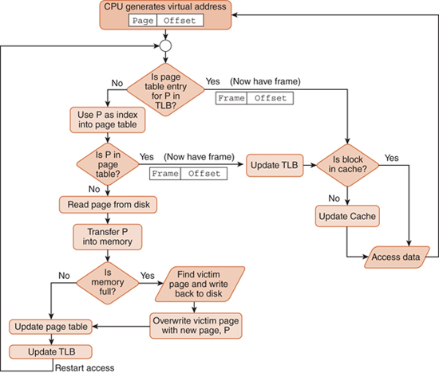Whole process from TLB hit to secondary access under paging.

First, we will look at the TLB which is in cache, if we get required page then we will fetch that frame from cache, result in one TLB and one cache access. The if TLB miss occur then we will look into page table which is in main memory and we update the cache and TLB simultaneously. Here cache and TLB access overlap so we consider only the TLB time. Then If we get Page hit means required page is in page table, we can directly access that page. This will result in (From starting) One TLB access, one main memory for page table and one memory after getting address of required page from page table. If page miss occurs than we will need to look into secondary memory. This will result in (form starting) One TLB, two main memory (One for page and one for secondary to main memory to put this address in Page table), one secondary memory access. In some cases, there can be two secondary memory access due to dirty bit write.

1. Formatting the floppy disk refers to writing identification information on all tracks and sectors.
2. Overlaying mean keep in memory only those instruction and data that are needed at any given time. Needed when process is larger than amount of memory allocated to it.
3. Each process is also a thread.